

Plant Fact Sheet

Pink Pappusgrass

*Pappophorum bicolor* E. Fourn.

Plant Symbol = PABI2

Contributed by: USDA NRCS E. “Kika” de la Garza Plant Materials Center and South Texas Natives

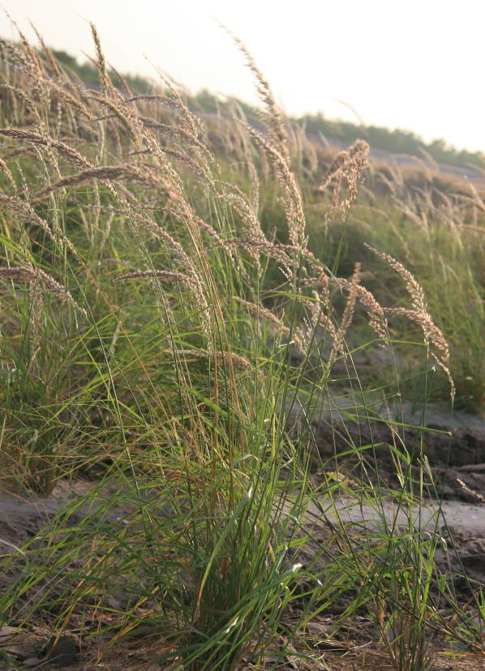 Pink Pappusgrass © Forrest Smith, South Texas Natives

Uses

Pink pappusgrass is recommended for upland wildlife habitat, highway rights-of-ways, and rangeland restoration and enhancement plantings.

Status

Please consult the PLANTS Web site and your State Department of Natural Resources for this plant’s current status (e.g., threatened or endangered species, state noxious status, and wetland indicator values).

Description and Adaptation

Pink pappusgrass is a native, warm-season, perennial grass, with stems 30-80 (sometimes 100) cm. tall. The blades are flat or slightly rolled in when dry, 10-20 (-30) cm. long and 1.5-5 mm. broad. Sheaths have a tuft of long hairs on either side of collar, and the hairs are deciduous with age. The ligule is a ring of short hairs, but base of blade immediately above ligule has hairs 2-4 mm. long. Panicles are tightly or loosely contracted, most frequently with short but somewhat erect-spreading branches, pink or purple-tinged at maturity, mostly 12-20 cm. long. Spikelets are 6-8 mm. long with 2-3 perfect florets and 2 reduced florets above. Chromosome number is reported as 2n=100 (Reeder and Toolin 1989). Pink pappusgrass flowers from April through November (Gould 1975). Cleaned seed of pink pappusgrass has an average of 322,400 seeds per pound.

Pink pappusgrass can be found from Texas to Arizona into Northern Mexico and in one county in New York State.

For updated distribution, please consult the Plant Profile page for this species on the PLANTS Web site.

Establishment

Numerous seeding trials have documented good establishment of pink pappusgrass from seed in south Texas. These plantings indicate good seed viability and persistence, an important characteristic for rangeland seed mix components in south Texas. Plantings have shown that seeding in the fall season has been superior to spring plantings for establishment of pink pappusgrass in south Texas.

The recommended seeding rate for pure stands of pink pappusgrass is 3 lbs. pure live seed per acre. Seed coatings (talc based) increase the flowability of seed through standard seed drills. Successful establishment has been obtained from both drill and broadcast plantings.

Management

Pink pappusgrass seed fields should be mowed or burned annually to promote vigorous growth. Deep soil tillage or frequent close cultivation is also recommended to promote seed production. Contact your local Agriculture Extension office for information on applicable pesticides.

Pests and Potential Problems

Common pests of pink pappusgrass seed include fall armyworms (*Spodoptera* spp.), thrips (*Thrips* spp.), and rice stink bugs (*Oebalus pugnax*). Control of the pests may be necessary in order to produce seed crops in dry years under irrigation.

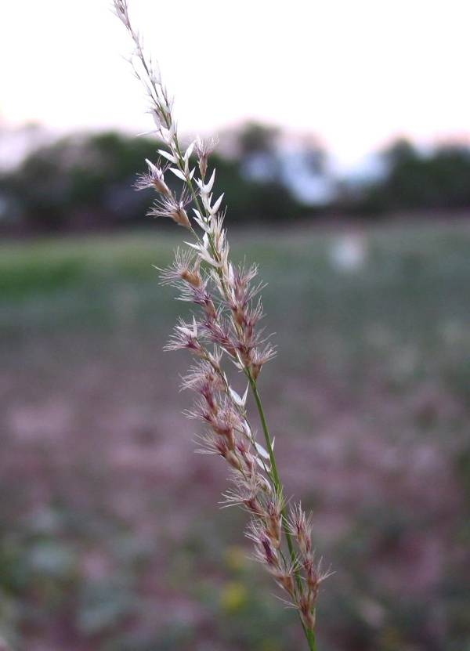 Pink Pappusgrass Seedhead © Forrest Smith, South Texas Natives

PLANTS Cultivars, Improved, and Selected Materials (and area of origin)

Maverick Germplasm pink pappusgrass was released by *South Texas Natives* and the E. “Kika” de la Garza Plant Materials Center in 2010 as a selected plant material class of certified seed (natural track). This release is comprised of seven collections from seven different south Texas counties (Smith et al. 2010).

References

Gould, F.W. 1975. The Grasses of Texas. Texas A&M University Press. College Station, TX.

Reeder J.R. and L.J. Toolin. 1989. Notes on *Pappophorum* (Gramineae: Pappophoreae).

Systematic Botany 14:3, 349-358.

Smith, F., W. Ocumpaugh, J. Lloyd-Reilley, K. Pawelek, S. Maher, and J. Garza. 2010. Notice of Release of Maverick Germplasm Pink Pappusgrass: Selected Class of Natural Germplasm. *South Texas Natives* CKWRI-TAMUK, Kingsville, TX.

Prepared By

USDA NRCS E. “Kika” de la Garza Plant Materials Center, Kingsville, Texas

Citation

Maher, S. and J. Lloyd-Reilley. 2010. Plant fact sheet for pink pappusgrass (*Pappophorum bicolor*). USDA-Natural Resources Conservation Service, E. “Kika” de la Garza Plant Materials Center. Kingsville, TX.

Published October, 2010

Edited:

For more information about this and other plants, please contact your local NRCS field office or Conservation District <<http://www.nrcs.usda.gov/>>, and visit the PLANTS Web site <[http://plants.usda.gov](http://plants.usda.gov/)> or the Plant Materials Program Web site <<http://plant-materials.nrcs.usda.gov>>

**USDA IS AN EQUAL OPPORTUNITY PROVIDER AND EMPLOYER**