|  |
| --- |
| KLEINGRASS |
| *Panicum coloratum* L. |
| Plant Symbol = PACO2 |

Contributed by: USDA–NRCS James E. “Bud” Smith Plant Materials Center, Knox City, Texas

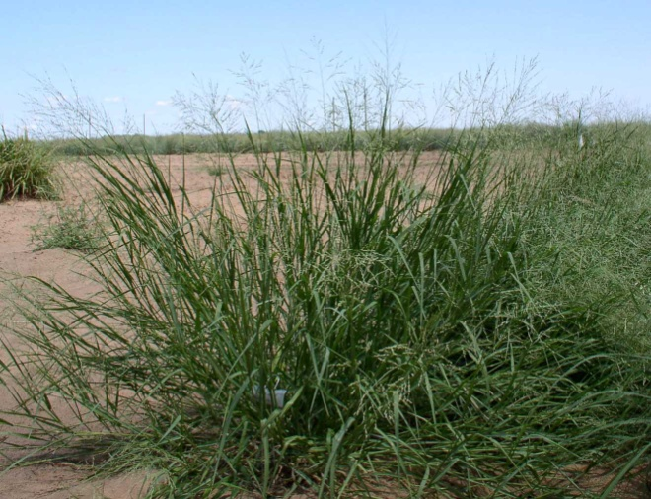

USDA NRCS James E. “Bud” Smith Plant Materials Center

Uses

*Livestock:* Kleingrass can provide abundant quantities of good quality forage for cattle. However, horses, sheep and goats have been known to develop severe photosensitization and liver damage. Green grass growth following moisture or grazing is reported to be relatively more toxic than old or dormant growth.

*Wildlife:* Kleingrass a bunch-type plant has value for nesting and loafing cover for wild birds and the small slick seed is readily eaten by quail. Whitetail deer graze young plant growth.

Status

Please consult the PLANTS Web site and your State Department of Natural Resources for this plant’s current status (e.g. threatened or endangered species, state noxious status, and wetland indicator values).

Description and Adaptation:

Grass Family (*Poaceae*). Kleingrass is a warm-season perennial bunchgrass introduced from Africa. Introductions were made as early as 1942, but it was not until the 1950’s that desirable types were introduced and evaluated. It is fine-stemmed and leafy at maturity which culms are erect, 50-120 centimeters (20-47 inches) tall, from a knotty base. Leave sheaths glabrous or with papillose based hairs and blades 2.5 millimeters (1/16 to 3/16 inches) wide, with scattered papillose based hairs on margins. Panicle is 7 to 20 centimeters (2 ¾ to 8 inches) long, spikelets on short pedicels. Spikelets are glabrous, 2.6 to 3.1 millimeters (about 1/8 inch) long with 2 florets which lower floret staminate, with long palea and upper floret fertile, glabrous, shiny, and hard, with acute apex. It is the same genus as switchgrass and blue panicum and bears a slight grass appearance. Kleingrass is quite variable in its makeup, sometimes prostrate but mostly erect. Kleingrass spreads by tillers or short rhizomes, and will root at the nodes when the stems contact with wet soils.

Kleingrass is adapted to a wide range of heavy soils and dry conditions in central Texas and on wet soils in the Gulf coast. In the Rio Grande Plains it does well on shallow sites, deep sandy soils and medium textured soils. Kleingrass grows in the southern United States (Texas, New Mexico, Arizona, California, Louisiana, Mississippi, Alabama, Georgia, Florida and South Carolina) as well as Mexico. The plant is moderate salinity tolerant. It produces good forage production with 46 to 76 centimeters (18 to 30 inches) rainfall or under irrigation, but is a poor cold tolerant plant. Cures for good winter forage in drier regions.

Establishment

Kleingrass seeds drilled ¼ to ½ inch deep on fine soils and up to 1 inch deep on coarser or prepacked sandy soils. Plant seeds at 2 pounds of Pure Live Seed (PLS) per acre in spring after the soil temperature reaches 60 degrees or early fall in coastal areas. Seedlings growing in a clean, firm and well-prepared ground are sturdy and have good development, but grow slow initially. Grazing should be restricted until new plants are well established. The seed is small and smooth, with approximately 500,000 seed per pound.

Management

Kleingrass is used for hay, pasture and silage. Fertilization is necessary for optimum growth and quality. Although kleingrass may not respond to high rates of fertilizer, essentially all soils, especially in the higher rainfall areas, will need fertilization to maintain production. A soil test is the best way to determine fertilization needs for establishment and production.

Pests and Potential Problems

There are no known serious pests of kleingrass.

Environmental Concerns

Other than noted potential toxicity to sheep, goats, and horses, no other known concerns.

Cultivars, Improved, and Selected Materials (and area of origin)

Kleingrass is native to Africa and was introduced in the United States as a forage plant for livestock.

‘Selection 75’was released cooperatively by the James E. “Bud” Smith Plant Materials Center and Texas Agriculture Experiment Station in 1969. Selected for forage production, the intended use of ‘Selection 75’ was for pastureland, range seeding, hay production, wildlife food and cover.

‘TEM-LD1’ was released in 1991 by USDA ARS and Texas Agriculture Experiment Station. ‘TEM-LD1’ was selected for rapid germination from the ‘Selection 75’ plant release.

‘TEM-SR1’ was released in 1992 by USDA ARS. ‘TEM-SR1’ was selected for seed shatter resistance.

‘Verde’ was released from Texas Agriculture Experiment Station and the James E. “Bud” Smith Plant Materials Center in 1982. ‘Verde’ was selected for increase seed size.

‘OKPC-1’was released by the Oklahoma Agriculture Experiment Station in 1982. ‘OKPC-1’ was selected for increased cold tolerance.

Prepared By and Species Coordinator:

*Rudy G. Esquivel*, USDA NRCS James E. “Bud” Smith Plant Materials Center, Knox City, Texas

Edited: 080916jsp

For more information about this and other plants, please contact your local NRCS field office or Conservation District, and visit the PLANTS Web site<<http://plants.usda.gov>> or the Plant Materials Program Web site <<http://Plant-Materials.nrcs.usda.gov>>

*The U.S. Department of Agriculture (USDA) prohibits discrimination in all its programs and activities on the basis of race, color, national origin, sex, religion, age, disability, political beliefs, sexual orientation, and marital or family status. (Not all prohibited bases apply to all programs.) Persons with disabilities who require alternative means for communication of program information (Braille, large print, audiotape, etc.) should contact USDA's* [*TARGET Center*](http://www.usda.gov/oo/target.htm) *at 202-720-2600 (voice and TDD).*

*To file a complaint of discrimination write USDA, Director, Office of Civil Rights, Room 326-W, Whitten Building, 14th and Independence Avenue, SW, Washington, DC 20250-9410 or call 202-720-5964 (voice or TDD). USDA is an equal opportunity provider and employer.*

*Read about* [*Civil Rights at the Natural Resources Conservation Service*](http://www.nrcs.usda.gov/about/civilrights/)*.*