

Plant Fact Sheet

WHIPLASH Pappusgrass

*Pappophorum vaginatum* Buckley

Plant Symbol = PAVA2

Contributed by: USDA NRCS E. “Kika” de la Garza Plant Materials Center and South Texas Natives

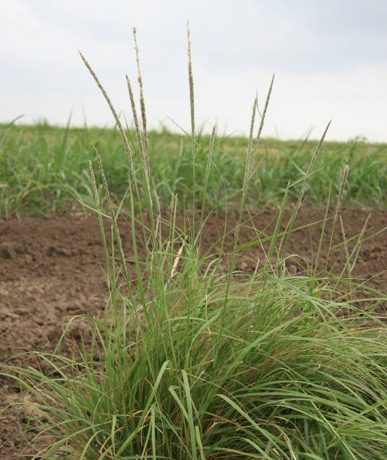

Whiplash Pappusgrass © Forrest Smith, South Texas Natives

Alternate Names

*Pappophorum apertum* Munro ex Scribn.

*Pappophorum mucronulatum* auct. non Nees

*Pappophorum suffulbosum* Arechav.

Uses

Whiplash pappusgrass is recommended for upland wildlife, highway rights-of-ways, and range plantings.

Status

Please consult the PLANTS Web site and your State Department of Natural Resources for this plant’s current status (e.g., threatened or endangered species, state noxious status, and wetland indicator values).

Description and Adaptation

Whiplash pappusgrass is a native, perennial bunchgrass. Stems are 30-80 (sometimes 100) cm. tall, stiffly erect or somewhat jointed near the base, and smooth. Sheaths have a tuft of long hairs on either side of collar, and the hairs are deciduous with age. Ligule is a ring of short hairs, but the base of blade immediately above the ligule has hairs 2-4 mm long. Leaf blades are flat or curled in when dry, 10-20 (sometimes 30) cm. long and 1.5-5 mm. broad. Panicles are narrow, tightly contracted, whitish or tawny, only rarely with a slight purple tinge, mostly 12-25 cm. long. Spikelets with 1, rarely 2, perfect florets and 2 reduced florets above. Chromosome number is reported to be 2n=40, or 60 (Reeder and Toolin 1989). Whiplash pappusgrass flowers from April through November (Gould 1975). Cleaned seed of whiplash pappusgrass contains approximately 436,250 seeds per pound.

Whiplash pappusgrass can be found from Texas to Arizona and south into Northern Mexico. It is also found in one county in New York and in one county in Maine.

For updated distribution, please consult the Plant Profile page for this species on the PLANTS Web site.

Establishment

Numerous seeding trials have documented good establishment of whiplash pappusgrass from seed in south Texas. These plantings indicate good seed viability and persistence, an important characteristic for rangeland seed mix components in south Texas. Plantings have shown that seeding in the fall season has been superior to spring plantings for establishment of pappusgrass in south Texas.

The recommended seeding rate for pure stands of whiplash pappusgrass is 3 lbs. pure live seed per acre. Seed coatings (talc based) increase the flowability of seed through standard seed drills. Successful establishment has been obtained from both drill and broadcast plantings.

Management

Whiplash pappusgrass seed fields should be mowed or burned annually to promote vigorous growth. Deep soil tillage or frequent close cultivation is also recommended to promote seed production. Consult your local Agriculture Extension office for herbicide recommendations.

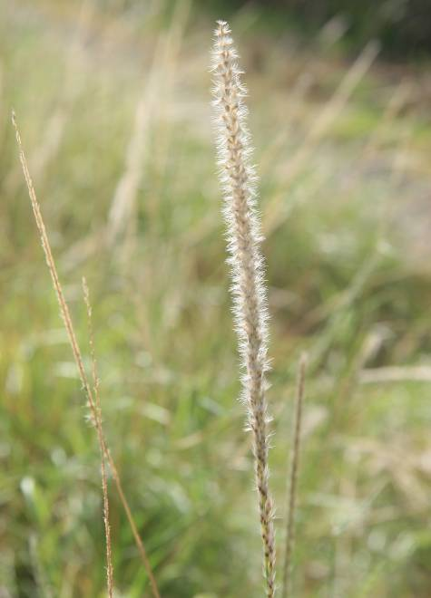

Whiplash Pappusgrass Seedhead © Forrest Smith, South Texas Natives

Pests and Potential Problems

Common pests of whiplash pappusgrass seed include fall armyworms (*Spodoptera* spp.), thrips (*Thrips* spp.), and rice stink bugs (*Oebalus pugnax*). Control of the pests may be necessary in order to produce seed crops in dry years under irrigation.

Cultivars, Improved, and Selected Materials (and area of origin)

Webb Germplasm whiplash pappusgrass was released by *South Texas Natives* and the E. “Kika” de la Garza Plant Materials Center in 2010 as a selected plant material class of certified seed (natural track).

This release is comprised of three collections from three different south Texas counties (Smith et al. 2010).

Pima Germplasm pima pappusgrass from Arizona was released in 2006 by the Tucson Plant Materials Center. Pima Germplasm is a composite of 16 accessions collected from native stands in southern Arizona. No selection was made in order to maximize the genetic adaptability of the release.

Prepared By

USDA NRCS E. “Kika” de la Garza Plant Materials Center, Kingsville, Texas

References

Gould, F.W. 1975. The Grasses of Texas. Texas A&M University Press. College Station, TX.

Reeder J.R. and L.J. Toolin. 1989. Notes on *Pappophorum* (Gramineae: Pappophoreae).

Systematic Botany 14:3, 349-358.

Smith, F., W. Ocumpaugh, J. Lloyd-Reilley, K. Pawelek, S. Maher, and J. Garza. 2010. Notice of Release of Webb Germplasm Whiplash Pappusgrass: Selected Class of Natural Germplasm. *South Texas Natives* CKWRI-TAMUK, Kingsville, TX.

Citation

Maher, S. and J. Lloyd-Reilley. 2010. Plant fact sheet for whiplash pappusgrass (*Pappophorum vaginatum*). USDA-Natural Resources Conservation Service, E. “Kika” de la Garza Plant Materials Center. Kingsville, TX.

Published October, 2010

Edited:

For more information about this and other plants, please contact your local NRCS field office or Conservation District <<http://www.nrcs.usda.gov/>>, and visit the PLANTS Web site <[http://plants.usda.gov](http://plants.usda.gov/)> or the Plant Materials Program Web site <<http://plant-materials.nrcs.usda.gov>>

**USDA IS AN EQUAL OPPORTUNITY PROVIDER AND EMPLOYER**