Plant Fact Sheet

# SWITCHGRASS

## Panicum virgatum L.

Plant Symbol = PAVI2

Contributed by: USDA NRCS Jimmy Carter Plant Materials Center

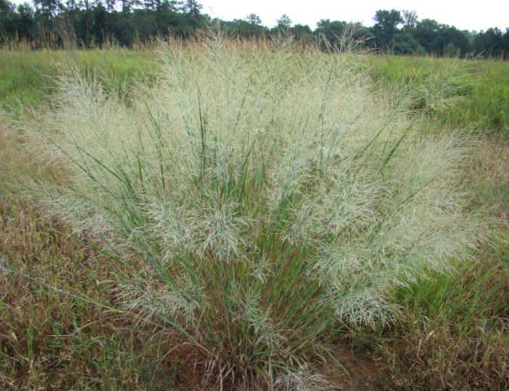

Mike Owsley

USDA Natural Resources Conservation Service

Jimmy Carter Plant Materials Center

### Alternate Names

Panic raide

### Uses

*Livestock:* Switchgrass produces heavy growth during late spring and early summer. It provides good warm-season pasture and high quality hay for livestock.

*Erosion Control*: Switchgrass is perhaps our most valuable native grass, adapted to a wide range of sites. It stabilizes soil on strip-mine spoils, sand dunes, dikes, gullies and other critical areas. It is also suitable for low windbreak plantings in crop fields.

*Wildlife*: Switchgrass provides excellent nesting and cover for pheasants, quail, and rabbits. It holds up in heavy snow (particularly ‘Shelter’ and ‘Kanlow’) and is useful on shooting preserves. The seed provide food for pheasants, quail, turkeys, doves, and songbirds. Due to its potential to spread some wildlife biologists have reduced or eliminated the use of switchgrass in some plantings.

*Biofuel Source*: Switchgrass is a native [perennial](http://en.wikipedia.org/wiki/Perennial) warm season [grass](http://en.wikipedia.org/wiki/Grass) with the ability to produce moderate to high biomass [yields](http://en.wikipedia.org/wiki/Crop_yield) on marginal lands. These characters have resulted in the use of switchgrass in several bioenergy conversion processes, including [cellulosic ethanol](http://en.wikipedia.org/wiki/Cellulosic_ethanol) production, [biogas](http://en.wikipedia.org/wiki/Biogas), and direct combustion for [thermal energy](http://en.wikipedia.org/wiki/Thermal_energy) applications.

### Status

Please consult the PLANTS Web site and your State Department of Natural Resources for this plant’s current status (e.g., threatened or endangered species, state noxious status, and wetland indicator values).

### Weediness

This plant may become weedy or invasive in some regions or habitats and may displace other vegetation if not properly managed. Please consult with your local NRCS Field Office, Cooperative Extension Service office, state natural resource, or state agriculture department regarding its status and use. Weed information is also available from the PLANTS Web site at [http://plants.usda.gov](http://plants.usda.gov/). Please consult the Related Web Sites on the Plant Profile for this species for further information.

**Description and Adaptation**

Switchgrass is native in the continental United States except California and the Pacific Northwest. It is a perennial bunch grass averaging 3 to 5 feet tall and may spread from short, stout rhizomes. The stem (culm) is round and can have a red to straw colored tint. The seed head is an open, spreading panicle.

Switchgrass is climatically adapted throughout most of the United States when planted on suitable soils. Moderately deep to deep, somewhat dry to poorly drained, sandy to clay loam soils are best. It does poorly on some heavy soils. In the East, it performs well on shallow and droughty soils. Switchgrass occurs naturally on prairies, open oak and pine woodlands, shores, riverbanks, and high brackish marshes along maritime forest ecotones.

For updated distribution, please consult the Plant Profile page for this species on the PLANTS Web site.

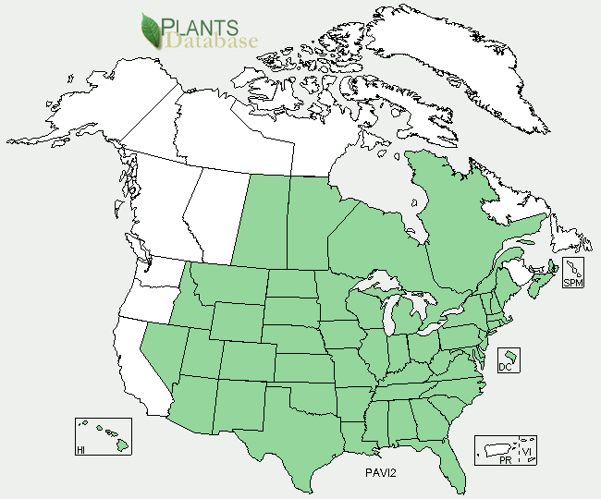

Switchgrass distribution from USDA-NRCS PLANTS Database.

### Establishment

Switchgrass is planted using the pure live seed (PLS), typically at a seeding rate of 6-12 lbs. PLS/acre. Seeding rates and dates vary according to cultivar, region of adaptation, and purpose. Consult with your local NRCS office or extension office for the proper seeding rates and dates for switchgrass cultivars in your region. Mixed plantings may be seeded at a lower rate. The seed can be planted using seed drills or broadcast spreaders. Seedbeds should be firmed prior to seeding. When using the broadcast method, the area should be rolled after seeding to increase the seed to soil contact. No tillseedings in closely grazed or burned sod also have been successful**.**

For further information on establishing switchgrass, see NRCS Technical Note No. 3, [*Planting and Managing Switchgrass as a Biomass Energy Crop*](http://plant-materials.nrcs.usda.gov/pubs/NPMtechnotes/npmptn3-13079.pdf)

**Management**

Control weeds during establishment by mowing to a height of 4 inches in May or 6 inches in June or July. Grazing is generally not recommended the first year.

Established stands of switchgrass may be fertilized in accordance with soil tests. Switchgrass benefits from burning prior to initiation of spring growth. Burning every 3 to 5 years decreases weed competition, eliminates excessive residue and stimulates growth. Switchgrass for wildlife food and cover should be burned once every 2 years to reduce mulch accumulations that inhibits movement of hatchlings and attracts nest predators.

### Switchgrass can provide quality forage for livestock when properly managed for grazing or cut for hay . Consult with your local NRCS office or extension service in developing a grazing and hay management plan for your region.

### Pests and Potential Problems

Grasshoppers, leafhoppers and armyworms can be major pests in new seedings and established stands. Some stands are impacted by damping off and seedling blight. Leaf rust may affect forage quality. Smut can cause significant seed loss. Smut has been found on the cultivars ‘Cave-in-Rock’, ‘Blackwell’, ‘Pathfinder’, ‘Shelter’, and ‘Summer’. A switchgrass moth has been reported on young switchgrass tillers that could affect stand and productivity in the northern Great Plains.

### Environmental Concerns

Switchgrass can spread, especially in a wildlife planting, and reduce growth of other native warm season grasses such as big bluestem, Indiangrass and little bluestem. Cultivars have been reported to dominate and reduce native switchgrasses stands in natural plant communities and restoration sites.

### Control

Please contact your local agricultural extension specialist or county weed specialist to learn what works best in your area and how to use it safely. Always read label and safety instructions for each control method. Trade names and control measures appear in this document only to provide specific information. USDA NRCS does not guarantee or warranty the products and control methods named, and other products may be equally effective.

### Cultivars, Improved, and Selected Materials (and area of origin)

‘Alamo’ (TX), ‘Blackwell’ (OK), Bomaster (NC) ‘Carthage’ (NC), ‘Cave-In-Rock’ (IL), Central Iowa Germplasm, ‘Dacotah’ (ND), Durham Germplasm (NC),‘Forestburg’ (SD), HighTide Germplasm (MD), ‘Kanlow’ (OK), ‘Nebraska 28’ (NE), ‘Pathfinder’, ‘Shawnee’, ‘Shelter’ (WV), ‘Sunburst’ (SD), ‘Summer’, Southlow Michigan Germplasm, Timber Germplasm (NC), Grenville (NM), Miami (Dade Co, FL), Stuart (Stuart, FL), Wabasso (Wabasso, FL), Penn Center (Beaufort Co.SC.; source identified vegetative)

### Prepared By: *Jimmy Carter Plant Materials Center*

### Citation

Jimmy Carter Plant Materials Center. 2011. Plant fact sheet for switchgrass (*Panicum virgatum* L.). USDA-Natural Resources Conservation Service,

Edited: [e.g., 08Sep2009 rg, 08Sep2009 jfh; 17Sep2009 jfe 21Jan 2011 mo]

For more information about this and other plants, please contact your local NRCS field office or Conservation District <<http://www.nrcs.usda.gov/>>, and visit the PLANTS Web site <[http://plants.usda.gov](http://plants.usda.gov/)> or the Plant Materials Program Web site <<http://plant-materials.nrcs.usda.gov>>

**USDA IS AN EQUAL OPPORTUNITY PROVIDER AND EMPLOYER**