|  |
| --- |
| narrowleaf penstemon |
| *Penstemon angustifolius* Nutt. ex Pursh. |
| Plant Symbol = PEAN4 |

Contributed by: USDA NRCS Los Lunas Plant Materials Center & New Mexico State University Los Lunas Agricultural Science Center

Alternate Names

broadbeard penstemon, taperleaf penstemon, broadbeard beardtongue

Uses

*Erosion control:* Narrow leaf penstemon is a drought tolerant forb. It is helpful in preventing wind erosion on sandy dunes, plains and grasslands where it establishes.

*Wildlife:* Narrow leaf penstemon provides a food source to small birds and mammals. It is heavily used by hummingbirds and various insects during flowering.

*Urban:* Narrow leaf penstemon is a drought tolerant forb that also produces beautiful flowers in early spring. This makes it an ideal plant for xeriscaping.

Status

Please consult the PLANTS Web site and your State Department of Natural Resources for this plant’s current status (e.g. threatened or endangered species, state noxious status, and wetland indicator values).

Description

*Penstemon angustifolius* Nutt. ex. Pursh., narrow leaf penstemon, is native to various western and plains states. It is a stout, smooth, waxy, gray green perennial herb. The plant grows from 8 to 24 inches with several stout, erect or somewhat curving stems. The flowers range from ½ to ¾ inch and are various shades of violet and pink. Insect guidelines may or may not be present.

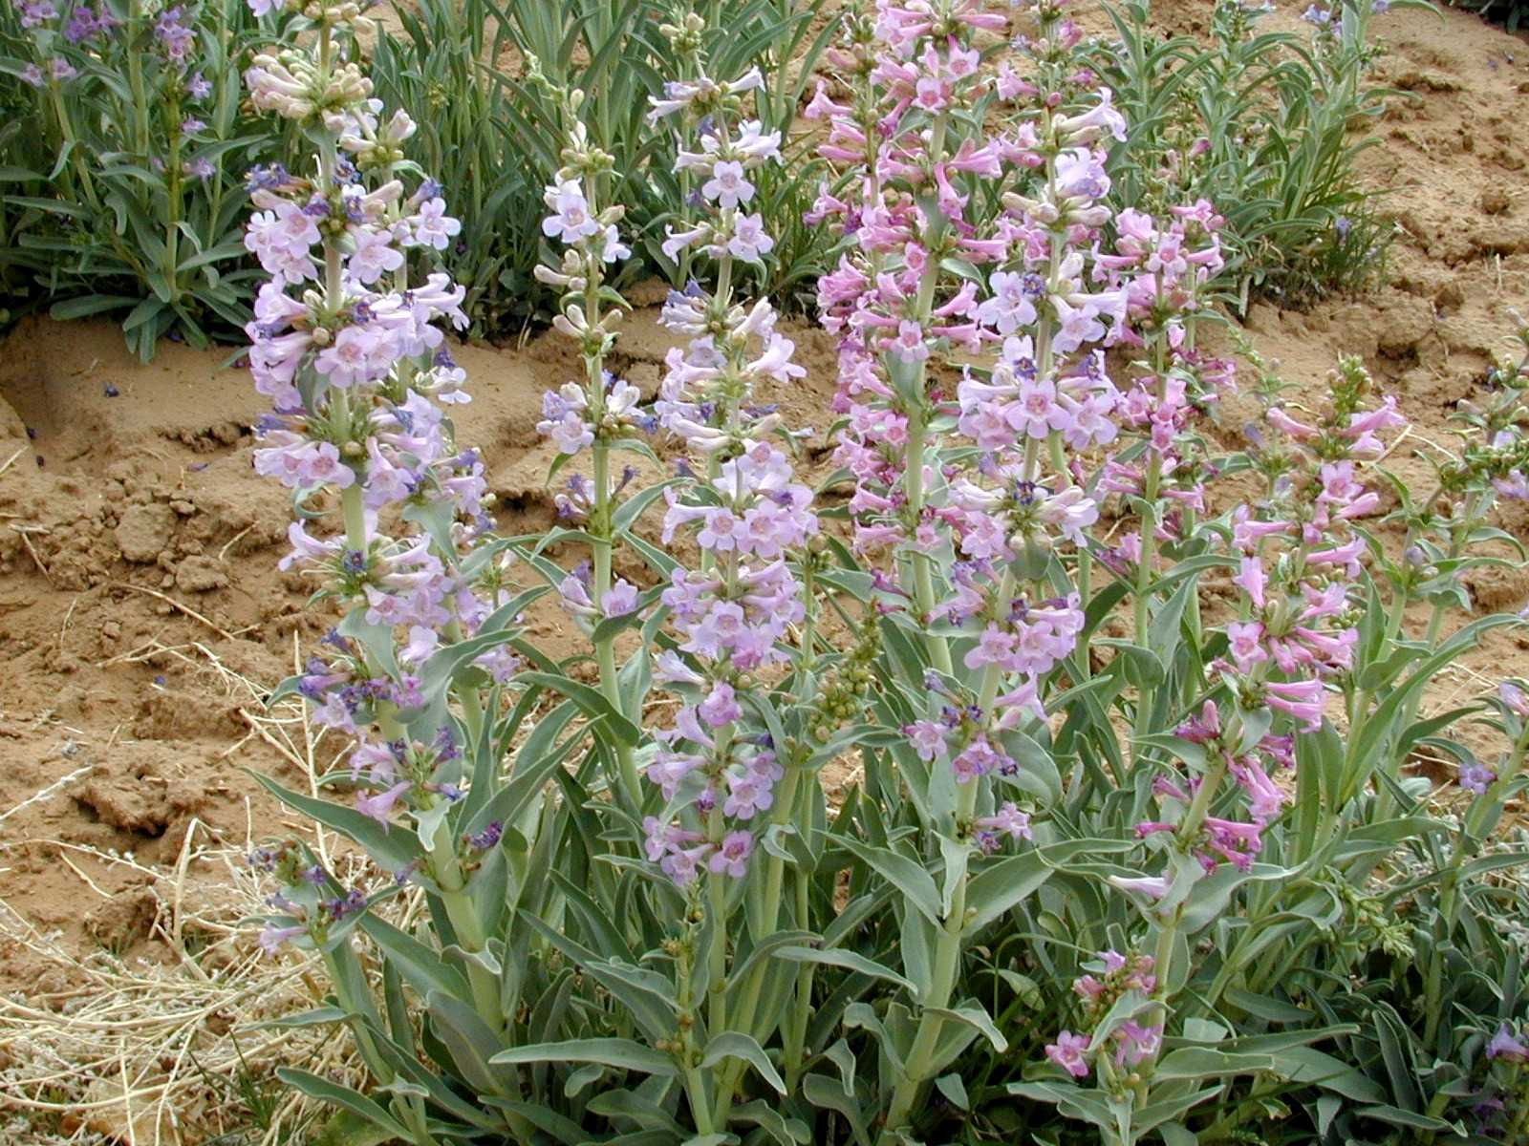

USDA NRCS Los Lunas Plant Materials Center

Los Lunas, New Mexico

Adaptation and Distribution

Narrow leaf penstemon is found throughout the western and Great Plains states. It is adapted to sandy mesas and grasslands and is frequently found on dunes. It does poorly and is short lived when planted in heavy soils.

Narrow leaf penstemon is distributed throughout the United States. For a current distribution map, please consult the Plant Profile page for this species on the PLANTS Website.

Establishment

The seed of narrow leaf penstemon requires cold stratification for germination. Approximately 85% of the seed are dormant. Total germination averages above 90%. Field plantings of this seed should be done in the fall. Seeding should be at approximately 12 seed per foot. With adequate winter moisture or supplemental irrigation, stands are generally good.

Management

After stand establishment, it is important to limit irrigation. In normal years with 8-10 inches of precipitation, no irrigation is necessary. Narrow leaf penstemon is extremely sensitive to root rot fungi and if overwatered the entire stand will be destroyed.

Although not necessary, narrow leaf penstemon responds well to fertilization. After establishment, it does not appear to be damaged by the use of pre-emergent herbicides. After harvest the plants soon become dormant and may then be mowed.

Cultivars, Improved, and Selected Materials (and area of origin)

San Juan Germplasm narrowleaf penstemon (New Mexico) is a selected class (pre-varietal) release from the Los Lunas Plant Materials Center and the New Mexico State University Agricultural Science Center in Los Lunas, New Mexico. Seed may be obtained through the New Mexico Crop Improvement Association. The plant is adapted to areas with annual precipitation of 6 to 10 inches, and has a variety of purposes. It helps prevent erosion on the sandy dunes, plains, and grasslands where it establishes. The beautiful flowers it produces in the early spring make it useful for xeriscaping. The seed of narrowleaf penstemon provides a food source to small birds and mammals. The flowers are particularly important in providing early forage for honeybees. Hummingbirds and various insects also rely heavily on the flowers in the early spring.

Prepared By & Species Coordinator:

*Dr. E. Ramona Garner*, Agronomist

USDA NRCS Los Lunas Plant Materials Center

Los Lunas, New Mexico

Edited: 05Feb2002 JLK; 29sep05 jsp; 060802 jsp

For more information about this and other plants, please contact your local NRCS field office or Conservation District, and visit the PLANTS Web site<<http://plants.usda.gov>> or the Plant Materials Program Web site <<http://Plant-Materials.nrcs.usda.gov>>

*The U.S. Department of Agriculture (USDA) prohibits discrimination in all its programs and activities on the basis of race, color, national origin, sex, religion, age, disability, political beliefs, sexual orientation, and marital or family status. (Not all prohibited bases apply to all programs.) Persons with disabilities who require alternative means for communication of program information (Braille, large print, audiotape, etc.) should contact USDA's* [*TARGET Center*](http://www.usda.gov/oo/target.htm) *at 202-720-2600 (voice and TDD).*

*To file a complaint of discrimination write USDA, Director, Office of Civil Rights, Room 326-W, Whitten Building, 14th and Independence Avenue, SW, Washington, DC 20250-9410 or call 202-720-5964 (voice or TDD). USDA is an equal opportunity provider and employer.*

*Read about* [*Civil Rights at the Natural Resources Convervation Service*](http://www.nrcs.usda.gov/about/civilrights/)*.*