

Plant Fact Sheet

# Taper-leaVED Penstemon

## Penstemon attenuatus Douglas ex Lindl.

Plant Symbol = PEAT3

Contributed by: NRCS Plant Materials Center, Pullman, WA

### Photo of Penstemon attenuatus by Pamela Pavek

*Penstemon attenuatus.* Pamela Pavek

### Alternative Names

*Common Alternate Names:* taper-leaved penstemon, sulphur penstemon, sulphur beardtongue (*P. attenuatus* var. *palustris*), south Idaho penstemon (*P. attenuatus* var. *militaris*), small penstemon (*P. attenuatus* var. *pseudoprocerus*)

*Scientific Alternate Names:* None

### Uses

*Pollinator habitat: Penstemon attenuatus* is a source of pollen and nectar for a variety of bees, including honey bees and native bumble bees, as well as butterflies and moths.

*Rangeland diversification:* This plant can be included in seeding mixtures to improve the diversity of rangelands.

*Ornamental: Penstemon attenuatus* is very attractive and easy to manage as an ornamental in urban, water-saving landscapes. It is hardy to USDA Plant Hardiness Zone 4.

### Status

Please consult the PLANTS Web site and your State Department of Natural Resources for this plant’s current status (e.g., threatened or endangered species, state noxious status, and wetland indicator values).

### Description and Adaptation

*General*: Figwort family (Scrophulariaceae). *Penstemon attenuatus* is a native, perennial forb that grows from a dense crown to a height of 10 to 90 cm (4 to 35 in). Leaves are dark green, opposite and have smooth edges, however the edges of *P. attenuatus* var. *attenuatus* leaves are often, at least in part, finely toothed. Basal leaves have petioles, and are up to 4 cm (1.5 in) wide and 17 cm (7 in) long. Stem leaves are smaller and mostly clasping. Flowers bloom in May and June, and can be blue to purple and pink, or pale yellow to nearly white. The inflorescence consists of two whorls of flowers around the stem at each leaf axis. Flowers have five long petals with translucent edges, and are 1 to 2 cm (3/8 to 3/4 in) long. The petals are fused to form a tube that is expanded toward the mouth and has two lips. The lower lip and stamens are hairy. Seeds are dark brown, round, and occur in capsules 3 to 6 mm (1/8 to 1/4 in) long. Overall the appearance of *P. attenuatus* is very similar to other *Penstemon* species, causing difficulties in identification.

*Penstemon attenuatus* is adapted to areas receiving 30 to 64 cm (12 to 25 in) annual precipitation at elevations up to 3,000 m (5,000 ft). It grows in well-drained, medium textured soils in dry meadows and on moist, open to wooded slopes in the mountains and foothills.

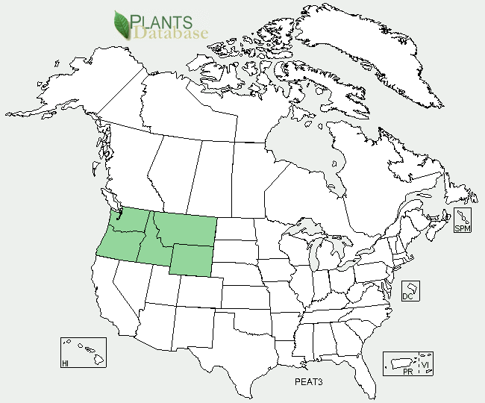

Taper-leaf penstemon distribution from USDA-NRCS PLANTS Database.

For updated distribution, please consult the Plant Profile page for this species on the PLANTS Web site.

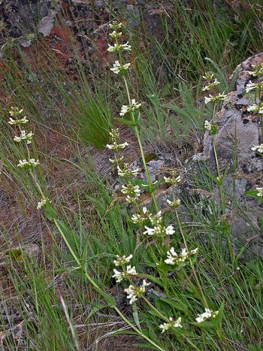

*Penstemon attenuatus* var. *attenuatus*. G.D. Carr, University of Washington Burke Herbarium

### Establishment

Plants can be established by seed or seedlings. Seed should be drilled into a firm, weed-free seed bed in the fall at a rate of 1.65 kg PLS/ha (1.5 lb PLS/ac). If the seed is planted in a mix, the seeding rate should be adjusted according to the proportion of *P. attenuatus* in the mix. The drill should be set no deeper than 0.3 cm (1/8 in) or the seed should be placed in a separate drill box (with other small-seeded species) and the tubes for this box should be pulled so the seed is dropped on the soil surface. Drag chains or press wheels should be used as long as the seed is not covered with more than 0.3 cm (1/8 in) of soil. The seed can also be broadcast onto the soil surface with a broadcast spreader, and pressed into the soil with a roller packer. When using a broadcast seeding method, the seeding rate should be doubled.

To establish plants by seedlings, the seed should be planted in containers in October, left outside to stratify in cold and moist conditions for a minimum of 90 days, and moved into a greenhouse in January. After growing in a greenhouse for three to four months, the plants should be hardened off in a cold frame for two to four weeks prior to transplanting to a prepared field site in the spring. Ideal plant spacing is 15 to 45 cm (6 to 18 in).

### Management

*Penstemon attenuatus* is able to withstand infrequent mowing. This method may be used for weed control in newly-established forb plantings, however mowing should be delayed until after seed maturity. Pre-emergent herbicides can be used to control annual weeds in fields with at least one year of growth, or where seedlings have been transplanted.

### Pests and Potential Problems

None known.

### Environmental Concerns

None.

### Cultivars, Improved, and Selected Materials (and area of origin)

None, however seeds and seedlings are available through several vendors.

### Prepared By

*Pamela L.S. Pavek*, USDA NRCS Plant Materials Center, Pullman, Washington

*David M. Skinner,* USDA NRCS Plant Materials Center, Pullman, Washington (*retired*)

### Citation

Pavek, P.L.S., and D.M. Skinner 2012. Plant fact sheet for taper-leaved penstemon (*Penstemon attenuatus*). USDA-Natural Resources Conservation Service, Pullman Plant Materials Center. Pullman, WA.

Published February 2012

Edited: 27Jan2012 dms; 07Feb2012 mes; 17Feb2012 jab; 17Feb2012plsp

For more information about this and other plants, please contact your local NRCS field office or Conservation District <<http://www.nrcs.usda.gov/>>, and visit the PLANTS Web site <[http://plants.usda.gov](http://plants.usda.gov/)> or the Plant Materials Program Web site <<http://plant-materials.nrcs.usda.gov>>

**USDA IS AN EQUAL OPPORTUNITY PROVIDER AND EMPLOYER**