|  |
| --- |
| Penstemon |
| *Penstemon* species |
| Plant Symbol = PENST |

Contributed by: USDA NRCS Plant Materials Program

**Alternate Names**

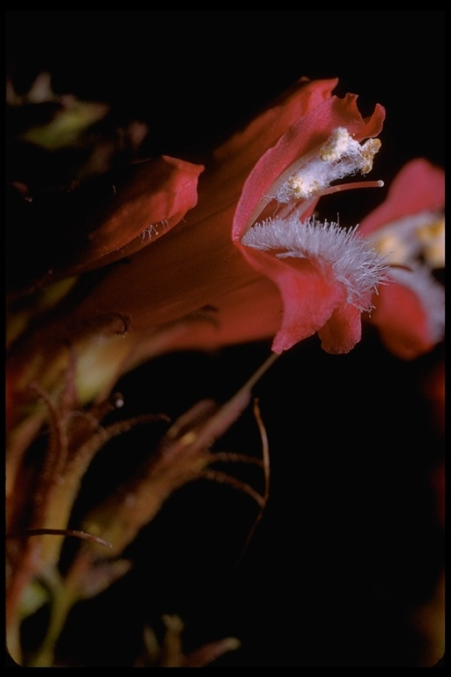

Dr. G Dallas and Margaret Hanna

©California Academy of Sciences

@CalFlora

beardtongue

Uses

*Grazing/rangeland*: 'Cedar' and 'Bandera' are the only released penstemons noted to have any forage value. 'Cedar' leaves stay green throughout the growing season providing some forage value. All other varieties are considered fair to poor palatability and considered to be only incidental forage value. All species provide diversity to the seeded plant community.

*Erosion control/reclamation*: All species are mentioned for their value in mixes for erosion control and beautification values.

*Wildlife*: Penstemons are considered desirable forages for deer, antelope and birds either as herbage or seed. They may also provide some cover for selected small bird species. They provide diversity to the plant community.

Status

Please consult the PLANTS Web site and your State Department of Natural Resources for this plant’s current status (e.g. threatened or endangered species, state noxious status, and wetland indicator values).

Description

Penstemons (*Penstemon* spp.) are perennial forbs, subshrubs to shrubs with attractive flowers. Common to the western United States. Except for one minor species, the genus Penstemon does not occur naturally outside of North America. They are short to long-lived. Penstemons have opposite, entire or toothed leaves. They have several stalked flowers or flower clusters that are borne in the axils of the upper leaves or leaflike bracts. The tubular flower is strongly to distinctly two-lipped at the mouth with a two-lobed upper lip and a three-lobbed lower lip. There are 4 fertile stamens and a single sterile stamen that is often hairy at the tip. The fruit is a many-seeded capsule.

Adaptation and Distribution

Penstemons do best on well-drained soils. Most ecotypes do well on infertile, disturbed soils. They have excellent cold winter and drought tolerance. They will tolerate weakly saline to weakly acidic sites. They are usually found in open areas, but will tolerate semi-shaded conditions. They are somewhat fire-resistant due to leaves staying green with relatively high moisture content during the fire season.

Penstemon is distributed throughout the entire United States. For a current distribution map, please consult the Plant Profile page for this species on the PLANTS Website.

Establishment

These species should be seeded with a drill or broadcast at a depth of 1/4 inch or less into a firm seedbed. Ideal seeding depth is 1/8 inch. Penstemons are not recommended for single species seeding. The full seeding rate (not recommended) for these forbs-shrubs is 1.5 to 3 pounds Pure Live Seed (PLS) per acre or 20 to 26 PLS per square foot (varies somewhat by species). When used as a component of a mix, adjust to percent of mix desired. For mined lands and other harsh critical areas, doubling the seeding rate component of penstemon is not required. The best seeding results are obtained from seeding in very early spring (because of grass component of mix) on heavy to medium textured soils and in late fall on medium to light textured soils. Late summer (August - mid September) seeding is not recommended. Dormant fall seedings (preferred seeding period for penstemons) will pre-chill seed and reduce seed dormancy which is very strong in some species. Mulching, irrigation and weed control all benefit stand establishment. Seedling vigor is good, but not as good as most grasses. Germination may not occur until the second growing season. Flowering should not be expected until at least the second growing season.

Management

Growth of penstemons begins in early spring and flowers appear in May through July depending on species. Weed control and removal of very competitive species may improve chance of establishment. Damage from wildlife and rodents may occur and they may need to be controlled. Disease problems are minimal except under irrigation. Under irrigation, fusarium wilt can be a problem.

Pests and Potential Problems

Stands may require weed control measures during establishment. Because penstemons are broad-leaved, use of 2,4-D is not recommended. Mow weeds at or prior to their bloom stage. New stands may also be damaged by grasshoppers and other insects and pesticides may be needed.

Environmental Concerns

Penstemon species establish and spread slowly via seed distribution. They are not considered "weedy" or invasive species, but can spread into adjoining vegetative communities under ideal climatic and environmental conditions. They coexist with other native species and add biodiversity to those plant communities.

Cultivars, Improved, and Selected Materials (and area of origin)

Alpine penstemon (*P. venustus* Dougl ex. Lindl.) is a selected class release from seed originally collected in

the Clearwater River drainage, Idaho; 'Bandera' (*P. strictus* Benth.) Rocky Mountain penstemon was developed from seed originally collected in Torrance County, New Mexico; 'Cedar' (*P. palmeri* Gray) Palmer penstemon was developed from seed originally collected near Cedar City in Iron County, Utah; Firecracker penstemon (*P. eatonii* Gray) is a selected release from seed originally collected near Richfield, Utah.

A number of other penstemons are seeded primarily for soil stabilization on depleted, disturbed and erosive areas for erosion control and as ornamentals. These include low penstemon (*P. humilis* Nutt. ex Gray), Rydberg penstemon (*P. rydbergii* A. Nels.), and thinleaf penstemon (*P. pachyphyllus* Gray ex Rydb.). No releases have been made.

Prepared By & Species Coordinator:

Daniel G. Ogle

USDA NRCS Plant Materials Program, Boise, Idaho

Edited: 05Feb2002 JLK; 060802 jsp

For more information about this and other plants, please contact your local NRCS field office or Conservation District, and visit the PLANTS Web site<<http://plants.usda.gov>> or the Plant Materials Program Web site <<http://Plant-Materials.nrcs.usda.gov>>

*The U.S. Department of Agriculture (USDA) prohibits discrimination in all its programs and activities on the basis of race, color, national origin, sex, religion, age, disability, political beliefs, sexual orientation, and marital or family status. (Not all prohibited bases apply to all programs.) Persons with disabilities who require alternative means for communication of program information (Braille, large print, audiotape, etc.) should contact USDA's* [*TARGET Center*](http://www.usda.gov/oo/target.htm) *at 202-720-2600 (voice and TDD).*

*To file a complaint of discrimination write USDA, Director, Office of Civil Rights, Room 326-W, Whitten Building, 14th and Independence Avenue, SW, Washington, DC 20250-9410 or call 202-720-5964 (voice or TDD). USDA is an equal opportunity provider and employer.*

*Read about* [*Civil Rights at the Natural Resources Convervation Service*](http://www.nrcs.usda.gov/about/civilrights/)*.*