|  |
| --- |
| Scots pine |
| *Pinus sylvestris* L. |
| Plant Symbol = PISY |

Contributed by: USDA NRCS Plant Materials Program

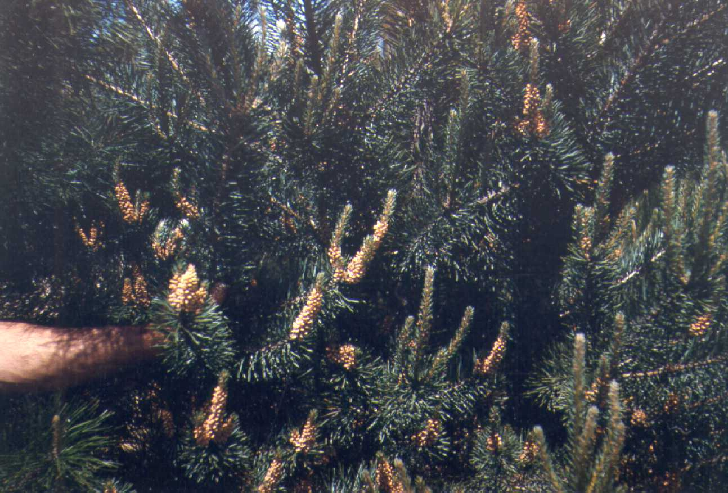

USDA NRCS National Plant Materials Center

Beltsville, MD

Uses

*Windbreaks*: Plant Scots pine in the central or leeward rows of multi-row plantings. It is also recommended for planting as single-row windbreaks.

*Wildlife*: Scots pine is of some importance as food and cover for many birds and small mammals. Although the plant is browsed by whitetail and mule deer, it is not a preferred forage.

*Timber/Christmas tree plantations*: Scots pine is suitable for ornamental and screen plantings. Its year long coloration adds variety to recreation plantings.

Status

Please consult the PLANTS Web site and your State Department of Natural Resources for this plant’s current status (e.g. threatened or endangered species, state noxious status, and wetland indicator values).

Description

Scots pine is an evergreen, spreading tree 80 to 100 feet, pyramidal when young, becoming round topped and irregular in age. The tree is introduced from Eurasia, and has become naturalized in eastern North America. It is cultivated for windbreaks, timber, and Christmas tree plantations. It does best on rich, moist soils, but its winter hardiness and moderate drought tolerance enable it to do well on other soils. It is moderately slow growing, but is long lived.

Description

Fruits are tawny-yellow, oblong, symmetrical cones, 1 to 2 inches long. Clusters of flowers are yellow, minute, male and female. Needles occur in bunches of 2, are stout and usually twisted, 1 to 3 inches long, and bluish-green in color. Scots pine branches are spreading, and stems are often crooked in early years. The plant’s bark is orange, thin and smooth on upper trunk, dark and fissured below. The tree’s root system is widespread, moderately deep, and wind-firm.

Adaptation and Distribution

Scots pine is distributed throughout the Northeast and upper Midwest. For a current distribution map, please consult the Plant Profile page for this species on the PLANTS Website.

Establishment

Plantings should be established during the spring of the year on weed free sites. Stand establishment can be enhanced by using 2 year old field-grown stock. Holes or furrows should be deep enough to contain roots without bending.

Management

Weed control is recommended in areas where the tree is grown for shade or Christmas tree plantings. It is also good to shape the tree for the form that you would like to have at time of harvest.

Pests and Potential Problems

There are several wood boring, root feeding, foliage feeding, and twig boring insects that attack this tree. The most common pest are cyclaneusma needle cast, western gall rust, Lophodermium needle cast, tip moth, sawflies, pine needle scales and giant conifer aphid.

Cultivars, Improved, and Selected Materials (and area of origin)

Scots pine has several intergrading cultivars, differing chiefly in leaf color and growth form. Most have ready use as Christmas trees, although leaves of some cultivars turn yellow-green in winter. Seedlings are available at most commercial conifer nurseries. Seed origin is extremely important in obtaining quality trees for a given sub-region. Consult the state extension forester for information from provenance testing to determine the best seed source for your planting.

Prepared By & Species Coordinator:

USDA NRCS Plant Materials Program

Edited: 05Feb2002 JLK; 060809 jsp

For more information about this and other plants, please contact your local NRCS field office or Conservation District, and visit the PLANTS Web site<<http://plants.usda.gov>> or the Plant Materials Program Web site <<http://Plant-Materials.nrcs.usda.gov>>

*The U.S. Department of Agriculture (USDA) prohibits discrimination in all its programs and activities on the basis of race, color, national origin, sex, religion, age, disability, political beliefs, sexual orientation, and marital or family status. (Not all prohibited bases apply to all programs.) Persons with disabilities who require alternative means for communication of program information (Braille, large print, audiotape, etc.) should contact USDA's* [*TARGET Center*](http://www.usda.gov/oo/target.htm) *at 202-720-2600 (voice and TDD).*

*To file a complaint of discrimination write USDA, Director, Office of Civil Rights, Room 326-W, Whitten Building, 14th and Independence Avenue, SW, Washington, DC 20250-9410 or call 202-720-5964 (voice or TDD). USDA is an equal opportunity provider and employer.*

*Read about* [*Civil Rights at the Natural Resources Convervation Service*](http://www.nrcs.usda.gov/about/civilrights/)*.*