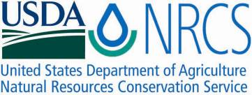

Plant Fact Sheet

# RIO GRANDE CLAMMYWEED

## Polanisia dodecandra (L.) DC. ssp. riograndensis Iltis

Plant Symbol = PODOR

Contributed by: E. “Kika” de la Garza Plant Materials Center, Kingsville, Texas & South Texas Natives, Kingsville, Texas

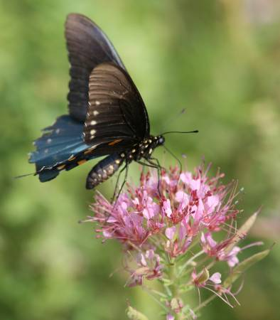

Forrest Smith, South Texas Natives

Uses

*Wildlife*: Rio Grande clammyweed is recommended for upland wildlife plantings and in range seeding mixes. Clammyweed seed is eaten by game birds such as bobwhite quail, scaled quail, mourning doves, white-wing doves, and Rio Grande wild turkeys, as well as many non-game species of birds and mammals. Rio Grande clammyweed is also an important nectar plant for many species of butterflies and provides habitat to many other insects. Clammyweed has no grazing value for livestock or wildlife. Clammyweed is often found in dense stands of non-native grasses, and may be useful in efforts to diversify these stands for wildlife.

*Beautification*: Rio Grande clammyweed is an attractive nectar plant for butterfly gardens. However, its leaves release a strong, unpleasant odor when crushed, so plants should be located away from foot traffic areas.

**Status**

Please consult the PLANTS Web site and your State Department of Natural Resources for this plant’s current status (e.g. threatened or endangered species, state noxious status, and wetland indicator values).

**Description and Adaptation**

Rio Grande clammyweed is a native annual forb, endemic to southern Texas. It is found in sandy, gravelly (sometimes limestone) or alluvial silty soil. The plants are 2-6 dm. tall and sparsely branched or unbranched. The leaflets are in groups of 3 with leaves 2-4 cm long, 5-20 mm wide. The flowers are pink to rose with petals 5-16 mm long. The fruit is a narrow capsule producing numerous rounded seeds. Rio Grande clammyweed has an average of 154,500 seeds per pound.

*Distribution*: Please consult the Plant Profile page for this species on the PLANTS Web site.

**Establishment**

Rio Grande clammyweed is an early successional plant. It is quick to establish on disturbed soils, grows quickly, and provides a favorable environment for other slow to germinate native species. In mixed species native plantings in south Texas, clammyweed is often the first planted species to emerge and flower. Rio Grande clammyweed readily re-seeds itself with moderate soil disturbance.

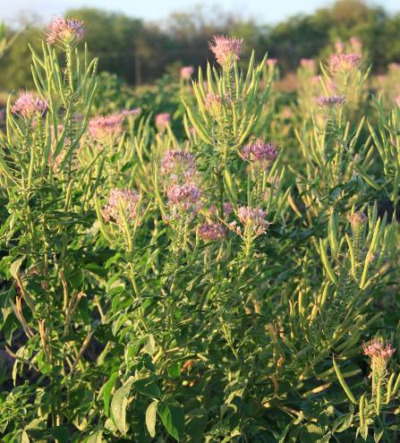

Forrest Smith, South Texas Natives

Seeding trials at Kingsville, Texas have shown good establishment from seed in fall (October) and spring (April) plantings. Fall plantings should be made at least 2 months prior to danger of frost so that seed is produced before freezing as clammyweed typically requires 45-60 days from emergence to seed maturity.

For direct seeding, broadcast or drill seed during March through May or in September and October into a clean, weed free seedbed. Seeds should be covered from ¼ to ½” depth to ensure good soil to seed contact. Plant at a seeding rate of 8 PLS (pure live seed) pounds per acre for a pure stand. When planting this as a component of a seed mixture, the seeding rate should be adjusted to the desired percent of the mix.

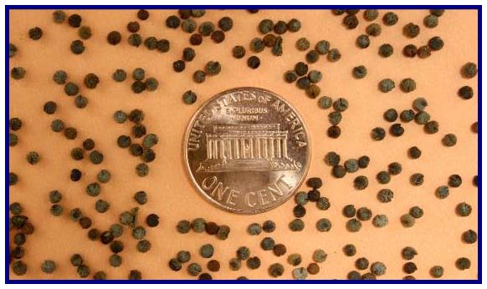

Javier Hernandez, South Texas Natives

Rio Grande clammyweed requires little management. Seed production plots will require occasional weeding. It can survive in both droughty and moist conditions. For seed production purposes, occasional irrigation during extremely droughty periods may help seed fertility.

Rio Grande clammyweed can be harvested with a combine. When harvesting clammyweed, run the combine’s cylinder speed at 1100 RPM, the concave at 8 mm, the sieve open 3/8", and the fan at 200 RPM. To clean the seed, simply run combined product through a clipper style seed cleaner. It is recommended that after cleaning, the seed should be stored at 45oF and less than 50% humidity.

Spring seed harvests near Monte Alto, Texas have had an average of 67% PLS, with 15% seed dormancy. Seed yields from June hand harvests (first crop produced) were 168 lbs. PLS/acre. Seed increase harvests in June 2008 at Kingsville, Texas (first crop produced) showed hand harvest seed yields averaging 144 lbs. PLS/acre under irrigated conditions. PLS of these harvests averaged 83%.

**Pests and Potential Problems**

Green bugs can cause extensive damage to the plants foliage, and weevils have been observed in the seed pods. Both pests are fairly easy to control with organophosphate (e.g.Malathion) and carbamate (e.g. Sevin) insecticides. Please contact your local agricultural extension specialist or county pest specialist to learn what works best in your area and how to use it safely. Always read label and safety instructions for each control method. Trade names and control measures appear in this document only to provide specific information. USDA NRCS does not guarantee or warranty the products and control methods named, and other products may be equally effective.

Commercial seed production of Rio Grande clammyweed should focus on production of the first seed crop following planting. Plants commonly flower and produce seed beyond the first seed crop, and will set seed until frost; however subsequent seed crops have poor seed fill, lower active germination, and significantly lower seed yields.

**Cultivars, Improved, and Selected Materials**

Zapata Germplasm is a selected class release developed from seed originating from Dimmit and Zapata County, Texas. It was released cooperatively between the South Texas Natives Project and the E. Kika de la Garza Plant Materials Center in 2009. Zapata Germplasm was selected for active seed germination and superior field performance in comparison to other South Texas collected accessions. It is intended to provide food for wildlife. Certified seed is available and Breeder Seed will be maintained by South Texas Natives, Kingsville, Texas.

**Prepared By and Species Coordinator:**

John Lloyd-Reilley & Shelly D. Maher, USDA NRCS, E. “Kika” de la Garza Plant Materials Center, Kingsville, Texas

Forrest S. Smith, South Texas Natives, Caesar Kleberg Wildlife Research Institute,

Texas A&M University-Kingsville, Kingsville, Texas

Published: November 2009

Edited:

For more information about this and other plants, please contact your local NRCS field office or Conservation District <<http://www.nrcs.usda.gov/>>, and visit the PLANTS Web site <[http://plants.usda.gov](http://plants.usda.gov/)> or the Plant Materials Program Web site <<http://plant-materials.nrcs.usda.gov>>

**USDA IS AN EQUAL OPPORTUNITY PROVIDER AND EMPLOYER**