|  |
| --- |
| fremont’s cottonwood |
| *Populus fremontii* S. Wats. |
| Plant Symbol = POFR2 |

Contributed by: USDA NRCS National Plant Data Center & USDA NRCS Los Lunas Plant Materials Center

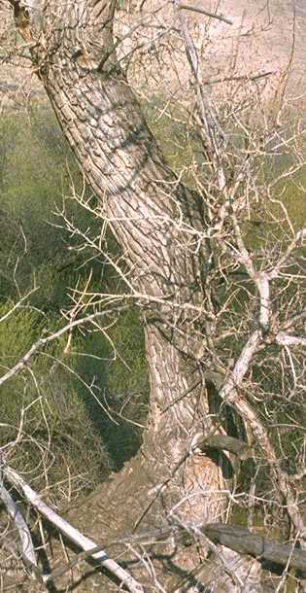Charles Webber

© California Academy of Sciences

@ CalPhotos

Alternate Names

poplar, Alamo cottonwood

Uses

Ecological diversity, bank and sediment stabilization, maintenance of channel morphology, water quality improvement, ground-water recharge, flood abatement, fish and wildlife habitat.

Status

Please consult the PLANTS Web site and your State Department of Natural Resources for this plant’s current status (e.g. threatened or endangered species, state noxious status, and wetland indicator values).

Description

Fremont’s cottonwood is a native tree growing in riparian areas near streams, rivers and wetlands in the American Southwest. Fremont's cottonwood trees range from 12 to 35 meters in height, and trunk diameter ranges from 0.30 to 1.5 meters. The bark is smooth in younger trees, becoming deeply furrowed with whitish cracked bark with age. The leaves are cordate (heart-shaped) with white veins and coarse crenate-serrate teeth on the margins. The leaves have petioles 1/2 to equal the blade length, laterally compressed near the blade which causes the leaves to flutter in the wind. These trees are dioecious, with flowers in drooping catkins, which are 4 to 14 cm long. Cottonwoods bloom from March-April. The fruit is an achene, which is attached to a silky hair, en masse looking like patches of cotton hanging from the limbs, thus the name cottonwood. The fruits are wind dispersed.

Adaptation and Distribution

Fremont’s cottonwoodis distributed throughout the Southwest, extending from California eastward to Nevada, Colorado, Arizona, Texas, New Mexico, and southward into Mexico. This species occurs throughout California and is most abundant in the San Joaquin and Sacramento Valleys. Cottonwoods dominate the riparian forests of lower terrace deposits and stabilized gravel bars. Cottonwoods are found near water. They require a bare gravel or sand substrate with adequate moisture for germination and development.

For a current distribution map, please consult the Plant Profile page for this species on the PLANTS Web site.

Establishment

Fremont's cottonwood establishment from seed is difficult and seldom used. Fremont's cottonwood propagation is possible from hardwood, pole and root cuttings, and containerized seedlings.

The Los Lunas, New Mexico Plant Materials Center, in cooperation with the U.S. Army Corps of Engineers, U.S. Bureau of Reclamation, and U.S. Fish and Wildlife Service, developed a pole (farm grown rootless sapling trees, 3-4 years old) planting technique for establishing Fremont's cottonwood. Trial planting on well adapted sites indicate more that 80% survival of cottonwood and willow poles with this method.

Currently the Plant Materials Center, in cooperation with the Albuquerque Parks Department, is conducting research on the effectiveness of sprinkle irrigation on Rio Grande floodplains to induce germination of naturally dispersed cottonwood seeds and subsequent tree establishment. Preliminary results indicate that, when natural flooding cycles are absent, appropriately timed sprinkler irrigation of riparian areas combined with weed control can induce germination of naturally dispersed Fremont’s cottonwood seed and subsequent tree establishment.

Management

Many land uses in arid watersheds significantly decrease or destroy cottonwood riparian forests. Livestock grazing has widely been identified as a leading factor causing or contributing to degradation of riparian habitats in the western United States. Timber harvests often adversely affect stream flows. Buffer strips can reduce sedimentation rates and flood velocities. Stream diversion for irrigation may reduce surface flows to a level insufficient to maintain cottonwood vegetation. Ground-water pumping lowers local and regional water tables and reduces stream flow, which can eliminate or weaken riparian vegetation.

Pests and Potential Problems

Cottonwood is susceptible to mistletoe.

Cultivars, Improved, and Selected Materials (and area of origin)

Currently, there are no released cultivars of Fremont's cottonwood. Containerized Fremont's cottonwood samplings are available from most nurseries in the areas where adapted. Fremont's cottonwood poles, suitable for transplanting, are available from the NRCS Plant Materials Centers in Los Lunas, New Mexico and Tucson, Arizona. The Plant Materials Center at Lockeford, California works with a private company that can provide cottonwood poles.

For a current distribution map, please consult the Plant Profile page for this species on the PLANTS Website.

Prepared By:

*James Henson*, Plant Physiologist

USDA NRCS National Plant Data Center

Baton Rouge, Louisiana

*Greg Fenchel*, Manager

USDA NRCS Los Lunas Plant Materials Center

Los Lunas, New Mexico

Species Coordinator

*James Henson*, Plant Physiologist

USDA NRCS National Plant Data Center

Baton Rouge, Louisiana

Edited: 05Feb2002 JLK; 060809 jsp

For more information about this and other plants, please contact your local NRCS field office or Conservation District, and visit the PLANTS Web site<<http://plants.usda.gov>> or the Plant Materials Program Web site <<http://Plant-Materials.nrcs.usda.gov>>

*The U.S. Department of Agriculture (USDA) prohibits discrimination in all its programs and activities on the basis of race, color, national origin, sex, religion, age, disability, political beliefs, sexual orientation, and marital or family status. (Not all prohibited bases apply to all programs.) Persons with disabilities who require alternative means for communication of program information (Braille, large print, audiotape, etc.) should contact USDA's* [*TARGET Center*](http://www.usda.gov/oo/target.htm) *at 202-720-2600 (voice and TDD).*

*To file a complaint of discrimination write USDA, Director, Office of Civil Rights, Room 326-W, Whitten Building, 14th and Independence Avenue, SW, Washington, DC 20250-9410 or call 202-720-5964 (voice or TDD). USDA is an equal opportunity provider and employer.*

*Read about* [*Civil Rights at the Natural Resources Convervation Service*](http://www.nrcs.usda.gov/about/civilrights/)*.*