

Plant Fact Sheet

# claspingleaf pondweed

## Potamogeton perfoliatus L.

Plant Symbol = POPE7

#### Contributed by: USDA NRCS National Plant Materials Center

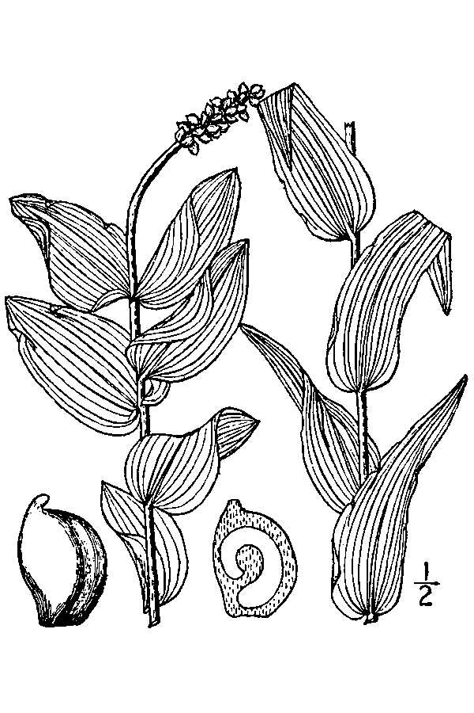

USDA-NRCS PLANTS Database / Britton, N.L., and A. Brown. 1913. An illustrated flora of the northern United States, Canada and the British Possessions. 3 vols. Charles Scribner's Sons, New York. Vol. 1: 80.

### Alternate Names

redhead grass, clasping leaved pondweed

### Uses

Claspingleaf pondweed beds stabilize sediments, reduce shoreline erosion, and provide valuable habitat and are a food source for a variety of fish, macroinvertebrates, crustaceans and waterfowl (Thayer et al 1975, Lubbers 1990).

*Habitat:*

Claspingleaf pondweed beds provide protection from predators, as well as attracting epiphytes and zooplankton upon which other species graze, providing an important link in the food web. During the breeding season up to 80 percent of waterfowl’s diet is plant material, much of it aquatic (Kenow and Rusch 1996).

### Status

Please consult the PLANTS Web site and your State Department of Natural Resources for this plant’s current status (e.g., threatened or endangered species, state noxious status, and wetland indicator values).

### Description and Adaptation

Claspingleaf pondweed is a submerged, rooted, flowering aquatic plant that grows in alkaline, brackish, and freshwater lakes, streams and estuaries. Substrate conditions are often low in organic content forming a firm muddy bottom or sand-based sediment in reasonably slow moving waters. Plants tend to be darker green colored in shallow waters and are a paler green in deeper water (Bergstrom et al. 2006).

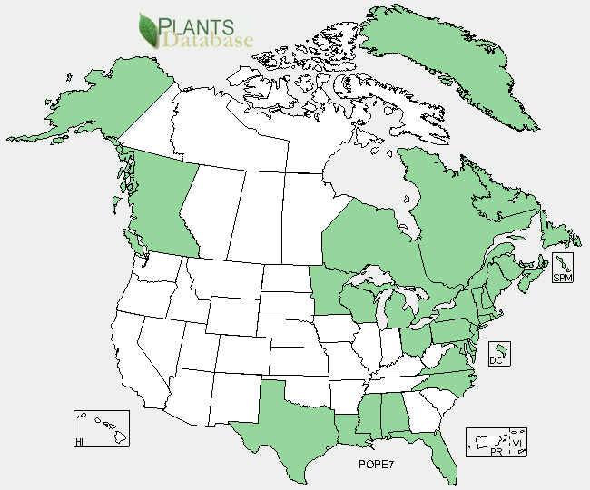

Claspingleaf pondweed distribution from USDA-NRCS PLANTS Database.

Claspingleaf pondweed is widespread in sheltered coves and bays throughout 24 states in the United States, 8 provinces in Canada, Greenland and St. Pierre Miquelon. For updated distribution, please consult the Plant Profile page for this species on the PLANTS Web site.

### Establishment

Claspingleaf pondweed pondweed is propagated through cuttings, rootstocks, and seeds. When starting new populations, using cuttings and rootstocks is the least time consuming method.. Cuttings can be taken and immediately planted to create new ones utilizing a planting substrate composed of oyster shell and peat moss. Seed propagation may result in a much higher yield of plants than asexual propagation. Seeds must be harvested from plants at the right time of year.

Germination rates under ideal conditions are variable from 16-60% (STAC 2007). Seed collections occur from late July to August. Seed harvesting of the upper third water column includes the plant stems and florescence (i.e. 1 foot down in 3 feet of water, or 10 inches down in a 30 inch tank). Seeds must be harvested from plants at the right time of year. Germination rates under ideal conditions are variable from 16-60% (STAC 2007). Best germination results require six to nine months of cold storage (at 40 deg F) submerged in 15 parts per thousand (ppt) saline water with aeration. To encourage fast and high germination after the 6 to 9 months of cold storage transfer the seed to a warm, freshwater environment.

### Management

In a domestic tank or experimental setting one of the major concerns is ensuring that algae or invasive vegetation does not overwhelm stock plants. Keeping nutrients and organic matter low helps , but additions of water and tank cleaning with nets similar to those used cleaning pools are important factors in aquatic plant maintenance.

### Pests and Potential Problems

In most propagation and restoration scenarios natural predators such as crabs or cownose rays require an exclosure is to protect plants. Non-migrating Canada geese graze extensively on the vegetation. The worst herbivores of submerged aquatic vegetation (SAV) are the non-native mute swans and native cownose rays. While it is unlikely they will wipe out the entire SAV population in a given water body, they do reduce above and belowground plant material, and they have the potential to destroy a restoration plantings in a single visit.

### Environmental Concerns

There are no known issues with respect to clasping pondweed and environmental problems.

### Cultivars, Improved, and Selected Materials (and area of origin)

There are no known cultivars, improved, and/or selected materials for claspingleaf pondweed. This plant is commercially available from specialized coastal and wetland plant nurseries.

### 

### Citation

Zinecker, E. and J. West. 2010. Plant fact sheet for claspingleaf pondweed (*Potamogaton perfoliatus* L.). USDA-Natural Resources Conservation Service, National Plant Materials Center. Beltsville,MD 20705.

*Edited:* 01/09/2010; 09/25/12 jad

For more information about this and other plants, please contact your local NRCS field office or Conservation District <<http://www.nrcs.usda.gov/>>, and visit the PLANTS Web site <[http://plants.usda.gov](http://plants.usda.gov/)> or the Plant Materials Program Web site <<http://plant-materials.nrcs.usda.gov>>

**USDA IS AN EQUAL OPPORTUNITY PROVIDER AND EMPLOYER**