|  |
| --- |
| PINE BLUEGRASS |
| ***Poa scabrella*** (Thurb.) Benth. ex Vasey |
| Plant Symbol = POSC |

*Contributed by: USDA NRCS Plant Materials Center, Corvallis, Oregon*

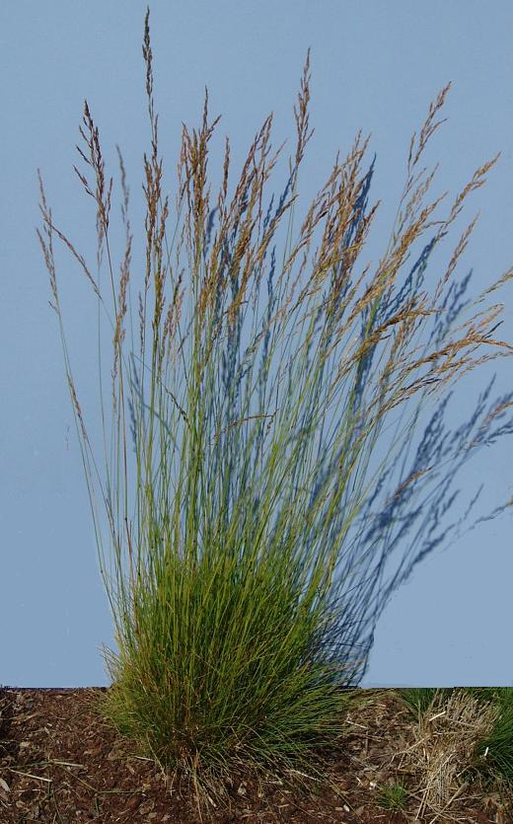

Dale Darris

USDA NRCS Corvallis PMC

**Alternate names:** Another common name is Sandberg bluegrass. *Poa scabrella* or pine bluegrass was formerly recognized as a separate species. It has since been combined with up to 44 other bluegrasses into a large complex known as *Poa secunda* or Sandberg bluegrass.

**Caution:** The *Poa secunda* complex represents a highly variable array of ecological forms occurring over a large area of the United States in diverse habitats. Information pertinent to certain forms may not apply well to the entire species across all regions. Therefore, this fact sheet applies best only to *Poa secunda* (formerly *Poa scabrella*) as it occurs west of the Cascades in the Pacific Northwest.

##### Uses: Pine bluegrass is a native cool season bunchgrass of small to moderate stature useful for restoration of upland meadows, wet prairies, and pine or oak savanna, depending on region. While slow to establish, it is drought tolerant and useful for dry, rocky outcrops as well as moist, slower draining sites. Other uses include revegetation, rehabilitation after wildfire, erosion control in mixes with other grasses, upland bird habitat (nesting cover, source of seed), and natural area landscaping. Specific information on livestock and wildlife utilization of pine bluegrass west of the Cascades is lacking. However, on drier western rangelands, ecotypes within the *Poa secunda* complex have value for livestock grazing and big game forage, especially in early spring. Palatability prior to dormancy and again in fall is rated fair to good for most ungulates, small mammals, and certain birds. Productivity can be low, especially in dry years. Potential uses that need further testing west of the Cascades are low input lawns and cover crops in vineyards or other horticultural crops where its early summer dormancy may be beneficial.

##### Description: Pine bluegrass is a fine textured, short to medium lived, strongly tufted perennial grass with erect culms (stems) 40-100 cm tall. Mature clumps are typically 10-16 cm wide and the foliage is light to medium green or slightly bluish, and mostly basal. Leaf blades are numerous, 1-2 mm wide, 5-22 cm long, flat to folded or rolled inward, and lax. The panicle (inflorescence or seed head) is upright and narrow. Dormancy occurs in summer when soils dry while new growth initiates during fall, winter and spring. Seed matures in June-July in the western interior valleys of Oregon and Washington and in August at higher elevations.

*Key to identification:*Pine bluegrass has narrower panicles, narrower leaf blades (1-2 mm vs. 2-5 mm), and does not spread by stolons (or rhizomes) in comparison to two common, weedy introduced relatives: roughstalk bluegrass (*Poa trivialis*) and Kentucky bluegrass (*Poa pratensis*). It does not have cobwebby hair along the veins or at the base of the floret (individual flower unit) like Kentucky bluegrass. Pine bluegrass is no longer distinguished from Sandberg bluegrass, Canby’s bluegrass (*Poa canbyi*), and other bluegrasses in the same complex.

**Commercial availability:** Populations originating from Oregon, California, Washington, and other western states are available and marketed as *Poa scabrella* or *Poa secunda.* Selected germplasm and cultivated varieties have also been released within the complex and some are better forage producers. However, given the limited testing and potential site or use specificity of different forms, utilization of any population should be confined within the same ecoregion and elevation zone, or a reasonable geographic distance from the original collection site.

**Relative abundance in the wild:** Pine bluegrass is somewhat infrequent west of the Cascades in Oregon and Washington. However, it is more common in other regions of the West.

**Limitations or environmental concerns:** The species is susceptible to stem and leaf rust in some years, especially under seed production. This can increase mortality and may necessitate the use of approved fungicides. It is slow to establish during the first year and may be out competed by weeds. There are no substantial environmental concerns.

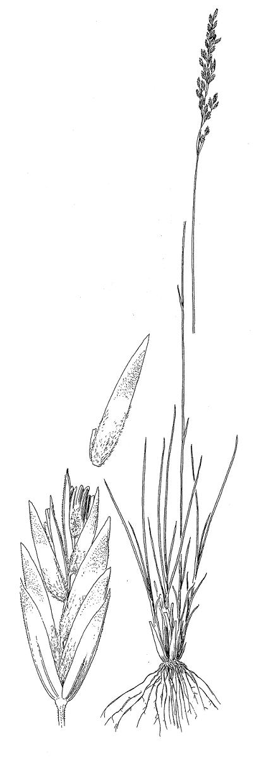

Line drawing reprinted with permission,

University of Washington Press

##### Adaptation: Pine bluegrass inhabits open woodlands and sagebrush steppe as well as on dry, rocky slopes, exposed slopes, or shallow soils with good drainage. However, populations are also found in higher precipitation zones under moister soil or slower draining conditions including seasonally wet prairies of western Oregon and Washington. The *Poa secunda* complex has a wide range, occurring from near sea level along the Pacific Coast eastward to higher elevations in the mountain west as well as Great Plains. Soil types vary from moderately acid sands to loams and clay loams with a pH from 6.0 to 8.0. The species occurs in full sun as well as in partial shade of open timber or savanna. It is well adapted to fire as a component of prairie ecosystems.

##### Establishment: Seed of *Poa secunda* is classified as nondormant and typically germinates without treatment. However some populations of pine bluegrass germinate more uniformly or at a higher percent with 14, 30 or 60 days of cold, moist chilling (stratification). Therefore, fall seeding is advised. No special physical conditioning of the seed is needed. Seed weight varies from 900,000-1,500,000 seeds/lb. Each pound of pure live seed (PLS) sown per acre results in 20-34 live seeds/sq. ft. Seeding depth must be shallow, preferably less than ¼ in. on heavier soils and ½ in. on lighter soils. Pine bluegrass is rarely sown alone (2-3 lbs/ac) but rather in mixes with other grasses (0.5-2 lbs/ac). Higher rates (4-8+ lbs/ac) are applied to higher precipitation zones (30+ inches/yr) and experimental uses such as low input cover. Rate of establishment from seed is slow. If fall sown, flowering can occur the following spring in milder climates.

Prepared by:

Dale Darris, USDA NRCS Plant Materials Center, Corvallis, Oregon. July 2007.

Species coordinator:

Dale Darris, USDA NRCS, Plant Materials Center, Corvallis, Oregon.

For more information about this and other plants, please contact your local NRCS field office or Conservation District, and visit the PLANTS Web site<<http://plants.usda.gov>> or the Plant Materials Program Web site <<http://Plant-Materials.nrcs.usda.gov>>

*The U.S. Department of Agriculture (USDA) prohibits discrimination in all its programs and activities on the basis of race, color, national origin, sex, religion, age, disability, political beliefs, sexual orientation, and marital or family status. (Not all prohibited bases apply to all programs.) Persons with disabilities who require alternative means for communication of program information (Braille, large print, audiotape, etc.) should contact USDA's* [*TARGET Center*](http://www.usda.gov/oo/target.htm) *at 202-720-2600 (voice and TDD).*

*To file a complaint of discrimination write USDA, Director, Office of Civil Rights, Room 326-W, Whitten Building, 14th and Independence Avenue, SW, Washington, DC 20250-9410 or call 202-720-5964 (voice or TDD). USDA is an equal opportunity provider and employer.*

*Read about* [*Civil Rights at the Natural Resources Conservation Service*](http://www.nrcs.usda.gov/about/civilrights/)