

Plant Fact Sheet

# chickasaw plum

## Prunus angustifolia Marsh.

### Plant Symbol = PRAN3

Contributed by: USDA NRCS Manhattan Plant Materials Center & Kansas State University, Forestry Research

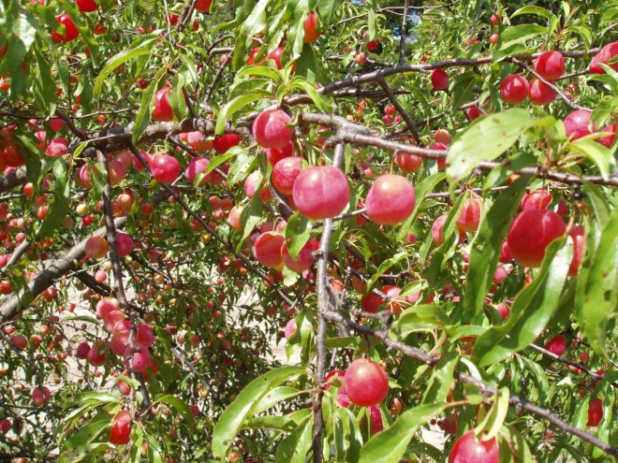

Figure . Chickasaw plum in full fruit.

Photo by John M. Row

#### **Alternate Names**

#### Sand plum, sandhill plum, sand hill plum, mountain cherry

#### **Uses**

Native Americans regularly consumed fresh fruits of Chickasaw plum or dried them for winter. First cultivated in 1874, the fruit was used for making wine, jam, and jelly. Its white flowers are attractive and fragrant in the spring, producing a beautiful flower show. It should be part of a native landscape planting. Chickasaw plum is a popular plant for use in developing wildlife habitat on sandy soils. The thorny thicket is valuable for songbird and game bird nesting, loafing, and roosting. Various other animals also use it for loafing, bedding, and escape cover. Numerous species of birds and other animals consume the fruit. The plums provide nesting cover for northern bobwhites, brown thrashers, northern mockingbirds, and gray catbirds in the southeastern U S. Northern bobwhites nest in mixed shrub communities composed predominantly of Chickasaw plum in Texas. Field sparrow, Bell’s vireo, loggerhead shrike, and painted bunting alsorequire woody plants including Chickasaw plum for nesting. Plum is important to lesser prairie-chickens for resting, escape, and thermal cover. Cattle use plum thickets to escape the summer sun and actually gain weight faster when the thickets form a usable part of their range. Chickasaw plum is very effective in stabilizing blowing soil. It may be used in the outside row of windbreaks for ground level protection. It is also used to stabilize stream banks and gullies.

#### Chickasaw plum distribution from USDA-NRCS PLANTS Database

Chickasaw plum distribution from USDA-NRCS PLANTS Database.

For updated distribution, please consult the Plant Profile page for this species on the PLANTS Web site.

#### **Status**

Please consult the PLANTS Web site and your State Department of Natural Resources for this plant’s current status (e.g., threatened or endangered species, state noxious status, and wetland indicator values).

#### **Description and Adaptation**

Chickasaw plum is a short, thickly branched shrub 3 to 10 feet tall, often forming extensive thickets or colonies due to extensive suckering in the western part of its range. In the eastern parts of its range it forms a small tree; height at maturity is 14 to 25 feet. Leaves are simple, lanceolate to oblong lanceolate, 0.8 to 2.4 inches long, 0.4 to 0.8 inches wide, acute or short acuminate, rounded at the base, slender, lustrous and glabrous above, strongly trough shaped with stalks that bear two red glands near the apex with leaf teeth finely serrate, tipped with glands or scars of these. Its numerous zigzag twigs are smooth, reddish brown and slender. Younger branches have smooth reddish brown bark with large, horizontal lenticels. Older trees have rough, scaly trunk bark. There are short, side twigs that bear flowers and endin sharp points. Open-pollinated and early blooming, March-April, the numerous off-white or yellowish-white flowers with little fragrance appear before the leaves and are less than 1/2 inch across; sepals green, no glands on the calyx lobes. The ripe fruits small, 1/4 to 1/2 inch in size, thin-skinned, red, orange-red, or yellow, not glaucous but with a slight bloom; the stone is small, rough, yellowish, and turgid, almost spherical; fruiting in June-August. Some trees bear edible fruits; others have very bitter fruits.

Chickasaw plum grows in almost any soil, except strongly alkaline. It occurs naturally on sandy soils, but will perform well when planted on heavier clay-loam soils. Although partially shade tolerant, it performs best in full sun.

#### **Establishment**

One-year-old, bare-root seedlings, 18 to 24 inches tall, are used in plantings. Control of weed and grass competition during the first and second years is important in survival, early growth, and final establishment of the plants.

#### **Management**

The plums are drought tolerant and require little maintenance once established. Young plants should be protected from herbivores such as rabbits, deer, and cattle. Protection of older stands during prescribed burns or other brush management programs would favor shrub nesting birds on grasslands. Fire can set back the above ground growth of Chickasaw plum, but does not kill the plants.  Protect the thickets from prescribed burning with disk strips.  Disk strips stimulate the production of forbs and legumes as food sources near the thickets which is beneficial to wildlife. Should fire run through the thicket, if it has bare ground, minimal damage occurs, otherwise expect 3-5 years of recovery time for the over story structure to be recreated.

#### **Pests and Potential Problems**

Insects and disease may occasionally attack this species, but are not a serious problem in conservation plantings. Plum curculio is the primary insect pest of Chickasaw plum. Fruit drop and fruit damage caused by this insect must be controlled if commercial plantings of plum are to be successful. Major disease problems include brown rot of the fruit and bacterial leaf spot. Little natural resistance to these diseases exist. Chemical controls for the major pests of plum are widely available. Consult your local agricultural extension specialist for recommended products and application rates. Rabbits may chew on the bark, but new sprouts will form to replace injured stems. Deer can rub on young trees and cause considerable damage.

#### **Environmental Concerns**

None known

#### **Cultivars, Improved, and Selected Materials (and area of origin)**

Chisholm Germplasm, a Selected Class plant material, was released by USDA NRCS, Manhattan Plant Materials Center, Manhattan, KS for conservation use; Rainbow Germplasm, a native wild plum chiefly *P. angustifolia* derived, released by USDA NRCS, James E. Bud Plant Materials Center, Knox City, TX. Pomological varieties include Caddo Chief, found in the wild in Caddo Parish, LA, and introduced by G. W. Stoner, Shreveport, LA.

#### **Prepared By**

#### John M. Row, Plant Materials Specialist

#### Manhattan Plant Materials Center, Manhattan, KS 66502

*Wayne A. Geyer,* Professor

Forestry Division, Kansas State University

Manhattan, KS 66506

#### **Citation**

Row, J. M. and W. A. Geyer. 2010. Plant Fact Sheet for Chickasaw plum (*Prunus angustifolia*). USDA-Natural Resources Conservation Service, Manhattan Plant Materials Center, Manhattan, KS 66502.

Published: December 2010

For more information about this and other plants, please contact your local NRCS field office or Conservation District <<http://www.nrcs.usda.gov/>>, and visit the PLANTS Web site <[http://plants.usda.gov](http://plants.usda.gov/)> or the Plant Materials Program Web site <<http://plant-materials.nrcs.usda.gov>>

**USDA IS AN EQUAL OPPORTUNITY PROVIDER AND EMPLOYER**