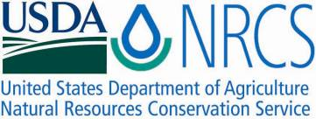

Plant Fact Sheet

# lance selfheal

## Prunella vulgaris L. ssp. lanceolata (W. Bartram) Hultén

Plant Symbol = PRVUL2

Contributed by: USDA NRCS Corvallis Plant Materials Center, Oregon

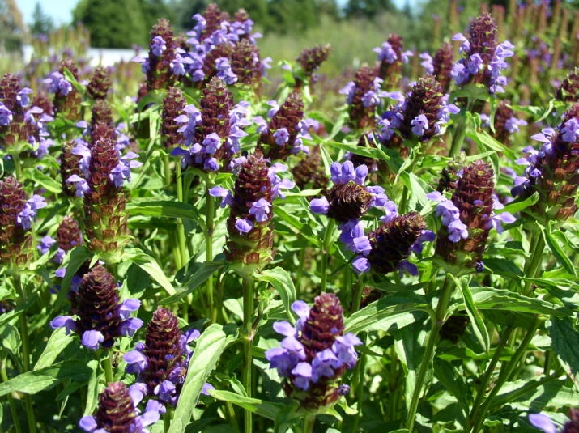

Photo by Amy Bartow, Corvallis Plant Materials Center, 2010

### Alternative Names

*Alternate Common Names:* mountain selfheal, narrowleaf selfheal, lanceleaf selfheal, American self-heal, self heal, heal-all, all heal

*Alternate Scientific Names: Prunella vulgaris* L. var. *elongata* Benth., *Prunella vulgaris* L. var. *lanceolata* (W. Bartram) Fernald, *Prunella pennsylvanica* Willd. var. *lanceolata* W.P.C.Barton, Prunella vulgaris var. calvescens

### Uses

*Ornamental:* Lance selfheal can be used as a native groundcover or alternative lawn that will generally stay green all summer in the Pacific Northwest without watering and will flower even when mowed fairly short. Plants will form a dense mat with small leaves when repeatedly mowed or grazed. This species is also a valuable addition to a wildflower meadow or butterfly garden, but can become weedy, so it may not be appropriate for small spaces or formal gardens.

*Wildlife and pollinators:* Flowers provide nectar and pollen to butterflies such as whites (Pierinae), sulfurs (Coliadinae), and skippers (Hesperiidae), as well as native bees such as bumblebees (*Bombus* spp.), digger bees (*Anthophora* spp.), small carpenter bees (*Ceratina* spp.), long-horned bees (*Eucera* spp.), and green sweat bees (*Agapostemon* spp.). Caterpillars of the gray marvel moth (*Agriopodes teratophora*) sometimes feed on the foliage. Due to its bitter taste, lance selfheal is not generally eaten by herbivorous mammals, but the plants may be incidentally eaten by cattle, sheep, or deer along with pasture grasses. Ground-foraging birds sometimes eat the nutlets.

*Erosion control:* Due to its fibrous, rhizomatous roots and spreading growth habit, lance selfheal can be used for erosion control along roadsides, streambanks and pond edges. The species also has potential as a perennial cover crop to provide habitat for pollinators and other beneficial insects in vineyards, orchards, and cane fruit or blueberry plantations, but more testing is needed.

*Ethnobotanic/medicinal:* This plant was used medicinally by many North American tribes, giving rise to the common names used today. The Quileute, Quinault, and Coast Salish in the Pacific Northwest rubbed the juice from the plant on boils to heal them. The Delaware, Mohegan and Iroquois made a drink or body wash of plant tops to reduce fevers. The Nuxalk boiled the entire plant to make a weak tea that was taken for the heart. Studies have shown that *P. vulgaris* has antibiotic properties, lowers blood pressure, and contains a compound (ursolic acid) that is believed to increase urination and fight tumors. It is still used as a medicinal herb today, but plants are known to concentrate lead compounds and other pollutants, so they should not be gathered from roadsides.

### Status

Please consult the PLANTS Web site and your State Department of Natural Resources for this plant’s current status (e.g., threatened or endangered species, state noxious status, and wetland indicator values).

### Weediness

This plant may become weedy or invasive in some regions or habitats and may outcompete, displace, or overrun desirable vegetation if not properly managed. *Prunella vulgaris* (no subspecies specified) is listed in *Weeds of the Northeast* and *Weeds of the Great Plains*. Please consult with your local NRCS Field Office, Cooperative Extension Service office, state natural resource, or state agriculture department regarding its status and use.

### Description and Adaptation

Lance selfheal is a native, fibrous-rooted, herbaceous perennial that grows from short rhizomes or an enlarged stem-base, reaching 4 to 20 inches tall. Like other members of the mint family (Lamiaceae), it has square stems and opposite leaves. The stems are generally un-branched, slightly hairy above, and may be solitary or clustered. Leaves are lance-shaped, 0.8 to 2.8 inches long, minutely hairy to hairless, with short stalks on lower leaves, and smooth or slightly toothed margins. The numerous, small (about ½ inch), purple to pink or white snapdragon-like flowers have short stalks and are tubular in shape, with a large, hooded upper lip and a large, 3-lobed lower lip that is sometimes fringed. They are arranged in a tight cluster 1 to 2 inches long by about 1 inch wide at the end of the stem. Within the cluster, the flowers are arranged in whorls of sixes, with each whorl above two spreading, pointed, leaf-like bracts. Flowers bloom progressively in the spike from the lower to upper end. Bloom occurs April to September, depending on the latitude and elevation. Each flower produces four smooth, egg-shaped, one-seeded nutlets that are retained in the persistent calyx. The nutlets are primarily distributed by flowing water, grazing mammals and birds.

Prunella vulgaris ssp. vulgaris in an introduced species from Eurasia. It is now naturalized throughout much of the same range as the North American native ssp. lanceolata. The two can be distinguished by their growth form and the shape of the leaves growing along the middle of the stems: ssp. lanceolata grows upright or reclining on the ground with tips ascending and its mid-stem leaves are narrower (about 3 times as long as wide), while ssp. vulgaris generally lies flat on the ground and has wider mid-stem leaves (twice as long as wide).

Lance selfheal is an early successional species commonly found in moist, often disturbed areas including forest edges, open woodlands, meadows, pasturelands, roadsides, clearings and lawns at elevations below 8000 ft. It grows best in full sun to partial shade and moist soil. It is native to North America and its distribution is circumboreal, including most of the Northern Hemisphere. For updated distribution, please consult the Plant Profile page for this species on the PLANTS Web site.

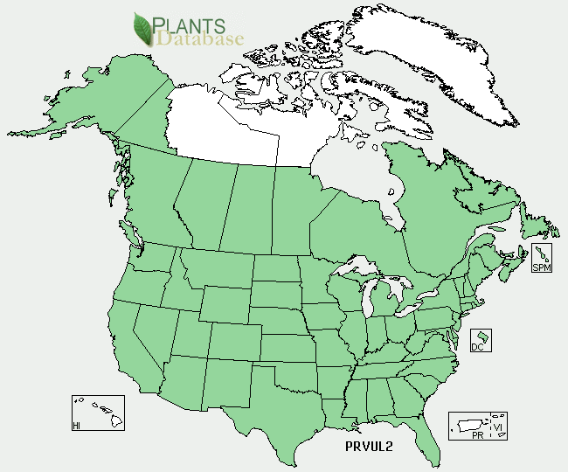

Lance selfheal distribution from USDA-NRCS PLANTS Database.

### Establishment

Lance selfheal establishes easily from seed, having high germination rates at most temperatures, with no pretreatment necessary. There are about 756,000 seeds per pound. The recommended single-species seeding rate for pollinator enhancement plantings is 2 to 4 lbs/acre, while the recommended rate in a mix for prairie restoration is 2 to 8 ounces per acre. Plants can also be propagated by dividing and planting out rhizomes in the spring.

### Management

For seed production, fields are direct sown and the first seed harvest occurs in the second year after planting. A small percentage of plants will flower the first year, especially if they are fall sown. Large fields can be direct combined, while smaller production fields are generally swathed and collected to dry on tarps. In seed production fields, plants usually die after harvest. In the wild, plants are typically short-lived but readily self-sow.

### Pests and Potential Problems

Information is lacking on pests and diseases associated with lance selfheal.

### Environmental Concerns

Plants can become weedy or invasive and may displace other desirable vegetation if not managed. Plants can regenerate from rhizome or shoot fragments, and the seed can persist in cultivated soil for at least 5 years.

### Control

A surface application of lime may help control selfheal infestations on pastures with poor soils. Please contact your local agricultural extension specialist or county weed specialist to learn what works best in your area and how to use it safely. Always read label and safety instructions for each control method.

### Cultivars, Improved, and Selected Materials (and area of origin)

There are no developed cultivars of lance selfheal, but both non-certified and certified source identified seed is available from commercial sources. Container plants are also sometimes available from native plant nurseries.

### Prepared By

*Annie Young-Mathews*

USDA-NRCS Corvallis Plant Materials Center, Oregon

### Citation

Young-Mathews, A. 2012. Plant fact sheet for lance selfheal (*Prunella vulgaris* ssp. *lanceolata)*. USDA-Natural Resources Conservation Service, Corvallis Plant Materials Center, Corvallis, OR.

Published April 2012

Edited: 16Dec2011 dcd, 16Dec2011 ab; 19Dec2011 klp; 03Jan2012 jab; 18Jan2012 gm

For more information about this and other plants, please contact your local NRCS field office or Conservation District <<http://www.nrcs.usda.gov/>>, and visit the PLANTS Web site <[http://plants.usda.gov](http://plants.usda.gov/)> or the Plant Materials Program Web site <<http://plant-materials.nrcs.usda.gov>>

**USDA IS AN EQUAL OPPORTUNITY PROVIDER AND EMPLOYER**