

Plant Fact Sheet

# bluebunch wheatgrass

***Pseudoroegneria spicata* (Pursh) A. Löve**

Plant Symbol = PSSP6

*Contributed by*: USDA NRCS Idaho Plant Materials Program

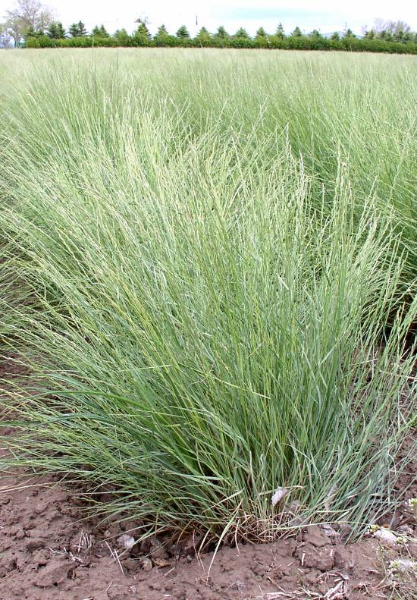

**Bluebunch wheatgrass seed production field at Aberdeen, Idaho. Photo by Derek Tilley, USDA-NRCS**

**Alternate Names** *Agropyron spicatum, Elytrigia spicata*

**Uses**

Bluebunch wheatgrass can be used for native hay production and will make nutritious feed, but is better suited to grazing use. Bluebunch wheatgrass is palatable to all classes of livestock and wildlife. In spring, the protein levels can be as high as 20 percent decreasing to about 4 percent protein as the forage matures and cures. Digestible carbohydrates remain about 45 percent throughout the active growth period.

Bluebunch wheatgrass is very drought resistant, persistent and adapted to stabilization of disturbed soils. It is very compatible with slower developing native grasses, but does not compete well with aggressive introduced species. Its drought tolerance, combined with extensive root systems and good seedling vigor, make this species ideal for reclamation in areas receiving 10 to 20 inches annual precipitation.

### Status

Consult the PLANTS Web site and your State Department of Natural Resources for this plant’s current status (e.g., threatened or endangered species, state noxious status, and wetland indicator values).

### Description and Adaptation

Bluebunch wheatgrass is a long-lived, cool-season native perennial bunchgrass growing to 4 feet tall with seed spikes 3 to 8 inches long. The lemma awns range from being short to prominent and divergent except on the beardless type where the awn is lacking. It has an extensive root system with strong tillers. Bluebunch wheatgrass spreads by seed but in high rainfall zones it may spread by short rhizomes.

Bluebunch wheatgrass is common to the northern Great Plains, Northern Rocky Mountains and the Intermountain regions of the western United States. For updated distribution, please consult the Plant Profile page for this species on the PLANTS Web site.

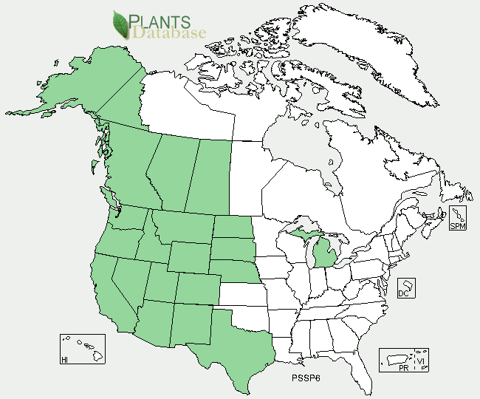

Bluebunch wheatgrass distribution from USDA-NRCS PLANTS Database.

Bluebunch wheatgrass does best on medium to coarse-textured soils, but can be found on a range of soil textures over 10 inches deep. It will tolerate weakly saline conditions but does not grow on highly acidic sites. It is cold tolerant, moderately shade tolerant, and highly fire tolerant. It is not tolerant of high water tables, poor drainage, or periods of extended inundation.

Bluebunch wheatgrass is most abundant in 10 to 20 inch annual precipitation areas in sagebrush and juniper communities. The elevation range is from 500 to 10,000 feet above sea level. It is a major component of many native plant communities and generally occupies 20 to 60 percent of the overall composition by weight.

**Establishment**

Seed should be drilled at a depth of 1/4 to 1/2 inch into a clean, firm, weed-free seedbed. The single-species seeding rate is 8 pounds Pure Live Seed (PLS) per acre. If used as a component of a mix, adjust to percent of mix desired. When broadcast seeding and for mine lands and other harsh critical areas, the seeding rate should be doubled. Bluebunch wheatgrass is compatible with other native species and should be used in seeding mixtures. It should not be seeded with strongly competitive introduced species. Best seeding results are obtained from seeding in early spring on heavy to medium-textured soils and in late fall on medium to light-textured soils. Late summer (August - mid September) seeding is not recommended unless irrigation is available.

**Management**

Grazing should be deferred for 2-3 years to ensure establishment. Established stands do not tolerate heavy continuous grazing, and six inches of new growth should be attained in spring before grazing is allowed. Deferred rotation grazing is recommended. Spring grazing should occur no more than one out of three years and less than 40% utilization should occur during rapid growth. Heavy early spring grazing is especially damaging and grazing should be delayed until at least mid-boot stage. No more than 60% utilization should occur after seed ripens.

### Environmental Concerns

Bluebunch wheatgrass is native to the Intermountain West and has no known negative impacts on wild or domestic animals. It is not considered a weedy or invasive species but can spread to adjoining vegetative communities under ideal environmental conditions.

### Cultivars, Improved, and Selected Materials (and area of origin)

Anatone Selected Class Germplasm originated near Anatone, Washington. It was released by the Forest Service, BLM, Aberdeen PMC, Idaho-Utah AES, ARS and the Utah Division of Wildlife Resources in 2003. Anatone establishes rapidly and can survive under dry conditions at or above 10 inches rainfall. It is intended for use on rangelands for re-establishment of native plant communities, vegetative firebreaks, and critical area stabilization. Certified seed is available. Generation 1 seed is produced by Aberdeen PMC.

'Goldar' was selected from seed collected on Mallery Ridge in Asotin County, Washington. It was released by Idaho-Utah AES, ARS and the Aberdeen PMC in 1989. 'Goldar' is noted for rapid establishment, high forage production, and the ability to survive with 12 inches precipitation. Certified seed is available and Breeder and Foundation seed is maintained by Aberdeen PMC.

P-7 Selected Germplasm was generated by open- pollinating 25 native populations of bluebunch wheatgrass resulting in high genetic diversity. ARS and the Utah AES released P-7 in 2001. It is expected to survive and thrive under dry conditions at or above 12 inches rainfall. Certified seed is available and early generation seed is maintained by USDA-ARS, Logan, Utah..

'Whitmar' a cultivar of beardless wheatgrass (*P. spicata* subsp*. inermis*) is the awnless form of bluebunch wheatgrass. It was selected from seed native to the Palouse grasslands near Colton, Washington. Idaho-Oregon-Washington AES and Aberdeen, Corvallis, and Pullman PMCs released ‘Whitmar’ in 1946. It performs best above 12 inches rainfall. 'Whitmar' was selected for forage quality, seedling vigor, and good seed production. Certified seed is available and Breeder seed is maintained by Pullman PMC.

### Prepared By

Derek Tilley; USDA NRCS Plant Materials Center, Aberdeen, Idaho.

Loren St. John, USDA NRCS Plant Materials Center, Aberdeen, Idaho.

### Citation

Tilley, D., and L. St. John. 2013. Plant fact sheet for bluebunch wheatgrass (*Pseudoroegneria spicata)*. USDA-Natural Resources Conservation Service, Aberdeen Plant Materials Center, Aberdeen, Idaho

Published January 2013

Edited: 19dec2012djt; 19dec2012ls

For more information about this and other plants, please contact your local NRCS field office or Conservation District <<http://www.nrcs.usda.gov/>>, and visit the PLANTS Web site <[http://plants.usda.gov](http://plants.usda.gov/)> or the Plant Materials Program Web site <<http://plant-materials.nrcs.usda.gov>>

**USDA IS AN EQUAL OPPORTUNITY PROVIDER AND EMPLOYER**