

Plant Fact Sheet

# narrowleaf mountainmint

## *Pycnanthemum tenuifolium* Schrad.

Plant Symbol = PYTE

*Contributed by:* USA NRCS Cape May Plant Materials Center

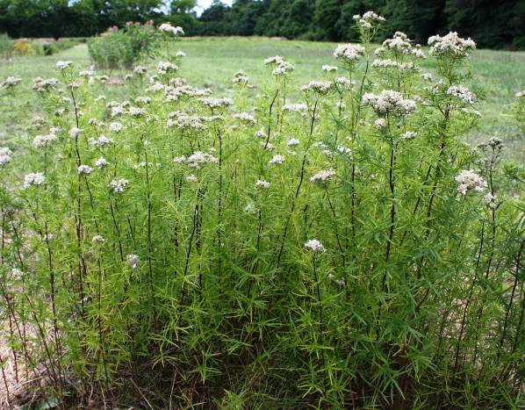

Narrowleaf mountainmint (Pycnanthemum tenuifolium) (Photo by, Jolie Dollar, Xerces Society

**Alternative Names**

*Common Alternate Names:*

Virginia thyme

slender mountain mint

common horsemint

**Uses**

*Wildlife Use:* Narrowleaf mountainmint provides a nectar source for pollinators and is well suited for use in pollinator restoration. Preliminary observation found that *P. tenuifolium* attracted 20 different species of Hymenoptera and Lepidoptera in Cape May, New Jersey. The sweat bees *Lasioglossum vierecki*, *Halictus confusus*, and *Halictus ligatus* were most frequently observed visiting the flower. Both *Lasioglossum* sp. and *Halictus confuses* in particularare important pollinators of pepper, watermelon, strawberry, and tomato plants.

Robertson (1928) collected 29 species of Lepidoptera from *P. tenuifolium* in Central Illinois. This is one of the greatest numbers of species to visit a flower from the 244 species of flowering plants in his study. In Tooker et al., (2006), 9 species of fly were found on P. tenuifolium; and Robertson (1929) captured 31 species of fly.

Deer may browse the leaves and a variety of animals will eat the seeds. It is reported that the seeds are too small to attract birds (Hilty, 2012).

*Erosion Control: P. tenuifolium* spreads quickly through rhizomes and so would make a good soil stabilizer.

**Status**

Please consult the PLANTS Web site and your State Department of Natural Resources for this plant’s current status (e.g., threatened or endangered species, state noxious status, and wetland indicator values).

**Description and Adaptation**

*Description*: *P. tenuifolium* is a native, warm season, perennial forb that grows 2–3 ft tall and spreads equally wide. It is a member of the Lamiaceae (mint) family and the crushed flowers or leaves emit a minty scent. Like other mints, it has a four angled stem and small opposite leaves. The stem is smooth, without hairs, and is slender and stiff. The plant has a taproot and rhizomes.

The pale green leaves are approximately 0.15–0.6 in wide and 0.5–2 in long. They are smooth or minutely hairy on the uppermost leaves. The upper leaves are stalkless while the lowest leaves have short stems. There are short leafy branches in the axils.

The plant has profuse clusters of small, tubular, white flowers which bloom in the middle of summer; July through August. The flower petals have an upper lip, and three-lobed lower lip. Clusters stagger their bloom period over a long period of time. It is thought that pollinators prefer this species because the florets are tightly clustered, have short corolla tubes, and are white (Tooker et al,. 2002).

*Adaptation:P. tenuifolium* grows in dry to medium wet soils and in full sun to partial shade. It can be found in rocky ground in open prairies and upland woods, as well as in low areas, wet thickets, pine barrens, oak woods, and on the edges of wooded areas. Gleason and Cronquist (1963) observe that it is found most often in dry soils of upland woods and prairies. For updated distribution, please consult the Plant Profile page for this species on the PLANTS Web site.

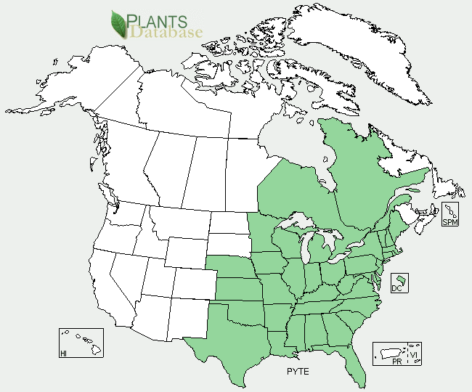

*Narrowleaf mountainmint (Pycnanthemum tenuifolium) distribution from USDA-NRCS PLANTS Database.*

**Establishment**

*P. tenuifolium* should begrown in full sun in moist to slightly dry soils. Although seeds are small and difficult **t**o use, it can be propagated by seed. Seeds germinate without pretreatment. It may also be propagated by cuttings or division. Cuttings should be made in June and divisions should be done during dormancy (from late fall to early spring).

**Pests and Potential Problems**

There are no major pests or problems known for this plant, although it may be vulnerable to rust.

**Environmental Concerns**

It forms colonies by spreading through rhizomes and can show aggressive growth.

**Prepared By:** *Christopher M. Sheahan*. USDA-NRCS, Cape May Plant Materials Center, Cape May, NJ.

**Citation:** Sheahan, C.M. 2012. Fact sheet for narrowleaf mountainmint(*Pycnanthemum tenuifolium*). USDA-NRCS, Cape May Plant Materials Center. Cape May, NJ. 08210.

Published July 2012

Edited:

For more information about this and other plants, please contact your local NRCS field office or Conservation District <<http://www.nrcs.usda.gov/>>, and visit the PLANTS Web site <[http://plants.usda.gov](http://plants.usda.gov/)> or the Plant Materials Program Web site <<http://plant-materials.nrcs.usda.gov>>

**USDA IS AN EQUAL OPPORTUNITY PROVIDER AND EMPLOYER**