|  |
| --- |
| sawtooth oak |
| *Quercus acutissima* Carruthers |
| Plant Symbol = QUAC80 |

Contributed by: USDA NRCS Northeast Plant Materials Program

C. Miller

USDA NRCS

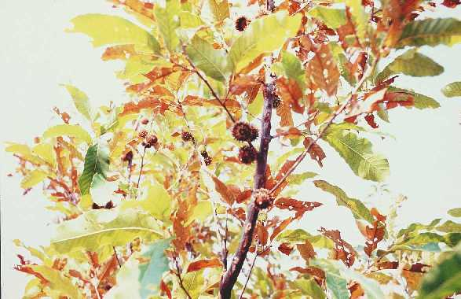

Uses

The primary use for this species is as a wildlife food source and cover. It is also a good shade tree.

Status

Please consult the PLANTS Web site and your State Department of Natural Resources for this plant’s current status (e.g. threatened or endangered species, state noxious status, and wetland indicator values).

Description

Sawtooth oak is a large species, reaching a mature height of 70 feet. The leaves are similar to those of the chestnut but are smaller, 4-8 inches, and have pointed teeth. The acorns are also small in size, ranging from 5/8-3/4 inch long and are enclosed in cups with long, spreading, recurving scales. Approximately 2/3 of the nut is covered by the cup. Trees produce about 150 acorns per pound.

Adaptation and Distribution

Sawtooth oak is native to eastern Asia but was introduced into the eastern United States around 1920. The range of adaptation extends from Northern Florida west to eastern Texas and Oklahoma, northward through Missouri to New York and into southern New England. On exposed sites in the northern Finger Lakes Region of New York, it may winterkill. Sawtooth oak is winter hardy and can be grown in soils from sandy loam to clay loam. However, the best performance is achieved in deep, well-drained soils. It can also be grown on reclaimed surface mined land where favorable moisture conditions are present and pH is above 5.0.

For a current distribution map, please consult the Plant Profile page for this species on the PLANTS Website.

Establishment

One year old seedlings should be planted 15-20 feet apart for maximum acorn production. In areas where multiple rows are used, the spacing should be no less than 20 feet apart. There should be at least 15 plants per planting for effective wind pollination. Site preparation consists of clearing the existing vegetation from an area at least 3 feet in diameter around the newly planted seedling. The seedling should be planted at the same depth it was growing at in the nursery. At the bottom of the hole, apply a handful of 10-10-10 or 18-8-3 fertilizer pellets. Cover the pellets with 2-3 inches of soil. Do not allow the seedling to come in contact with the fertilizer. Water and mulch immediately to conserve water and discourage weeds.

If planting by acorns, begin in the early fall. Plant acorns 3/4-1 inch deep. The seedlings should not be transplanted until they reach 12-18 inches in height.

Management

To achieve desired results, keep competition to a minimum for 2 years. By this time, the seedlings should be well established. If growth is stunted, eliminate competition and apply a complete fertilizer.

Sawtooth oak seedlings do not do well in poorly drained soils or in areas subject to flooding. If under water for 24 hours in the summer, they will not survive.

This plant has been found to be resistant to disease and insect damage.

Cultivars, Improved, and Selected Materials (and area of origin)

‘Gobbler’ was released in 1986 by the Quicksand Plant Materials Center in cooperation with the Kentucky Agricultural Experiment Station, Kentucky Department of Fish & Wildlife, and the Kentucky Division of Forestry. It was selected for resistance to insects and disease, wildlife food value, and growth form compared to similar use species. Plant materials are available from nurseries throughout the region.

Prepared By & Species Coordinator:

USDA NRCS Northeast Plant Materials Program

Edited: 05Feb2002 JLK; 060815 jsp

For more information about this and other plants, please contact your local NRCS field office or Conservation District, and visit the PLANTS Web site<<http://plants.usda.gov>> or the Plant Materials Program Web site <<http://Plant-Materials.nrcs.usda.gov>>

*The U.S. Department of Agriculture (USDA) prohibits discrimination in all its programs and activities on the basis of race, color, national origin, sex, religion, age, disability, political beliefs, sexual orientation, and marital or family status. (Not all prohibited bases apply to all programs.) Persons with disabilities who require alternative means for communication of program information (Braille, large print, audiotape, etc.) should contact USDA's* [*TARGET Center*](http://www.usda.gov/oo/target.htm) *at 202-720-2600 (voice and TDD).*

*To file a complaint of discrimination write USDA, Director, Office of Civil Rights, Room 326-W, Whitten Building, 14th and Independence Avenue, SW, Washington, DC 20250-9410 or call 202-720-5964 (voice or TDD). USDA is an equal opportunity provider and employer.*

*Read about* [*Civil Rights at the Natural Resources Convervation Service*](http://www.nrcs.usda.gov/about/civilrights/)*.*