|  |
| --- |
| prairie coneflower |
| *Ratibida columnifera* (Nutt.) Woot. & Standl. |
| Plant Symbol = RACO3 |

Contributed by: USDA NRCS Bridger Plant Materials Center

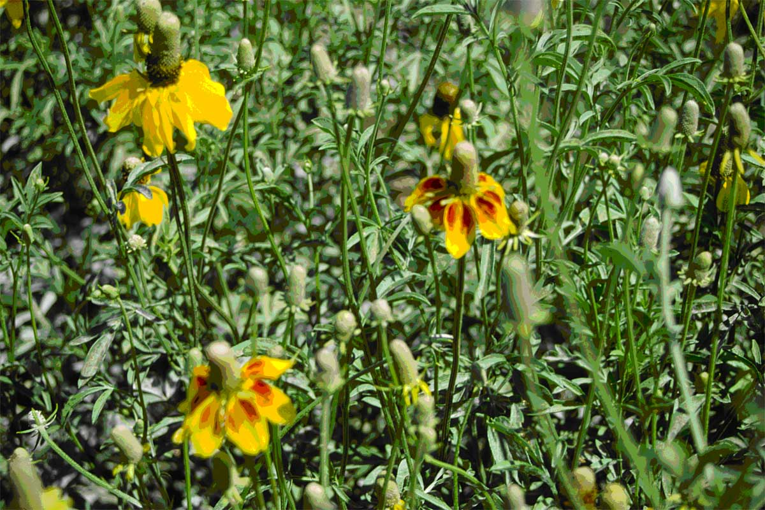

Susan R. Winslow

USDA NRCS Bridger PMC

**Alternate Names**

Upright prairie coneflower, yellow coneflower, long headed coneflower, columnar prairie coneflower, Mexican hat

Uses

*Grazing*: Prairie coneflower is palatable and nutritious to all classes of domestic livestock when utilized in early stage of plant growth and development. It is considered a desirable spring browse plant for big game animals, and the seed of prairie coneflower is preferred by several species of upland birds and small mammals.

*Restoration*: Prairie coneflower is a medium to tall-statured forb that may fill a structural cover and nesting niche for multiple species of upland birds in a variety of plant community types. A more diverse native plant community will be attained when this species is included in native seed mixes for the rehabilitation of such disturbed sites as rangelands, minelands, roadsides, park and restoration areas, prairie restoration projects, and conservation plantings in accordance with government farm bill program requirements.

*Landscape:* Prairie coneflower is commonly recommended as an ornamental wildflower in pollinator friendly, low maintenance, or natural landscapes.

*Ethnobotanic:* Native peoples utilized a decoction of leaves and stems to treat pain, poison ivy rash, and rattlesnake bites. An infusion was made from plant tops to treat headache, stomachache, cough, fever, epileptic fits, and to induce vomiting. A medicinal or beverage-type tea was made from the ripened flower heads and leaves. An orange-yellow dye was produced from boiled flowers.

Status

Please consult the PLANTS Web site and your State Department of Natural Resources for this plant’s current status (e.g. threatened or endangered species, state noxious status, and wetland indicator values).

Description and Adaptation

Prairie coneflower is a native, late-season, herbaceous perennial in the Aster Family. It usually has a taproot and grows upright from a woody base to a height of 12 to 24 inches (30 to 60 cm). The numerous, pinnate leaves are deeply cut into linear or lance-shaped segments along alternately branched stems. Showy yellow ray flowers droop and surround the columnar-shaped, brown, central disk. Occasionally, the ray flowers are reddish-brown in color. The flowers tend to bloom from late June until August, with seed ripening completed in early August to September. The mature seedhead has a pleasant odor when crushed that is similar to anise or licorice. The fruit is a 1-seeded, gray-black achene.

Prairie coneflower is a native, drought-tolerant wildflower of the Great Plains that is commonly found from south central Canada to northern Mexico, and west from Manitoba and Minnesota to southeastern Idaho. It prefers to grow in the dry, open spaces of prairie grasslands and mountain foothills and is found along roadsides, in waste and disturbed areas, and along railroad rights-of-way. Prairie coneflower does well on a variety of soil types, including loams and rocky to gravelly-sandy textures. It tolerates a pH range from slightly acidic to moderately alkaline and weak saline soils, in areas receiving 10 to 30 inches (254 to 762 mm) of annual precipitation. Prairie coneflower attains optimum growth in full sun and low to moderate levels of competition within a native plant community. This plant is a common component of such ecological sites as shallow, silty, shallow to gravel, and silty steep. Associated species include western wheatgrass, bluebunch wheatgrass, prairie Junegrass, Sandberg bluegrass, common gaillardia, white and purple prairie clover, big sagebrush, and western yarrow.

For a current distribution map, please consult the Plant Profile page for this species on the PLANTS Website.

Establishment

Seed should be planted into a firm, weed-free seedbed, preferably with a drill that will ensure uniform seed placement depth of ¼ to ½ inch (6 to 12 mm). The processed seed of prairie coneflower has approximately 600,000 seeds/lb (1,320,000 seeds/kg). The full seeding rate is 2 lb/acre (2.2 kg/ha) pure-live-seed (PLS), but it would seldom be seeded in a pure stand. It is recommended that prairie coneflower be included as a component of a native seed mixture at a rate of ¼ to ½ lb/acre (0.3 to 0.6 kg/ha). When used in a mix adjust the seeding rate to the desired percentage of mix. Spring seeding is preferred over a dormant, fall planting date. Periodic mowing during the establishment year is one option for weed suppression.

Seed Production

Seed production fields should be established in rows at 25 PLS per linear foot of row (82 per linear meter of row). Between-row spacing is dependent on the type of planting and cultivation equipment, and ranges from 24 to 36 inches (60 to 90 cm). Adequate between-row space should be provided to perform mechanical cultivation. At 24-inch row spacing, the recommended seeding rate is 1 PLS lb/acre (1.1 kg/ha), and at 30- and 36-inch row spacing, the seeding rate is 0.7 and 0.6 PLS lb/acre (0.8 and 0.7 kg/ha), respectively. There are presently no herbicides specifically labeled to control weeds in seed production fields. Seed harvest of prairies coneflower is effective by several methods such as swathing and combining or direct-combining. Direct-combining should take place when the seed has just begun to shatter from the very top of the ripened conehead. Processing of the seed works well over a 2- to 3-screen fanning mill with final cleaning over an indent cylinder or gravity table. Seed production of 300 to 500 lb/acre (336 to 560 kg/ha) can be expected under irrigated conditions. Seed production stands may remain productive for only 3 years (2 seed crops). Seed viability is very high and longevity can be expected for 5 to 8 years when stored at moderate temperatures and low humidity.

Management

Growth of prairie coneflower begins in mid spring and flowers begin to appear in early summer. Excessive competition from other species may require removal to promote prairie coneflower establishment and longevity. Livestock grazing and wildlife browsing should be limited to avoid over-utilization during the active growing season.

Pests and Potential Problems

There are no major insect or disease pests of prairie coneflower. Stands can be reduced by powdery mildew and root and crown rot organisms.

Environmental Concerns

Prairie coneflower will establish relatively quickly via seed distribution. It is not considered weedy, but often finds its way into adjacent vegetative communities. Prairie coneflower coexists with other species and adds biodiversity to a variety of native plant communities.

Cultivars, Improved, and Selected Materials (and area of origin)

Stillwater Germplasm was released in 2004 from the Bridger Plant Materials Center. It is a selected class release of prairie coneflower that is a composite of five accessions collected from native stands in Montana. The five accessions were selected because of their consistent taller stature, uniformity in seed maturity dates, and superior seed production.

G1 seed (analogous to foundation seed) is produced at the Bridger PMC and made available to commercial growers through the Montana Foundation Seed Program at Montana State University-Bozeman and the University of Wyoming Foundation Seed Service at Powell, Wyoming. One generation (G2 equivalent to certified) beyond G1 is recognized.

Prepared By & Species Coordinator:

*Susan R. Winslow*

USDA NRCS Bridger Plant Materials Center, Bridger, Montana

Edited: 24jan06 jsp; 060816 jsp

For more information about this and other plants, please contact your local NRCS field office or Conservation District, and visit the PLANTS Web site<<http://plants.usda.gov>> or the Plant Materials Program Web site <<http://Plant-Materials.nrcs.usda.gov>>

*The U.S. Department of Agriculture (USDA) prohibits discrimination in all its programs and activities on the basis of race, color, national origin, sex, religion, age, disability, political beliefs, sexual orientation, and marital or family status. (Not all prohibited bases apply to all programs.) Persons with disabilities who require alternative means for communication of program information (Braille, large print, audiotape, etc.) should contact USDA's* [*TARGET Center*](http://www.usda.gov/oo/target.htm) *at 202-720-2600 (voice and TDD).*

*To file a complaint of discrimination write USDA, Director, Office of Civil Rights, Room 326-W, Whitten Building, 14th and Independence Avenue, SW, Washington, DC 20250-9410 or call 202-720-5964 (voice or TDD). USDA is an equal opportunity provider and employer.*

*Read about* [*Civil Rights at the Natural Resources Convervation Service*](http://www.nrcs.usda.gov/about/civilrights/)*.*