

Plant Fact Sheet

# Fragrant sumac

## Rhus aromatica Ait. var. serotina (Greene) Rehd.

Plant Symbol = RHARS

Contributed by: USDA NRCS Manhattan Plant Materials Center

[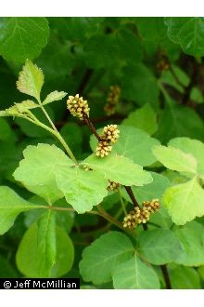](http://plants.usda.gov/java/largeImage?imageID=rhar4_012_avp.jpg)

Figure 1. Example of leaves and flowers of fragrant sumac. Photo by Jeff McMillian PLANTS Database website.

### Alternate Names

Aromatic sumac, lemon sumac, polecat sumac

### Uses: The fruit is an important winter food for birds, including turkeys, ruffed grouse, robins and flickers, and for various small mammals. The foliage is relatively unpalatable due to the high tannin content of the leaves. Fragrant sumac root was used by Native Americans to produce a yellow dye, and the berries in an acidic tasting beverage. The Cheyenne dried leaves of fragrant sumac and mixed them with tobacco, red willow dogwood and bearberry to make a smoking mixture. The leaves and bark were used for tanning leather because of the high tannin content of these plants. The Native American tribes also used the sumac’s astringent power to stop bleeding in all forms from wounds to hemorrhage after child birth. It may also be grown for landscape purposes and for its orange to red fall foliage color.

### Status

Please consult the PLANTS Web site and your State Department of Natural Resources for this plant’s current status (e.g., threatened or endangered species, state noxious status, and wetland indicator values).

### Description and Adaptation

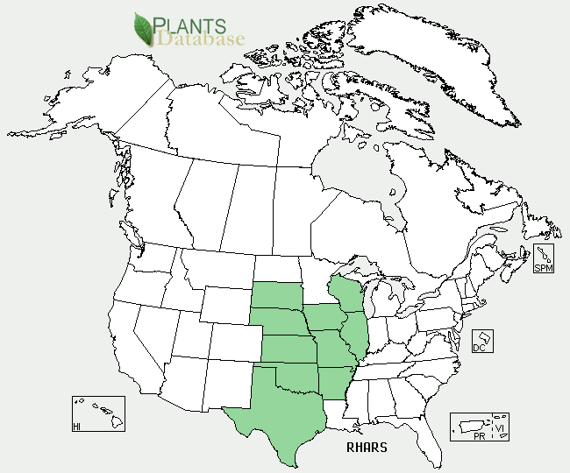

Figure . Fragrant sumac distribution from USDA-NRCS PLANTS Database.

**Description:** Fragrant sumac belongs to the Anacardiaceae family. A straggling to upright native shrub 6 to 8 feet tall rarely tree like in appearance. This shrub occurs singly or in dense thickets that may be connected by rhizomes. Root systems are deep and extensively branched. Plants are deciduous, woody, spreading, often forming clumps or thickets. Crown diameter often exceeds height and may be more that 30 feet across. Stems are numerous, woody, spreading, highly branched, and brown and pubescent when young, but develop a gray bloom with age. Leaves are 1 to 3 inches long, trifoliate, petiolate, and puberulant beneath. Leaves are alternate and compound with three leaflets which are variable in shape, lobing, and margins. Plants of fragrant sumac are polygamo-dioecious, thus functionally dioecious, but having a few perfect flowers on an otherwise staminate or pistillate plant. Flowers are yellow in small dense inflorescences on short lateral shoots, male (staminate) flowers in yellowish catkins, female (pistillate) flowers in bright yellow, short panicles at the branches ends. Fruits are orange red, sticky, berry like drupe containing a single bony seed. Leaves are fragrant or at least odorous.

**Adaptation:** Fragrant sumac grows in a range of sites including open rocky woodlands, valley bottoms, lower rocky slopes, and roadsides. The plants are hardy and can grow in sun or partial shade. It flowers in March to May, usually before the leaves expand, and produces densely hairy, drupe like fruits in June to August

For updated distribution, please consult the Plant Profile page for this species on the PLANTS Web site.

### Establishment

Fruits can be harvested in the summer and early fall. Fruit of *Rhus aromatic* is synchronous and does not support a staggered fruit ripening pattern. Fruits are collected by hand or by flailing the stems after leaf drop in the fall. Harvested seed are macerated and flushed with water to remove pulp and debris. The remaining materials, including the seeds, are dried and fanned to remove loose debris. There are approximately 20,000 cleaned seeds per pound. Recommended standards of seed for purchase is 40 percent germination and 95 percent purity. Cleaned seed can remain viable under cool, dry storage for up to five years. Seed germination is restricted by a hard impervious seed coat and embryo dormancy. Erratic seed germination is a factor in this shrub not being more extensively planted. Both forms of dormancy vary widely among seed lots. Seedcoat permeability may be increased by a 20 minute to 2 hour sulfuric acid scarification. A wet prechill for 30 to 120 days is required to release embryo dormancy. Embryo dormancy can also be broken in fragrant sumac by treatment with gibberellic acid (GA3) at 500 to 1000 parts per million (ppm) concentrations.

### Management

Seedlings grow moderately well, but young plants are not highly competitive with herbaceous plants. Scarified seed should be planted in the fall to provide a wet cool stratification period; scarified seed planted in the spring must have a cold, wet period or be treated with GA3. Seed should be planted at a ½ inch depth in a dry, course textured soil. Seeding rates of 2 to 4 pounds per acre are recommended depending on row spacing. It may be broadcast on rough surfaces or in pits. If drilled the seed should be planted with other slow growing shrub species that provide some distance from aggressive fast growing species. In the bareroot nursery trade seed should be planted ½ inch deep. A seeding density of 25 viable seed units per linear foot of row is recommended. Beds should be mulched to prevent excessive drying. Plants may be lifted as 1-0 or 2-0 stock, depending on their growth rate. Field transplanted seedlings should be at least 8 to 11 inches tall. Established seedlings are hardy and resilient.

### Pests and Potential Problems

The species is susceptible to vascular wilt caused by *Fusarium oxysporum.* A sumac feeding psyllid (*Calophya triozomiwa*) has been collected on fragrant sumac in many locations.

### Control

Please contact your local agricultural extension specialist or county weed specialist to learn what works best in your area and how to use it safely. Always read label and safety instructions for each control method. Trade names and control measures appear in this document only to provide specific information. USDA NRCS does not guarantee or warranty the products and control methods named, and other products may be equally effective.

### Cultivars, Improved, and Selected Materials (and area of origin)

Fragrant sumac can be found in the commercial nursery trade. ‘Konza’ is a 1980 release from the Manhattan Plant Materials Center in Manhattan, KS. Konza was a cooperative release with the Kansas Agricultural Experiment Station, Nebraska Agricultural Experiment Station, Nebraska Game and Parks Commission and the Kansas Fish and Game Commission. The original germplasm for the release was collected on a limestone breaks site south of Manhattan, KS. After initial evaluation and selection at the Manhattan PMC, it was field tested in Oklahoma, Nebraska, and Kansas for over 10 years. Konza proved to be superior in growth form, disease resistance, adaptability and wildlife cover potential over other similar standards of comparison.

### Prepared By Richard L. Wynia, USDA – NRCS Manhattan Plant Materials Center, Manhattan, KS.

### Citation

Wynia, R. 2011. Plant fact sheet for fragrant sumac (*Rhus aromatic* var. serotina*)*. USDA-Natural Resources Conservation Service, Plant Materials Center. Manhattan, KS.

Published March 2011

Edited:

For more information about this and other plants, please contact your local NRCS field office or Conservation District <<http://www.nrcs.usda.gov/>>, and visit the PLANTS Web site <[http://plants.usda.gov](http://plants.usda.gov/)> or the Plant Materials Program Web site <<http://plant-materials.nrcs.usda.gov>>