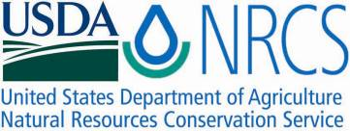

Plant Fact Sheet

# Golden Currant

## Ribes aureum Pursh var. villosum DC

Plant Symbol = RIAUV

Contributed by: USDA NRCS Manhattan Plant Materials Center

[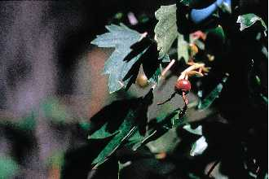](http://plants.usda.gov/java/largeImage?imageID=riod_005_ahp.tif)

Figure 1. Example of leaves and fruit on golden currant from the PLANTS Database website. Photo by D.E. Herman, USDA-NRCS Plants database.

### Alternate Names

Buffalo currant, fragrant golden currant, golden flowering currant, clove currant, wild currant, clove bush

### Uses

Golden currant has been widely planted for wildlife habitat, ground cover, watershed protection, and in conservation plantings. Golden currant is a highly preferred spring and midsummer browse for big game with only moderate summer and light fall grazing by big game animals. Golden currant is an excellent species for stabilization of roadways and other disturbances, particularly when transplanted stock is utilized. Both bare root and containerized plants will establish well on disturbed sites. Golden currant is also widely used for hedges, windbreaks and in conservation and landscape plantings. It is usually planted in combination with other woody species. This species is also planted in hedges or rows to provide berries for jam and jelly production. Some Native American tribes used currants for making pemmican; a high protein, high energy food made with meat, fat and fruit in a dry, edible form.

### Status

The golden currant is a widespread species that is the alternate host for the pine blister rust fungus; this has caused the species to be a target for eradication in areas where white pine is of economic and commercial value.

Please consult the PLANTS Web site and your State Department of Natural Resources for this plant’s current status (e.g., threatened or endangered species, state noxious status, and wetland indicator values).

### Description and Adaptation

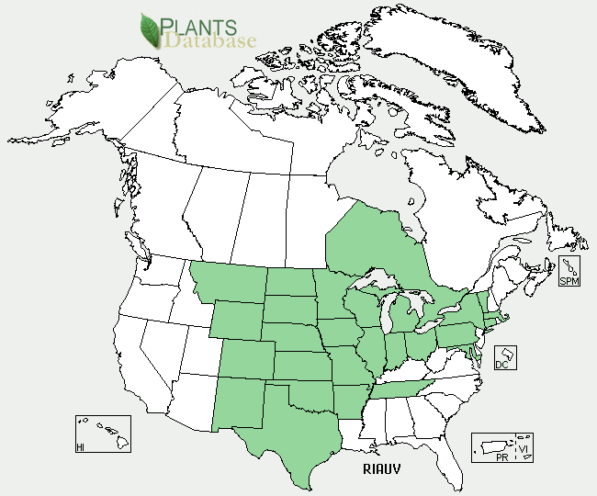

Figure . Golden currant distribution from USDA-NRCS PLANTS Database.

Golden currant belongs to the Grossulariaceae or currant family. Golden currant is an unarmed, irregularly shaped, multi-stemmed shrub 3 to 10 feet tall that spreads by suckering. The reddish bark of young twigs turns gray with age. Leaves are simple, alternate, deciduous, and petiolate. Leaf blades are ovate with a cuneate to chordate base, usually glaborous, and palmately three lobed with the lobes being entire, toothed, or lobed. In May, either before or as leaves appear, golden currant produces many racemes of ¾ to 1 inch long yellow tubular flowers that emit a pleasant clove or spicy odor. The cylindrical hypanthium consists of five spreading calyx lobes alternating with five shorter erect petals. The perfect flowers are initially golden yellow, but turn reddish with age. The edible fruit is a globose, glabrous, many seeded berry. Fruit colors vary from yellow, to red orange to black. The large fruit, up to ½ inch in diameter, is excellent for human and wildlife consumption. The minute embryo is embedded in a large amount of endosperm. Golden currant is generally not widely abundant, but it occurs as scattered plants, patches, and clumps in corridors along waterways and fence rows. It normally grows on fertile, well drained sites such as moist streambanks, washes, ditches, seeps and springs. While considered a species of moist sites, golden currant is also found on well-drained soils that only receive 16 inches of precipitation annually. Plants generally grow in full sun to partial shade on soils ranging from slightly acidic to slightly basic. Golden currant is moderately fire tolerant and recovers by resprouting or natural seeding. For updated distribution, please consult the Plant Profile page for this species on the PLANTS Web site

### Establishment

Fruits are hand harvested by stripping them from branches or by flailing them into containers as soon as they ripen. Few wild land stands are large enough to produce much seed. Collection of 100 pounds of fruit will only yield about 4 pounds of usable seed. Thus, seed collection costs are high and limit the use of this shrub in large scale plantings. Fruits are processed by maceration in water to separate the fruit pulp from the seed. Pulp and empty seeds are separated from sound seeds by floatation. There are 200,000 to 285,000 seeds per pound. Seed viability is normally quite high, usually in excess of 75 percent. Seed germination can be hastened and increased by a long period of cold, moist stratification. A wet prechill of 60 to 90 days at 28 to 36 degrees Fahrenheit (°F) is often sufficient to reduce embryo dormancy. Seeds retain good viability for 5 to 17 years if stored cool and dry in sealed containers.

### Management

Seeds should be fall planted to provide a cold, moist period for maximum germination. Seeds are small, round, and easily dispersed by most seeders. Golden currant can be seeded alone or more commonly in mixtures with other woody shrub and forb species. Seeds are usually sown at a rate of 0.25 to 2.0 pounds per acre depending on mixture components, method of seeding and row spacing.

In a nursery setting, seeds are usually sown at a rate of 60 to 80 seeds per square foot or 40 viable seed units per linear foot of row. Seed should be planted 0.25 inches deep on a firm, weed free seed bed. Adding mulch to the soils surface is recommended for nursery beds subject to rapid drying and crusting of the soil surface. Seeds that germinate often due so uniformly and initial emergence is usually very good even under range or wild land conditions. Compared with most shrubs, seedlings of golden currant are very persistent. Seedlings grow rapidly and generally attain heights of 6 to 12 inches the first year of growth. Seedlings of few other shrubs are as vigorous as this species.

Bareroot or containerized transplants can be quickly grown. Planting beds are normally thinned to the correct spacing and density. One year old transplants develop a dense, well branched root system, and field survival of 1-0 transplants is usually high. Transplants establish well on harsh disturbed sites due, in part to their well developed root system. Container stock is grown from seed or hardwood or softwood cuttings.

### Pests and Potential Problems

Currants are subject to defoliation by western tent caterpillars and they are the alternate host for white pine blister rust (*Cronartium ribicola*). A bacterial spot (*Pseudamonas syringae* pathovar *ribicola*) can cause severe defoliation of golden currant and necrotic spots to form on leaves, shoots and fruit.

### Control

Please contact your local agricultural extension specialist or county weed specialist to learn what works best in your area and how to use it safely. Always read label and safety instructions for each control method. Trade names and control measures appear in this document only to provide specific information. USDA NRCS does not guarantee or warranty the products and control methods named, and other products may be equally effective.

### Cultivars, Improved, and Selected Materials (and area of origin)

These plants are readily available from commercial sources. The cultivar ‘Crandall’ was discovered by R.W. Crandall of Newton, Kansas and introduced into commercial production by Frank Ford and Sons, Nursery, Ravenna, Ohio, in 1888. Fruit of this clone is mild, sweet, pleasant, and very different from European black currants. It performs well in hot summers, is resistant to white pine blister rust, and shows little or no damage from powdery mildew in Idaho and Oregon trials.

### Prepared By: Richard L. Wynia, USDA-NRCS Manhattan Plant Materials Center

### Citation

Wynia, R. 2011. Plant fact sheet for Golden Currant (*Ribes aureum)*. USDA-Natural Resources Conservation Service, Plant Materials Center, Manhattan, KS.

Published: March, 2011

Edited:

For more information about this and other plants, please contact your local NRCS field office or Conservation District <<http://www.nrcs.usda.gov/>>, and visit the PLANTS Web site <[http://plants.usda.gov](http://plants.usda.gov/)> or the Plant Materials Program Web site <<http://plant-materials.nrcs.usda.gov>>