|  |
| --- |
| bristly locust |
| *Robinia hispida* L. var. *fertilis* (Ashe) Clausen |
| Plant Symbol = ROHIF8 |

Contributed by: USDA NRCS Plant Materials Program

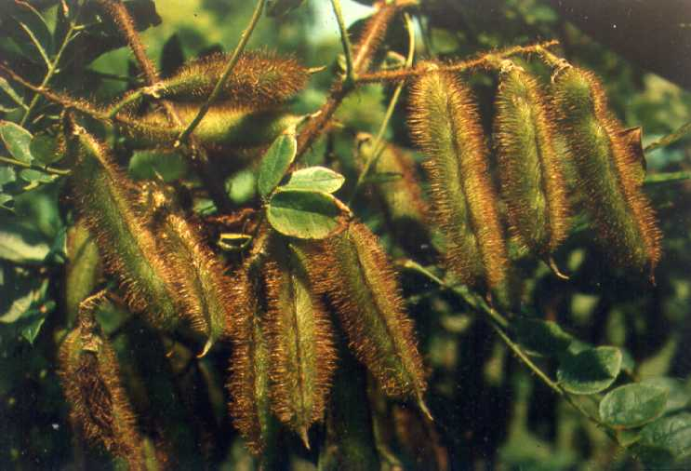

Charles B. Ford

Upper Darby, PA

Alternate Names

*Robinia fertilis* Ashe, *Robinia grandiflora* Ashe, *Robina pedunculata* Ashe

Uses

Bristly locust is perhaps the best erosion control shrub for steep sloping sites with active erosion. It provides quick, woody, vegetative cover on droughty, critical areas needing stabilizing cover. It is useful for vegetating acid soils with a pH of 3.5 to 4.0, as well as alkaline soils of a pH 8.0. Bristly locust is especially adapted to stabilizing soils with active rill and gully erosion. Rill erosion that exposes the roots stimulates root suckering there by creating a denser growth. Bristly locust is primarily used for surface mine spoil reclamation, industrial waste piles, roadbanks, cuts and fills, etc. In comparison with most other shrubs it will excel in seedling vigor. It has the ability to fix nitrogen in the soil, and with light shade it does not inhibit growth of annual and perennial herbs. Its value for wildlife food is minimal, but is a very attractive shrub when in bloom. It should not be used for residential plantings, or anywhere that formal landscaping is desired.

Bristly locust is used by the Maine Department of Transportation as living fence along major highways. The stems trap snow, improving public safety. Bristly locust winterkills above the snow line in USDA Hardiness Zones 4 and 3, which keeps the growth in check.

Status

Please consult the PLANTS Web site and your State Department of Natural Resources for this plant’s current status (e.g. threatened or endangered species, state noxious status, and wetland indicator values).

Description

Bristly locust is an open branched, straggly, woody legume of vigorous growth. It attains a height of 8 to 12 feet in a few years, but normally when planted on critical sites it will grow no taller than 6 to 7 feet. It spreads rapidly on some sites by root suckers, particularly those soils light in texture. Where herbaceous plants are dense, spreading is severely restricted. Spreading by seed is secondary to root suckers. There are 23,000 seeds per pound.

Numerous small leaflets comprise the compound leaf that occurs alternately on the bristle covered branches. The sweet pea-like rose colored flowers bloom in May and June. Flowering usually begins the second year. Seed is produced in the bristle covered pods that are 2 to 5 inches in length. Seeds are about 3/16 inch in size, dark brown, and very hard.

Root suckers may appear the first year, and the thicket forming growth habit will begin by the second year. Leaf litter accumulates early, and is held in place by the many small stems that develop from the roots.

Adaptation and Distribution

Bristly locust will grow throughout the Northeast. In the northern sections of Maine, New Hampshire, Vermont, and New York it may winterkill above the snow. Bristly locust grows best on silt loams and loamy soils with good drainage; however, it will tolerate soils that are moderately well drained. It will grow on acid soils as low as pH 3.5 but it thrives at a pH of 6.0 to 7.0.

For a current distribution map, please consult the Plant Profile page for this species on the PLANTS Website.

Establishment

Follow standard tree planting techniques. Planting stock should be 1 year old seedlings. Prepare holes large enough to take care of entire root system. Fertilizer is not required. Bristly locust responds to fertilizers high in phosphorous, such as Mag-Amp, particularly on acid sites.

Management

On steep eroded sites, plant 3 to 4 feet apart in the row, and space rows 4 to 6 feet apart. Spacing of 6 by 6 feet is satisfactory where quick cover is not essential.

Cultivars, Improved, and Selected Materials (and area of origin)

'Arnot' (NY) bristly locust was selected by the USDA NRCS Big Flats Plant Materials Center in New York. This variety is available as seedlings from both state and private nurseries. Seed is available from collectors in West Virginia, Pennsylvania, and New York.

Prepared By & Species Coordinator:

USDA NRCS Northeast Plant Materials Program

Edited: 05Feb2002 JLK; 060816 jsp

For more information about this and other plants, please contact your local NRCS field office or Conservation District, and visit the PLANTS Web site<<http://plants.usda.gov>> or the Plant Materials Program Web site <<http://Plant-Materials.nrcs.usda.gov>>

*The U.S. Department of Agriculture (USDA) prohibits discrimination in all its programs and activities on the basis of race, color, national origin, sex, religion, age, disability, political beliefs, sexual orientation, and marital or family status. (Not all prohibited bases apply to all programs.) Persons with disabilities who require alternative means for communication of program information (Braille, large print, audiotape, etc.) should contact USDA's* [*TARGET Center*](http://www.usda.gov/oo/target.htm) *at 202-720-2600 (voice and TDD).*

*To file a complaint of discrimination write USDA, Director, Office of Civil Rights, Room 326-W, Whitten Building, 14th and Independence Avenue, SW, Washington, DC 20250-9410 or call 202-720-5964 (voice or TDD). USDA is an equal opportunity provider and employer.*

*Read about* [*Civil Rights at the Natural Resources Convervation Service*](http://www.nrcs.usda.gov/about/civilrights/)*.*