|  |
| --- |
| Rugosa rose |
| *Rosa rugosa* Thunb. |
| Plant Symbol = RORU |

Contributed by: USDA NRCS New York State Office and New Jersey State Office

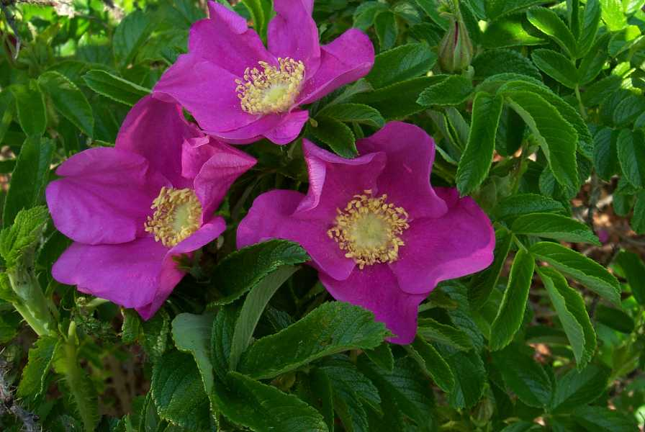

William Skaradek

USDA NRCS Cape May Plant Materials Center

Cape May Court House, New Jersey

Uses

Traditionally used for its beautification qualities, rugosa rose’s value as an erosion control type plant has recently expanded to include sand dune stabilization. Its ability to withstand salt spray makes it a good choice to plant on sand dunes and roadsides. With its thorny stems, this shrub can be strategically established at locations to direct pedestrians between the sand dunes. The ripe fruits (hips) this plant produces are high in vitamin C, and can be made into teas, jams and jellies. To a lesser degree, this species offers some food and cover to deer, and small birds and mammals.

Status

Please consult the PLANTS Web site and your State Department of Natural Resources for this plant’s current status (e.g. threatened or endangered species, state noxious status, and wetland indicator values).

Invasiveness

This plant is considered noxious in some states. This plant may be invasive in some regions or habitats and may displace desirable vegetation if not properly managed. Please consult with your local NRCS Field Office, Cooperative Extension Service office, or state natural resource or agriculture department regarding its status and use. Invasive information is also available from the PLANTS Web site at plants.usda.gov.

Description

This erect, many branched, introduced, leafy shrub will grow to a height of four or five feet. The deciduous compound leaves are dark green and lustrous. The stout stems are densely covered with fine thorns and develop colonies from underground stems after a few years. The two to three inch diameter flowers will range from white to purple. Single blooms emerge all summer long. The flowers give rise to tomato-like red hips which range in size from ½ inch to 1½ inch in diameter. Heavy fruiting usually begins the second year after establishment.

Adaptation and Distribution

Rugosa rose is a native of China, but has a wide range of adaptability. Its best performance is on sandy, light textured soils, but it will do well on medium textured soils. This rose will not tolerate poorly drained sites. It is well adapted to coastal environments.

Rugosa rose is distributed primarily throughout the Northeast. For a current distribution map, please consult the Plant Profile page for this species on the PLANTS Website.

Establishment

For successful establishment on roadbanks and sand dunes, vegetative establishment techniques are required. One year old bare-root seedlings or rooted cuttings are typically adequate for planting most sites; but where establishment is critical, container-grown 1 year old plants are recommended. All potentially competing vegetation should be removed or controlled prior to planting, unless it is critical to site stability.

For optimum nursery production, standard raised bed propagation techniques can be utilized. After soil temperatures reach the 40s in fall, but before dropping into the 30s, apply a maximum of 3 grams pure live seed (PLS) per square foot area of bed to attain adequate production of quality seedlings. For the over-winter period, these beds should be mulched. Time released fertilizers, applied in late spring, have yielded the best growth results under nursery environments. Hardwood cuttings harvested during the dormant season, placed in a heated bench, work well to start rooted cuttings.

Management

Periodic removal of older stems can improve the appearance of rugosa rose stands.

Environmental Concerns

There is some concern that this rose is becoming naturalized at the expense of native species. Where native roses occur in local stands, rugosa rose should be used with discretion.

Cultivars, Improved, and Selected Materials (and area of origin)

Many improved horticultural varieties are grown for beautification purposes. Only one cultivar has been selected and released specifically for use on sand dune stabilization. That cultivar is ‘Sandy’ (DE, MD, MA, NJ) which was released in 1992 by the Cape May PMC. ‘Sandy’ is a polycross of twelve separate collections. Foundation seed and seed orchard stock can be obtained by commercial nurseries from the Cape May PMC. This released conservation variety and others are available from various commercial nurseries for use by the public.

##### Control

Please contact your local agricultural extension specialist or county weed specialist to learn what works best in your area and how to use it safely. Always read label and safety instructions for each control method. Trade names and control measures appear in this document only to provide specific information. USDA, NRCS does not guarantee or warranty the products and control methods named, and other products may be equally effective.

Prepared By & Species Coordinators:

##### *John Dickerson* (retired), USDA NRCS New York State Office, Syracuse, New York

*Chris Miller*, Mid Atlantic Plant Materials Specialist

USDA NRCS New Jersey State Office, Somerset, New Jersey

Edited: 13May2002 JLK; 060809 jsp

For more information about this and other plants, please contact your local NRCS field office or Conservation District, and visit the PLANTS Web site<<http://plants.usda.gov>> or the Plant Materials Program Web site <<http://Plant-Materials.nrcs.usda.gov>>

*The U.S. Department of Agriculture (USDA) prohibits discrimination in all its programs and activities on the basis of race, color, national origin, sex, religion, age, disability, political beliefs, sexual orientation, and marital or family status. (Not all prohibited bases apply to all programs.) Persons with disabilities who require alternative means for communication of program information (Braille, large print, audiotape, etc.) should contact USDA's* [*TARGET Center*](http://www.usda.gov/oo/target.htm) *at 202-720-2600 (voice and TDD).*

*To file a complaint of discrimination write USDA, Director, Office of Civil Rights, Room 326-W, Whitten Building, 14th and Independence Avenue, SW, Washington, DC 20250-9410 or call 202-720-5964 (voice or TDD). USDA is an equal opportunity provider and employer.*

*Read about* [*Civil Rights at the Natural Resources Convervation Service*](http://www.nrcs.usda.gov/about/civilrights/)*.*