

Plant Fact Sheet

# Pitcher Sage

*Salvia azurea* Michx. ex Lam. var. *grandiflora* Benth.

Plant Symbol = SAAZG

Contributed by: USDA NRCS Plant Materials Center Manhattan, Kansas

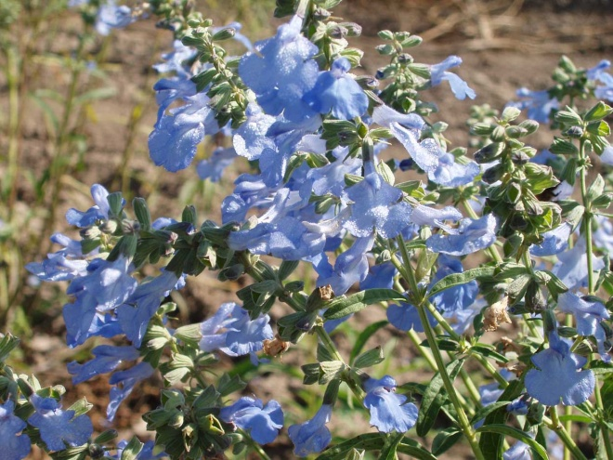

Alan Shadow, East Texas Plant Materials Center, Nacogdoches, Texas.

Alternate Names

azure blue sage, blue salvia, blue sage, pitcher salvia, and wild blue sage

Uses

Pitcher sage is a readily eaten forb, which is especially sought out by livestock in the early spring when protein levels are high and palatability is good. Pitcher sage numbers will decrease in native pastures that are over grazed or over stocked with livestock. The flowers, which are deep blue and attractive to pollinators such as bumble bees and hummingbirds, have a persistent, long bloom period late into the fall when little else is blooming. The plants are also attractive to migrating monarch butterflies and other insects.

Status

Please consult the PLANTS Web site and your State Department of Natural Resources for this plant’s current status (e.g. threatened or endangered species, state noxious status, and wetland indicator values).

Description and Adaptation

*General:* The Mint family (Lamiaceae). Pitcher sage is a long-lived, warm-season, herbaceous, native perennial species. The common name Pitcher sage comes from the name of Doctor Zina Pitcher, a 19th century U.S. Army field surgeon and amateur botanist. Each plant has one major stem or a few stems growing in a clump. It grows from 2 to 5 feet tall and the foliage is gray-green. The root system is branched and grows up to 8 feet deep. John Weaver, prairie ecologist, reported that pitcher sage could double its rooting depth as a response to extreme drought. Each stem is simple or may be branched near its terminal point. The stems, like those of many other mints, are square in cross section with opposite leaves. The foliage has a mint fragrance, but is much milder than many of the members of the mint family. The leaves are lance shaped and three to four inches long on the lower stem and become smaller as they ascend the stem. Lower leaves can be shed early in the growing season.

Pitcher sage begins blooming in July and may bloom until early October. Light blue two-lipped flowers are borne in a series of dense clusters with 2 to 8 flowers in a cluster. Only a few flowers in a cluster are in bloom at any one time. The flower corollas are 1/2 to 1 inch in length. The enlarged, drooping lower lip of the flower is covered at the base by a short, stiff, upper lip or hood. A bee will land on the lower lip and force its way under the hood to reach the nectar glands at the base of the flower tube. As is common in other species of flowers, the anthers mature before the stigma is receptive to pollen, thus ensuring cross fertilization. The pollen bearing anther is on one end of a slender filament and a sterile anther is located on the other end. When the bee enters the flower tube, its head will push on the sterile anther. The filament, just like a seesaw, will pivot and dust the bees back with pollen from the fertile anther. The bee then visits other flowers, that are more mature, and pollinates a receptive stigma completing the act of cross pollination. The resulting fruits consist of one or two light brown, resin-dotted nutlets borne at the bottom of the persistent calyx tube. The nutletts are elliptical, flattened and approximately 1/8 inch long.

*Adaptation*: Pitcher sageis easy to grow in a wide range of soil types that have dry to medium amounts of moisture. It prefers sandy to gravelly soils, and the number one consideration is for soils to be well drained, otherwise the roots are subject to root rot. This species tolerates heat, humidity and drought very well. Full sun is required for this plant to thrive, but some shade is tolerated. A study conducted in central Nebraska found that *Ratibida pinnata* and *Salvia azurea* had the highest survival rating of 16 wildflowers planted in blue grama and buffalo grass plots after ten years.

*Distribution*: Please consult the Plant Profile page for this species on the PLANTS Web site. Pitcher sage grows in the eastern 3/4 of Kansas. This species is also found in parts of Oklahoma, Nebraska, Missouri and the panhandle of Texas. The species ranges east to South Carolina and Florida.

Establishment

Unstratified seed can be planted in the fall or stratified seed can be planted in the field in the spring. With no cold, moist stratification approximately 40 percent of the seed will germinate. Pretreatment of cold, moist stratification for 4 to 8 weeks will increase total germination to around 80 percent.

Management

When *Salvia azurea* is grown without competition, in a monoculture for seed production, it tends to become taller than it should and sprawl out or lodges. This leads to what some describe as a disorderly plant. However, moderate clipping early in the growing season will allow the plant to maintain a better, more upright form. This plant flowers over an extended period of time which makes it good for landscape purposes, but bad when trying to time a seed production harvest. With a protracted flowering season the plant will contain all stages of seed maturity at the same time making harvest more difficult.

Pests and Potential Problems

There are no serious insect or disease problems of any consequence with this member of the Lamiaceae family. However, rust and leaf spots can occur on the foliage. It does tend to grow tall and will lodge under certain circumstances.

Environmental Concerns

There are no real environmental concerns regarding this plant species. It is commonly used in prairie restoration plantings where it is not considered a weed problem. Pitcher sage is known to volunteer from seed, but does not spread aggressively.

Cultivars, Improved, and Selected Materials (and area of origin)

‘Nekan’ Pitcher Sage is a cooperative release by USDA-NRCS; Manhattan Plant Materials Center in Manhattan, KS and the Nebraska Agriculture Experiment Station in Lincoln, NE. Initial evaluation of accessions from Kansas, Nebraska, and South Dakota revealed that the accession from Marion County, Kansas had overall better performance and was selected for further evaluation. This selection was tested as PMK-1408 and was rated excellent for vigor and stand establishment. Growth of PMK-1408 was uniform with respect to plant height and spread. It was released and named ‘Nekan’ in 1977 and is commercially available in the wildflower seed trade.

Prepared By and Species Coordinator:

*Richard Wynia*, USDA NRCS Manhattan Plant Materials Center, Manhattan, KS

### Citation

Wynia, R. 2009. Plant fact sheet for pitcher sage (*Salvia azurea* Michx. ex Lam. var. *grandiflora* Benth). USDA-Natural Resources Conservation Service, Kansas Plant Materials Center, Manhattan, Kansas 66502

Published March, 2009

Edited: 090226 jsp

For more information about this and other plants, please contact your local NRCS field office or Conservation District <<http://www.nrcs.usda.gov/>>, and visit the PLANTS Web site <[http://plants.usda.gov](http://plants.usda.gov/)> or the Plant Materials Program Web site <<http://plant-materials.nrcs.usda.gov>>

**USDA IS AN EQUAL OPPORTUNITY PROVIDER AND EMPLOYER**