|  |
| --- |
| dwarf willow |
| *Salix x cotteti* Kerner |
| Plant Symbol = SACO28 |

Contributed by: USDA NRCS Plant Materials Program

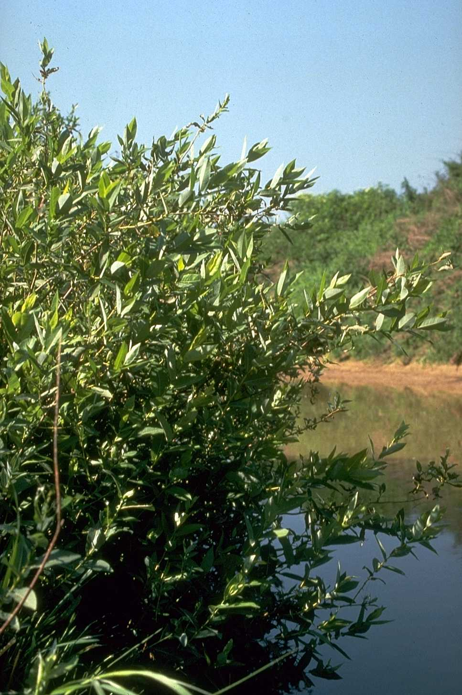

USDA NRCS National Plant Materials Center

Beltsville, MD

Alternative Names

Cottet willow

Uses

Dwarf willow is recommended for erosion control plantings along small stream channels. It can be incorporated into soil bioengineering systems to control erosion along streambanks resulting from flood and ice damage. Fast growth, resilient stems, and ability to recover from mechanical damage make it an ideal plant for this use. When used in this manner, it provides cover for small animals and browse for deer, beaver, and rabbits and exceptional nesting sites for birds.

This willow is also suitable for use as a living snow fence and/or a farmstead windbreak where moisture is adequate.

Status

Please consult the PLANTS Web site and your State Department of Natural Resources for this plant’s current status (e.g. threatened or endangered species, state noxious status, and wetland indicator values).

Description

Dwarf willow is a small to medium sized shrub growing only 6 to 8 feet high, with smooth, slender, tough, resilient branches that are lime green at first but later change to a darker green. The cultivar, ‘Bankers’ was introduced from the alpine region of West Germany in the mid-1960s. This selection is a natural hybrid between *Salix retusa* L. and *Salix myrsinifolia* Salisb. It is a sterile hybrid, therefore it produces no seed.

‘Bankers’ is a semiprostrate shrub, sending up many branches from the roots to form a dense surface cover. The roots themselves form an interlocking network to tie the soil together. It rarely spreads by layering of branches. Growth is rapid from cuttings, with plants reaching full height in 3 to 5 years. Plantings made on 2-foot centers can produce solid stands in 2 to 3 years.

Adaptation and Distribution

Dwarf willow grows best on moist sites that are subject to periodic flooding and overflow. It can be used on soils of any texture. Dwarf willow competes well with herbaceous plants that are less than 2 feet tall. The cultivar ‘Bankers’ is climatically adapted throughout the Appalachian region from New York to Alabama, and has also been used successfully in Oregon and Washington west of the Cascade Range.

For a current distribution map, please consult the Plant Profile page for this species on the PLANTS Website.

Establishment

Dwarf willow is susceptible to severe browsing by livestock and cannot be established without protection. Banks that are eroded and undercut to a steep unplantable slope require grading prior to planting.

*Cuttings*: Plant as one year old rooted cuttings, or dormant hardwood cuttings. If dormant cuttings are used, they should be 3/8 to 1/2 inch at the thick end, 12 to 15 inches long, and made before the leaves emerge. Dormant cuttings should be planted vertically with only an inch or two protruding. If they cannot be pushed in the soil by hand, use a rod to make a hole but be sure the cutting is tamped in well with the heel to avoid leaving any air spaces. If the soil is too stony to for this technique, the cutting may be buried horizontally about two inches deep in damp soil. Rooted cuttings should be planted in a hole dug big enough to accommodate the root system when well-spread. On difficult streambanks, it is sometimes necessary to mulch the planting with coarse plant material, even wiring and staking the mulch down in some cases. Plant at two to three foot spacing from just above water's edge or rip-rap, to the top of the bank.

*Soil Bioengineering Uses*: Dormant whips are very useful when bundled into wattles (live fascines) or for brush layering and mattressing systems. ‘Bankers' willow can be produced in the nursery to specification to meet all the above uses. Planting methods for soil bioengineering are regionally varied. Consult with the Plant Materials Specialist for planting recommendations.

Management

Dwarf willow used on streambanks is subject to considerable mechanical damage. The site should be inspected annually in spring, after heavy run-off has subsided, for needed repairs. Gaps should be filled in by replanting, or laying down and covering branches of nearby plants. Any mechanical measures used to control the bank, such as stone rip-rap, must be kept in repair as well.

Pests and Potential Problems

There are no serious pests or diseases of dwarf willow.

Cultivars, Improved, and Selected Materials (and area of origin)

A variety of dwarf willow, 'Bankers' (Germany), was released by the Quicksand, Kentucky Plant Materials Center in 1983. Rooted and unrooted cuttings, whips, and wattles can be purchased from a variety of nurseries in the Northeast.

Prepared By & Species Coordinator:

USDA NRCS Northeast Plant Materials Program

Edited: 05Feb2002 JLK; 060817 jsp

For more information about this and other plants, please contact your local NRCS field office or Conservation District, and visit the PLANTS Web site<<http://plants.usda.gov>> or the Plant Materials Program Web site <<http://Plant-Materials.nrcs.usda.gov>>

*The U.S. Department of Agriculture (USDA) prohibits discrimination in all its programs and activities on the basis of race, color, national origin, sex, religion, age, disability, political beliefs, sexual orientation, and marital or family status. (Not all prohibited bases apply to all programs.) Persons with disabilities who require alternative means for communication of program information (Braille, large print, audiotape, etc.) should contact USDA's* [*TARGET Center*](http://www.usda.gov/oo/target.htm) *at 202-720-2600 (voice and TDD).*

*To file a complaint of discrimination write USDA, Director, Office of Civil Rights, Room 326-W, Whitten Building, 14th and Independence Avenue, SW, Washington, DC 20250-9410 or call 202-720-5964 (voice or TDD). USDA is an equal opportunity provider and employer.*

*Read about* [*Civil Rights at the Natural Resources Convervation Service*](http://www.nrcs.usda.gov/about/civilrights/)*.*