|  |
| --- |
| sandbar willow |
| *Salix interior* Rowlee |
| Plant Symbol = SAIN3 |

Contributed by: USDA NRCS Plant Materials Program

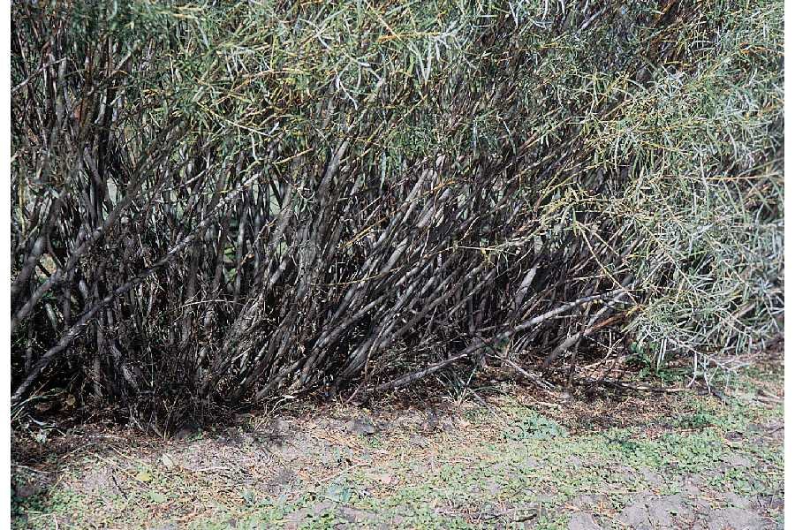

Herman, D.E., et al. 1996. *North Dakota tree handbook*. USDA NRCS ND State Soil Conservation Committee

Alternate Names

narrowleaf willow

Uses

Erosion control: Sandbar willow is used for streambank and lake shore stabilization and riparian area development or restoration. It is recommended for deep wet lowland, overflow areas, wet meadow sites, streambanks, lake shores, and other areas with a high water table.

Wildlife: This plant is provides wood and shelter for many game birds and forage for deer.

Status

Please consult the PLANTS Web site and your State Department of Natural Resources for this plant’s current status (e.g. threatened or endangered species, state noxious status, and wetland indicator values).

Weediness

This plant may become weedy or invasive in some regions or habitats and may displace desirable vegetation if not properly managed. Please consult with your local NRCS Field Office, Cooperative Extension Service office, or state natural resource or agriculture department regarding its status and use. Weed information is also available from the PLANTS Web site at plants.usda.gov.

Description

*Salix interior*.*,* sandbar willow, is a common native suckering shrub 3 to 20 feet high found throughout the Northern Great Plains and the Northeast US. It quickly forms thickets on sand or gravel deposits along streams, roadside ditches, sloughs, and other places frequent to flooding. Branchlets are reddish brown, smooth or nearly so. Leaves are 2 to 5 inches long, narrowly lance-shaped, and pointed at both ends, with margins that have shallow, widely spaced teeth; they are green and smooth on both surfaces or sometimes silvery-silky. Leafstalks are very short and stipules, if present, are very small. This shrub is dioecious, so male and female flowers are produced by separate plants.

Sandbar willow leaves are very narrow with serrated leaf edges. The leaf edges of purpleosier willow are not serrated, and the leaf width is greater. Also, purpleosier willow does not form thickets.

Note: sandbar willow is an aggressive spreader and this should be considered when selecting materials for a given site. It can spread off of the streambank to other sites under favorable circumstances.

Adaptation and Distribution

Sandbar willow is adapted to sandy soils in stream, river, and shoreline sites, it is not well adapted to other sites.

Sandbar willow is distributed primarily throughout the West. For a current distribution map, please consult the Plant Profile page for this species on the PLANTS Website.

Establishment

Planting 1-0 rooted cuttings or unrooted cuttings are both effective planting methods. The un-rooted cuttings should be used where moisture conditions are good. On droughty sites, the rooted cuttings are preferred. Plant rooted cuttings using techniques that are common to bare root seedlings. Un-rooted cuttings should be at least 12 inches long, with the lower 10 inches buried vertically in the sand. Plant spacing of 2x2 to 4x4 works well.

Sandbar willow is also planted in soil bioengineering systems. It should be planted in mixtures with other species such as ‘Streamco’ and ‘Bankers’ willows and ‘Ruby’ dogwood for live fascines, brush layers and brush mattress.

Under-seeding with a cool season grass mixture is recommended.

Management

Once sandbar willow is planted, it requires little care. Blowouts along the stream should be addressed when they occur and repaired.

Pests and Potential Problems

This willow is susceptible to twig cankers, tar spot, aphids, willow galls, and scale insects.

Cultivars, Improved, and Selected Materials (and area of origin)

**‘**Greenbank’ is the only Northeastern cultivar. It was released for commercial production by the Big Flats PMC in 1996. ‘Greenbank’ is a male clone. It was selected from field testing of several clones, and provided stronger growth over a wide range of conditions.

The cultivar ‘Silver Sands’ was released by the Bismarck (ND) PMC for use in the Northern Great Plains.

Prepared By & Species Coordinator:

USDA NRCS Northeast Plant Materials Program

Edited: 05Feb2002 JLK; 060817 jsp; 090309 jsp

For more information about this and other plants, please contact your local NRCS field office or Conservation District, and visit the PLANTS Web site<<http://plants.usda.gov>> or the Plant Materials Program Web site <<http://Plant-Materials.nrcs.usda.gov>>

*The U.S. Department of Agriculture (USDA) prohibits discrimination in all its programs and activities on the basis of race, color, national origin, sex, religion, age, disability, political beliefs, sexual orientation, and marital or family status. (Not all prohibited bases apply to all programs.) Persons with disabilities who require alternative means for communication of program information (Braille, large print, audiotape, etc.) should contact USDA's* [*TARGET Center*](http://www.usda.gov/oo/target.htm) *at 202-720-2600 (voice and TDD).*

*To file a complaint of discrimination write USDA, Director, Office of Civil Rights, Room 326-W, Whitten Building, 14th and Independence Avenue, SW, Washington, DC 20250-9410 or call 202-720-5964 (voice or TDD). USDA is an equal opportunity provider and employer.*

*Read about* [*Civil Rights at the Natural Resources Convervation Service*](http://www.nrcs.usda.gov/about/civilrights/)*.*