

Plant Fact Sheet

# AMERICAN ELDER

## Sambucus nigra L. ssp. canadensis (L.) R. Bolli

Plant Symbol = SANIC4

Contributed by: USDA NRCS Plant Materials Program

**Robert H. Mohlenbrock
USDA, NRCS 1989
Midwest Wetland Flora
@USDA NRCS PLANTS
** Robert H. Mohlenbrock

USDA, NRCS 1989

Midwest Wetland Flora

@USDA NRCS PLANTS

**Warning: New growth of American elder contains a glucoside than can be fatal to livestock.**

**Alternate Names**

*Sambucus canadensis* L., common elderberry

#### **Uses**

At least 50 species of songbirds, upland game birds, and small mammals relish the fruit of American elder during summer and early fall. White-tailed deer browse the twigs, foliage and fruit during the summer. American elder is outstanding as nesting cover for small birds. During summer, the partial shade under American elder promotes a dense ground cover of grasses and forbs that offers good loafing or feeding areas for broods of young pheasants and quail.

American elder can be used for erosion control on moist sites. It pioneers on some strip-mine spoils and may occasionally be useful for reclamation planting.

It is very decorative when in bloom; elder flowers later than most shrubs. Elderberries are also attractive to makers of pies, jellies and wine.

Status

Please consult the PLANTS Web site and your State Department of Natural Resources for this plant’s current status (e.g. threatened or endangered species, state noxious status, and wetland indicator values).

#### **Description and Adaptation**

The American elder is an erect, thicket-forming, somewhat woody shrub, 4-12 feet tall, with smooth yellowish-gray branchlets and white pith. Compound leaves are set oppositely in pairs in a feather-like arrangement. The leaf surface is bright green. The oval to lance-shaped leaflets are up to 6" long and 2 1/2" wide, with finely serrated margins. They are abruptly narrowed at the tip and lopsidedly narrowed or rounded at the base. Leaflets are usually held on short stalks; the terminal leaflet is on a longer stalk.

Numerous 1/4" fragrant white flowers emerge from late June into August. The terminal clusters of flowers, measuring 4"-10" across, are broad, flat or slightly rounded and long-stalked. Flowers usually develop in the second-year on older canes, and are arranged in branched clusters of 5.

Fruits ripen from late July into September. They are round, slightly bitter, edible purple-black berries with crimson juice. Each is less than 1/4" across, borne in large clusters. Each berry contains 3-5 small seeds. Seed dispersal occurs from July to October, usually through vigorous ingestion by birds and mammals. There are about 230,000 seeds per pound.

American elder occupies well-drained, slightly acid soil bordering streams, and in the adjacent bottomlands, but also grows on gray forest soils and muck. This shrub is widespread and abundant. American elder grows best in full sunlight. Once established, elders soon outdistance herbaceous competition. Thickets of elder are replaced by more shade-tolerant species during the later stages of forest succession, but individual plants and small runners will persist under a forest canopy.

American elder is distributed primarily throughout the eastern and Midwestern United States.

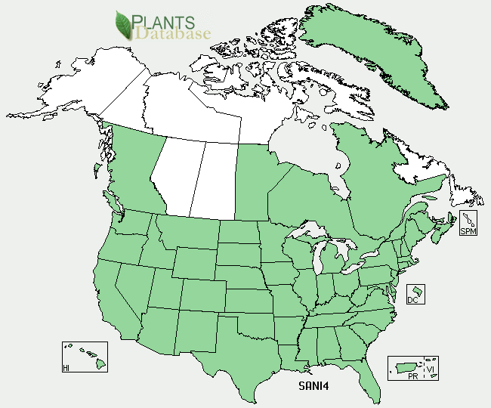

Common Elderberry distribution from USDA-NRCS PLANTS Database.

For updated distribution, please consult the Plant Profile page for this species on the PLANTS Web site.

#### **Establishment**

American elder naturally reproduces from seeds, sprouts, layers, and root suckers. Variable degrees of hard-seediness and embryo dormancy are exhibited. Prior to spring or fall planting, the seed should be scarified with sulfuric acid, also stratification at 36-40 degrees F for two months is required for spring planting. Seedling growth is rather slow during the first year.

Elders can also be propagated from 10” to 18” hardwood cuttings taken from vigorous one-year-old canes, each must include three sets of buds. Cuttings may be taken while dormant, placed in moist peat or sphagnum moss, and held in cold storage at approximately 40 degrees F for spring planting. One-year-old seedlings or rooted cuttings are usually large enough for field planting.

#### **Management**

Mulching around each plant will improve seedling survival. Annual pruning will considerably improve fruit yield. Removal of terminal shoots and dead canes will reduce winter-kill and help control elder borers.

#### **Cultivars, Improved, and Selected Materials (and area of origin)**

Seedlings or rooted cuttings are available commercially. Horticultural selections or local and regional ecotypes are marketed by nurseries. Vintage Germplasm was released through the USDA-NRCS Plant Materials Program in 2010. Vintage Germplasm is a selected class release that was evaluated for characteristics important to conservation uses, including stem production, plant height, fruit production and ability to regrow after cutting.

#### **Prepared By**

USDA NRCS Northeast Plant Materials Program

**Citation:**

Peterson, S, 2006. Plant Fact Sheet for American elder (Sambucus nigra L. ssp canadensis (L.) R. Bolli. USDA-Natural Resources Conservation Service PLANTS database, Baton Rouge, LA.

Published: February, 2002

Edited: 05Feb2002 JLK; 02 Sep2010 JWL, 060817 JSP

For more information about this and other plants, please contact your local NRCS field office or Conservation District <<http://www.nrcs.usda.gov/>>, and visit the PLANTS Web site <[http://plants.usda.gov](http://plants.usda.gov/)> or the Plant Materials Program Web site <<http://plant-materials.nrcs.usda.gov>>

**USDA IS AN EQUAL OPPORTUNITY PROVIDER AND EMPLOYER**