|  |
| --- |
| purpleosier willow |
| *Salix purpurea* L. |
| Plant Symbol = SAPU2 |

Contributed by: USDA NRCS New York State Office

Uses

Purpleosier willow is used extensively in soil bioengineering systems and to control erosion along streambanks resulting from flood and ice damage. Its fast growth, resilient stems, and ability to recover from mechanical damage make it an ideal plant for this use. When used in this manner, it provides cover for small animals and browse for deer, beaver and rabbits and exceptional nesting sites for birds. The whips are useful in vineyards for tying up grapevines and also for basket making. This species was brought to North America by the Europeans and grown for these purposes.

Status

Please consult the PLANTS Web site and your State Department of Natural Resources for this plant’s current status (e.g. threatened or endangered species, state noxious status, and wetland indicator values).

Description

Purpleosier willow is a medium to tall introduced shrub growing 10 to 20 feet high, with smooth, slender, tough, resilient branches, purplish at first but later changing to gray or olive-gray. The leaves arise in pairs but not quite oppositely, are smooth tongue-shaped, finely-toothed near the tip only, 2 to 4 inches long, bluish-green above and pale below. The catkins are small, arise in almost opposite pairs, and mature in spring before the leaves come out. Male and female flowers are borne on separate plants. Purpleosier willow is a solitary shrub, sending up many branches from the base. Growth is rapid, reaching from 2 to 8 feet in two years; often to full height of 15-20 feet in five years. On nutrient-rich sites it can grow to 25 feet.

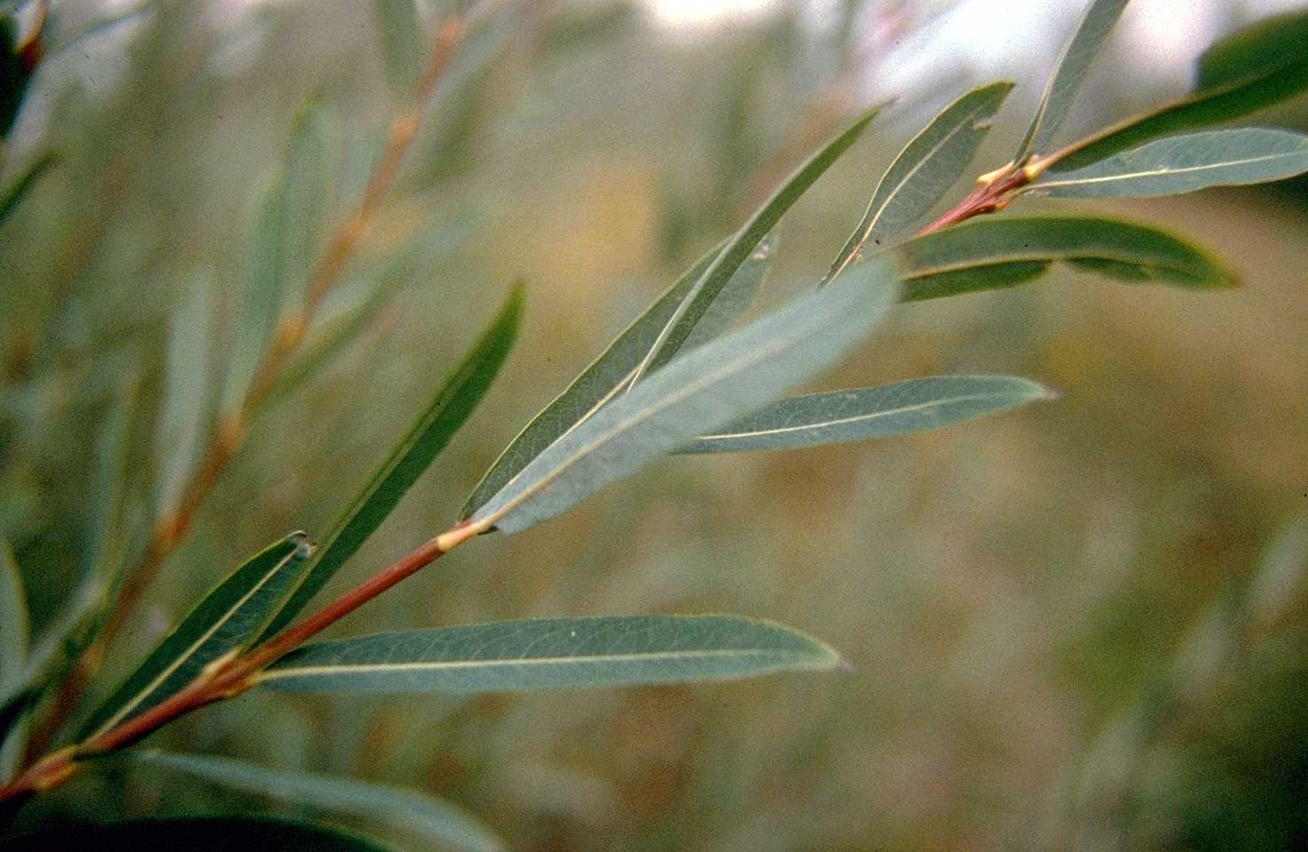

Martin van der Grinten

Big Flats Plant Materials Center

Big Flats, New York

Adaptation and Distribution

Purpleosier willow is climatically adapted to all the northeastern states. Well-drained to imperfectly-drained soils are most suitable for this species. It can be used on soils of any texture, but makes best growth on silt loams.

Purpleosier willow is distributed primarily throughout the Northeast. For a current distribution map, please consult the Plant Profile page for this species on the PLANTS Website.

Establishment

Purpleosier willow is susceptible to severe browsing by livestock and cannot be established without protection. Banks that are eroded and undercut to a steep unplantable slope require grading prior to planting.

*Cuttings:* Plant as one year old rooted cuttings, or dormant hardwood cuttings. If dormant cuttings are used, they should be 3/8 to 1/2 inch at the thick end, 12 to 15 inches long, and made before the leaves emerge. Dormant cuttings should be planted vertically with only an inch or two protruding. If they cannot be pushed in the soil by hand, use a rod to make a hole but be sure the cutting is tamped in well with the heel to avoid leaving any air spaces. If the soil is too stony to for this technique, the cutting may be buried horizontally about one inch deep in damp soil. Rooted cuttings should be planted in a hole dug big enough to accommodate the root system when well-spread. On difficult streambanks, it is sometimes necessary to mulch the planting with coarse plant material, even wiring and staking the mulch down in some cases. Plant at 2 to 3 foot spacing from just above water's edge or rip-rap, to the top of the bank.

*Soil Bioengineering Uses*: 'Streamco' purpleosier willow is the premier source of materials for these practices. 'Streamco' provides the best combination of growth, stem density, flexibility, and toughness of any willow tested for these uses. Dormant whips are very useful when bundled into wattles (live fascines) or for brush layering and mattressing systems. Stem sections work well in live staking systems, and larger diameter (1 1/2-2 inches) older stems are useful in pole applications. ‘Streamco’ willow can be produced in the nursery to specification to meet all the above uses. Planting methods for soil bioengineering are regionally varied. Consult with the Plant Materials Specialist for planting recommendations. Other species can be added to plantings of "Streamco' to create diversity.

Living Snow Fence 'Streamco' willow is an excellent choice for creating living snow fence due to its stem density. With Streamco, a single row snow fence will begin to trap snow in the second year, and become very effective in three to four years.

Management

Purpleosier willow used on streambanks may experience mechanical damage. The site should be inspected annually in spring, after heavy run-off has subsided, for needed repairs. Gaps should be filled in by replanting, or laying down and covering branches of nearby plants. Any mechanical measures used to protect the bank toe, such as stone rip-rap, must be kept in repair as well.

Pests and Potential Problems

Purpleosier willow is relished by livestock and planting sites must be protected for this reason. Beaver can also have a big impact on this species. Gypsy moths will defoliate purpleosier willow, and twig galls are created from attacks by willow midges, however these attacks are not fatal. The most severe pest is willow blight which is a fatal disease complex brought on by two fungi affecting leaves and stems.

Fungicides and cultural management can be used to combat this disease. Purpleosier willow plants that have been damaged by summer hailstorms are prime candidates for willow blight.

Cultivars, Improved, and Selected Materials (and area of origin)

A cultivar of purpleosier willow, ‘Streamco,’ was released by the Big Flats Plant Materials Center in 1975. ‘Streamco’ is a male clone and does not root sucker, so it does not spread. Rooted and unrooted cuttings, whips, branches, live stakes, and wattles can be purchased from a variety of nurseries in the Northeast.

Prepared By & Species Coordinator:

*John Dickerson* (retired), USDA NRCS New York State Office, Syracuse, New York

Edited: 05Feb2002 JLK; 060817 jsp

For more information about this and other plants, please contact your local NRCS field office or Conservation District, and visit the PLANTS Web site<<http://plants.usda.gov>> or the Plant Materials Program Web site <<http://Plant-Materials.nrcs.usda.gov>>

*The U.S. Department of Agriculture (USDA) prohibits discrimination in all its programs and activities on the basis of race, color, national origin, sex, religion, age, disability, political beliefs, sexual orientation, and marital or family status. (Not all prohibited bases apply to all programs.) Persons with disabilities who require alternative means for communication of program information (Braille, large print, audiotape, etc.) should contact USDA's* [*TARGET Center*](http://www.usda.gov/oo/target.htm) *at 202-720-2600 (voice and TDD).*

*To file a complaint of discrimination write USDA, Director, Office of Civil Rights, Room 326-W, Whitten Building, 14th and Independence Avenue, SW, Washington, DC 20250-9410 or call 202-720-5964 (voice or TDD). USDA is an equal opportunity provider and employer.*

*Read about* [*Civil Rights at the Natural Resources Convervation Service*](http://www.nrcs.usda.gov/about/civilrights/)*.*