|  |
| --- |
| Gulf bluestem |
| *Schizachyrium maritimum* (Chapman) Nash |
| Plant symbol = SCMA3 |

Contributed by: USDA NRCS Golden Meadow Plant Materials Center, Galliano, Louisiana

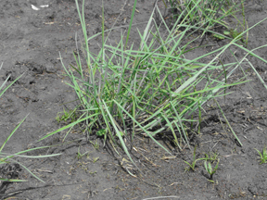

Photo provided by Gary Fine, NRCS ACES Program

Alternate Names

Seacoast bluestem; *Andropogon maritimus*

Uses

Conservation plant material for coastal beach dune enhancement and stabilization. Habitat for small mammals, shorebirds, and migratory birds.

Status

This species is ranked on the Rare, Threatened, and Endangered Species state heritage conservation status lists in Alabama and Louisiana as an S1 (extensive rarity and factors which make it especially vulnerable to extirpation), and a global ranking by NatureServe.org of G3 (very rare and local throughout its range).

Please consult the PLANTS Web site and your State Department of Natural Resources for this plant’s current status (e.g. threatened or endangered species, state noxious status, and wetland indicator values).

**Description**

Gulf bluestem is a native, warm-season, perennial grass that spreads by seed and short rhizomes. Plants are rhizomatous and colonial, stems usually decumbent, glaucous, reddish, and flattened at the base, terminal inflorescences with stalked spikelets. Found native to coastal and offshore islands of the Florida panhandle west to Louisiana.

Adaptation

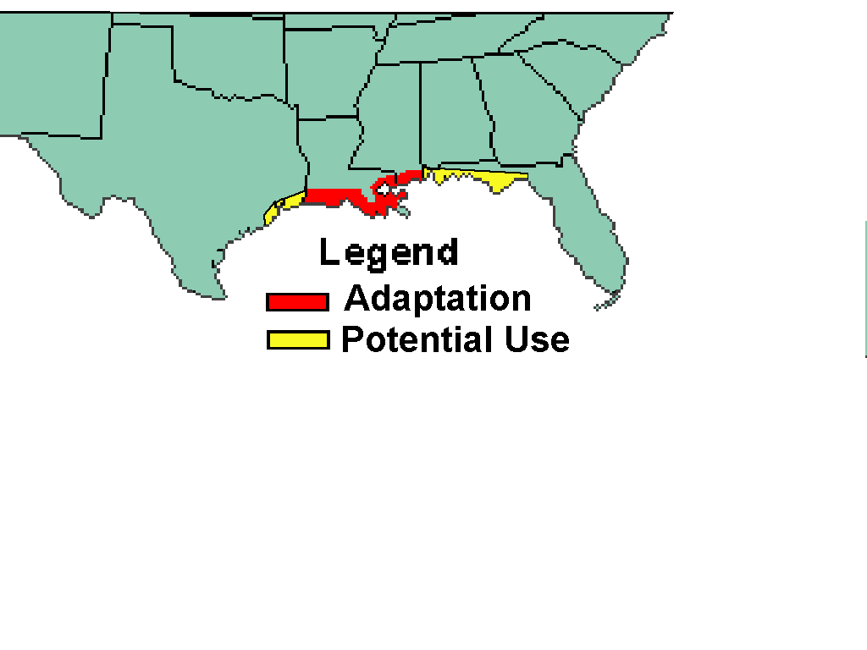

Establishment

Gulf bluestem can be successfully established using container grown or bareroot plant materials. Vegetative propagules from plant division or lower stem nodal tissue are used for nursery production.

Container grown or bareroot propagules should be planted on 2-5 foot centers on the primary dune ridge and back side and the more stable dune and swale areas behind the primary dune. Interspacing with other desirable dune species enhances habitat diversity and conservation effectiveness. Apply a blended fertilizer broadcast or slow release tablet or packet with each plant when planting. Gulf bluestem produces viable seed. The potential establishment of gulf bluestem by seed is being evaluated at the Golden Meadow Plant Materials Center in Galliano, Louisiana.

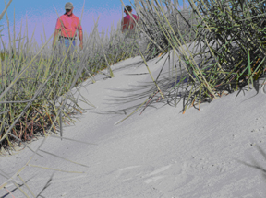

Management

No special management strategy is needed other than restricting traffic during the first year of establishment.

Pests and Potential Problems

There are no pests of concern associated with this species.

Cultivars, Improved, and Selected Materials (and area of origin)

Timbalier Germplasm Gulf Bluestem is a tested pre-varietal plant materials release available from the USDA Natural Resources Conservation Service, Golden Meadow Plant Materials Center in Galliano, Louisiana.

Prepared By: Gary Fine, NRCS Retired, NRCS ACES Program

Species Coordinator: Dr. Richard Neill, USDA, NRCS Golden Meadow Plant Materials Center, Galliano, Louisiana

Edited: Joel L. Douglas, Plant Materials Specialist, USDA-NRCS, Central National Technology Support Center, Fort Worth, Texas; 060823 jsp

For more information about this and other plants, please contact your local NRCS field office or Conservation District, and visit the PLANTS Web site<<http://plants.usda.gov>> or the Plant Materials Program Web site <<http://Plant-Materials.nrcs.usda.gov>>

*The U.S. Department of Agriculture (USDA) prohibits discrimination in all its programs and activities on the basis of race, color, national origin, age, disability, and where applicable, sex, marital status, familial status, parental status, religion, sexual orientation, genetic information, political beliefs, reprisal, or because all or a part of an individual's income is derived from any public assistance program. (Not all prohibited bases apply to all programs.) Persons with disabilities who require alternative means for communication of program information (Braille, large print, audiotape, etc.) should contact USDA's TARGET Center at (202) 720-2600 (voice and TDD). To file a complaint of discrimination write to USDA, Director, Office of Civil Rights, 1400 Independence Avenue, S.W., Washington, D.C. 20250-9410 or call (800) 795-3272 (voice) or (202) 720-6382 (TDD). USDA is an equal opportunity provider and employer."*

*Read about* [*Civil Rights at the Natural Resources Conservation Service*](http://www.nrcs.usda.gov/about/civilrights/)*.*