|  |
| --- |
| cereal rye |
| *Secale cereale* L. |
| Plant Symbol = SECE |

Contributed by: USDA NRCS Plant Materials Program

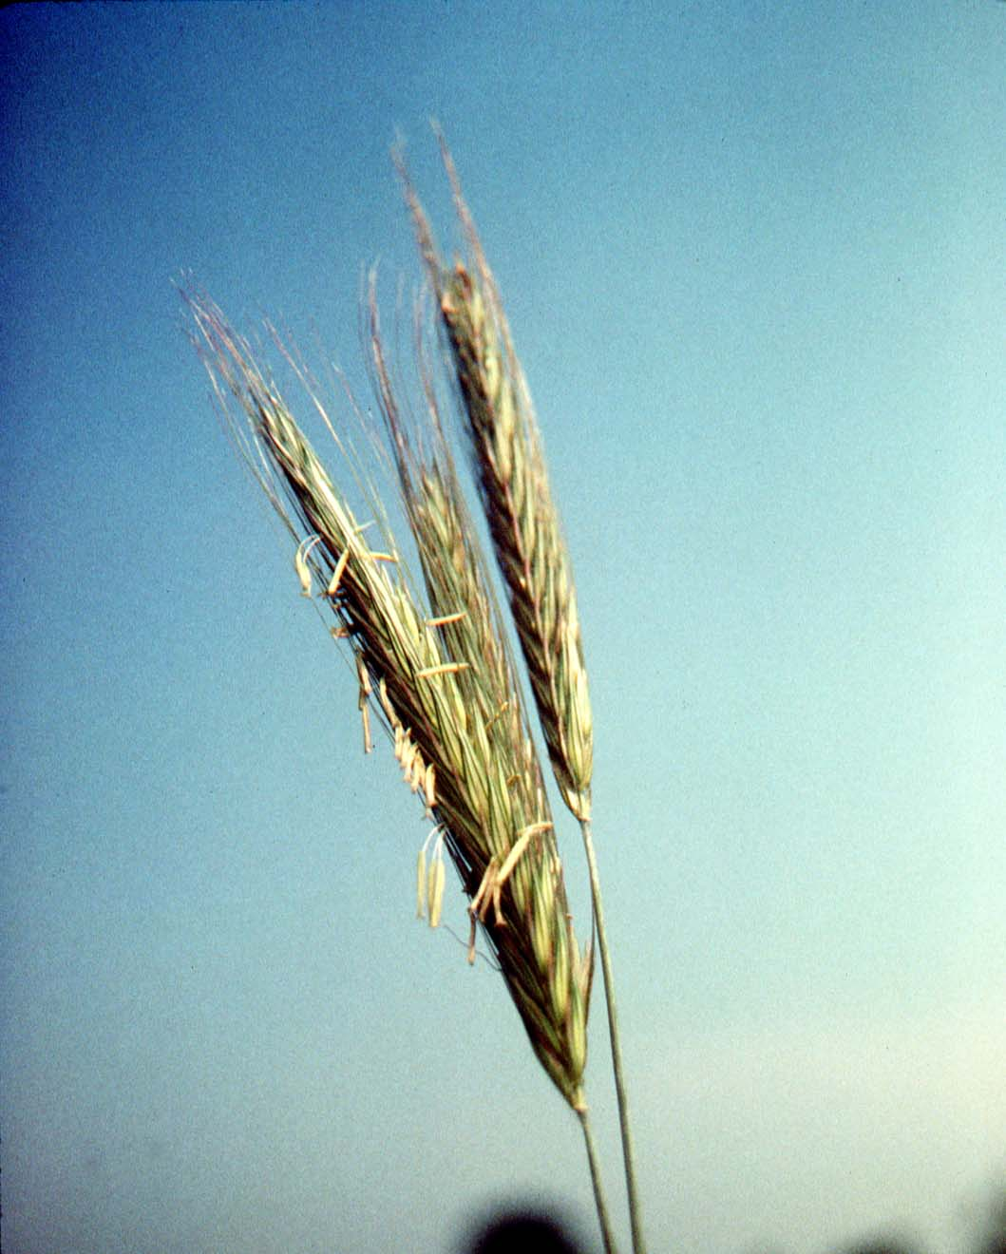

USDA NRCS National Plant Materials Center

Beltsville, MD

Uses

Cereal rye is a commonly used winter cover crop in the northeastern U.S. Due to the late harvest of many crops, fall-planted cover crops often do not make adequate growth to provide winter soil protection, but cereal rye can germinate and grow under cooler conditions than other covers. Cereal rye can also be used for spring forage production, and fed as pasture, green chop, or put up as haylage. It is reported that rye forage may impart an off-flavor to milk. Cereal rye does have an allelopathic affect on some weed species.

Status

Please consult the PLANTS Web site and your State Department of Natural Resources for this plant’s current status (e.g. threatened or endangered species, state noxious status, and wetland indicator values).

Weediness

This plant may become weedy or invasive in some regions or habitats and may displace desirable vegetation if not properly managed. Please consult with your local NRCS Field Office, Cooperative Extension Service office, or state natural resource or agriculture department regarding its status and use. Weed information is also available from the PLANTS Web site at plants.usda.gov.

Description

Cereal rye is an erect annual grass, with flat leaf blades and dense flower spikes. Each large spike consists of many 2-flowered spikelets with long awns. The grain is relatively large, typically around ½ inch long. There are 18,000 seeds per pound.

Adaptation and Distribution

The cultivar ‘Aroostook’ is expected to produce a satisfactory stand as a late seeded cover crop if a minimum of 260-350 growing degree days (base 40 degrees F) remain after seeding. While ‘Aroostook’ was developed primarily for use in northern climates, it is widely adapted as a cover crop and forage producer outside the Northeast.

Cereal rye is distributed throughout the United States. For a current distribution map, please consult the Plant Profile page for this species on the PLANTS Website.

Establishment

The best method to plant ‘Aroostook’ following potatoes, corn, soybeans, and other row crops, is to drill the seed one inch deep using a conventional grain drill equipped with packer wheels. Another satisfactory method is to broadcast the seed followed by a shallow disking or harrowing and cultipacking. Use a minimum of 2 bushels per acre (110 to 120 lb/acre). ‘Aroostook’ rye can also be aerial seeded in standing corn or other row crops. Aerial seeding is very dependent on favorable weather for success. For very late plantings or aerial seedings, 3 bushels per acre is recommended. No seed treatment is recommended.

Management

There is usually adequate residual fertilizer following a row crop to produce the cover crop. Due to ‘Aroostook’s abundant spring growth, it is important to plow, spray, graze, or cut its stands in a timely manner when managed for green manure, cover crop, or forage. Strong growth can be anticipated in March in the southern part of the Northeast. Northern locations typically begin growth in April. For pasture, extremely rapid rotation or stocking with large numbers of animals is required to capture the spring growth. In areas with high nitrogen availability, take preventative measures for grass tetany or other related reactions; an acclimation period for livestock is highly recommended.

Pests and Potential Problems

This section is under development.

Cultivars, Improved, and Selected Materials (and area of origin)

Late fall and early spring growth, and prostrate fall leaf growth make ‘Aroostook’ (New York) rye a valuable cover crop. ‘Aroostook’ rye can be seeded in northern Maine as late as September 30th. The leaf area index, (when the plants are growing at 200 growing degree days with a base of 32 degrees F) is significantly greater than ‘Balbo.’ The foundation seed for ‘Aroostook’ rye is produced by the Big Flats, NY Plant Materials Center, and is available to commercial seed producers. Commercially produced certified seed is available from some dealers. Currently, most seed production occurs in the Midwest.

Control

Please contact your local agricultural extension specialist or county weed specialist to learn what works best in your area and how to use it safely. Always read label and safety instructions for each control method. Trade names and control measures appear in this document only to provide specific information. USDA, NRCS does not guarantee or warranty the products and control methods named, and other products may be equally effective.

Prepared By & Species Coordinator:

USDA NRCS Plant Materials Program

Edited: 05Feb2002 JLK; 060817 jsp

For more information about this and other plants, please contact your local NRCS field office or Conservation District, and visit the PLANTS Web site<<http://plants.usda.gov>> or the Plant Materials Program Web site <<http://Plant-Materials.nrcs.usda.gov>>

*The U.S. Department of Agriculture (USDA) prohibits discrimination in all its programs and activities on the basis of race, color, national origin, sex, religion, age, disability, political beliefs, sexual orientation, and marital or family status. (Not all prohibited bases apply to all programs.) Persons with disabilities who require alternative means for communication of program information (Braille, large print, audiotape, etc.) should contact USDA's* [*TARGET Center*](http://www.usda.gov/oo/target.htm) *at 202-720-2600 (voice and TDD).*

*To file a complaint of discrimination write USDA, Director, Office of Civil Rights, Room 326-W, Whitten Building, 14th and Independence Avenue, SW, Washington, DC 20250-9410 or call 202-720-5964 (voice or TDD). USDA is an equal opportunity provider and employer.*

*Read about* [*Civil Rights at the Natural Resources Convervation Service*](http://www.nrcs.usda.gov/about/civilrights/)*.*