

Plant Fact Sheet

# Canada

# Goldenrod

## Solidago canadensis L.

Plant Symbol = SOCA6

#### Contributed by: NRCS Plant Materials Center, Pullman, WA

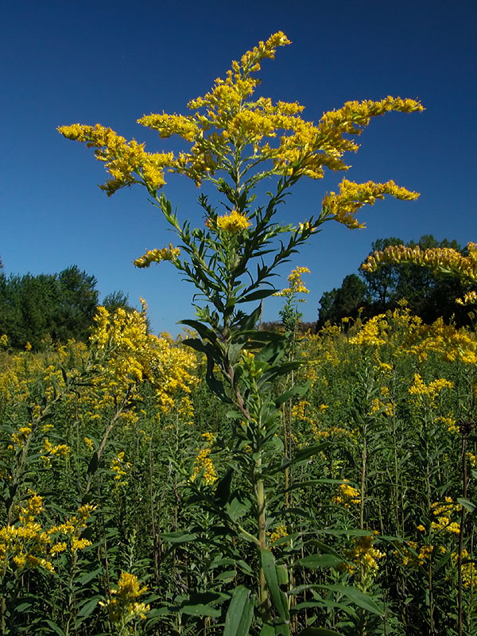

*Solidago canadensis.* www.discoverlife.org

### Alternate Names

### Canadian goldenrod, meadow goldenrod, common goldenrod, giant goldenrod, tall goldenrod, shorthair goldenrod (*S. canadensis* var. *gilvocanescens*), Hager’s goldenrod (*S. canadensis* var. *hargeri*), rough goldenrod (*S. canadensis* var. *salebrosa*).

### Uses

*Pollinator habitat: Solidago* species provide vital sources of pollen and nectar for bees and other insects in the late summer and fall throughout North America.

*Rangeland revegetation:* Canada goldenrod can be used for revegetation of disturbed areas, for mine spoil reclamation, and soil stabilization.

*Forage:* This plant is grazed by cattle, sheep, horses, and whitetail deer.

*Ethnobotanical:* The Iroquois, Okanagan-Colville, Potowatomi, Shuswap, Zuni, Gosiute and Navajo utilized Canada goldenrod for various medical purposes.

*Ornamental:* Canada goldenrod is not typically planted in a landscaped setting due to its spreading rhizomatous growth. However, it is possible to manage plants by planting in a pot submersed in the ground, or by removing new growth each year. Seed dispersal can be controlled by removing flower heads prior to seed ripening.

### Status

Consult the PLANTS Web site and your State Department of Natural Resources for this plant’s current status (e.g., threatened or endangered species, state noxious status, and wetland indicator values).

### Weediness

Goldenrods have a reputation of being weedy due to their aggressive rhizomatous growth. However, in stable rangeland environments they seldom achieve densities that are problematic. Please consult with your local NRCS Field Office, Cooperative Extension Service office, state natural resource, or state agriculture department regarding this plant’s status and management.

### Description and Adaptation

*General*: Sunflower family (Asteraceae). *Solidago canadensis* is a native, warm-season, long-lived perennial that spreads by rhizomes and forms large, dense patches. Stems are mostly smooth, covered with fine hairs at the top and are 1 to 7 ft tall. Leaves are sharply toothed, lance-shaped, covered with fine hairs, triple-nerved and 2 to 5 inches long. Flower panicles occur at the end of each stem, and when open, are 10 inches wide. Inflorescences occur mostly on one side of long, drooping panicle branches, have 10 to 17 ray flowers, and bloom July through October. Pollination typically occurs by the aid of insects. Seeds are small and dry with sparse hairs and numerous pale bristles at the tip.

*Solidago canadensis* can be distinguished from *S. missouriensis* by its taller stature and its larger, more branched, open flower panicles. *S. canadensis* can be distinguished from *S. giganteus* by its hairs on the stems and yellow bracts.

Canada goldenrod is adapted to areas receiving full sun or part shade and 16 to 60 in of annual precipitation. Plants typically grow in moist soil with medium texture and moderate levels of organic matter. They are found in damp meadows, waterways, and ditches along roadsides and railroads. They may also inhabit dry, open slopes in upland prairies, and deciduous and evergreen forests. Plants are not found on waterlogged sites and only rarely found on very dry sites.

Canada goldenrod grows in all US states except HI, LA, AL, GA, SC and FL, and all Canadian provinces except Nunavut. The plant has five varieties (ecotypes): var. *canadensis* (Canada goldenrod),var. *gilvocanescens* (shorthair goldenrod), var. *hargeri* (Harger’s goldenrod), var. *lepida* (Canada goldenrod), and var. *salebrosa* (rough goldenrod). For current distribution of this species and varieties, consult the Plant Profile page on the PLANTS Web site.

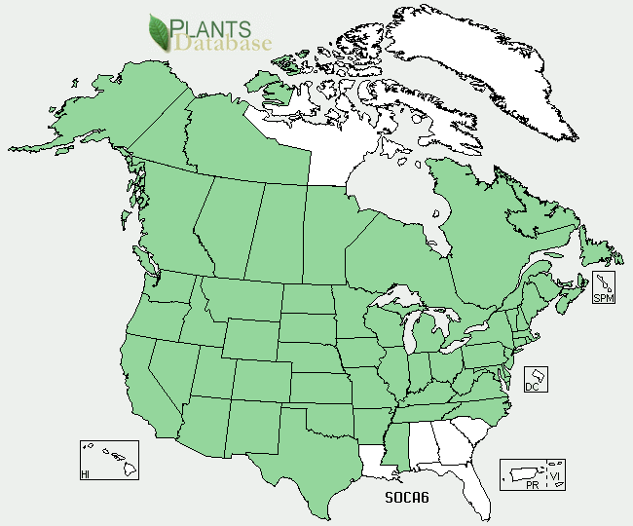

Canada goldenrod distribution from the USDA PLANTS Database

### Establishment

Plants can be established by seed, seedlings, or rhizomes. Seed should be planted into a firm, weed-free seed bed at a rate of 0.5 lb PLS/ac and at a depth of 0.125 to 0.25 inches. If planted in a mix, the seeding rate should be adjusted according to the proportion of the mix. Seed is non-dormant, and can be planted in the fall or spring.

Plants established by seedlings can be started by sowing seed in containers placed in a greenhouse in January. Seed should be covered lightly with soil and kept moist until germination. A layer of pea gravel can be applied to the soil surface to prevent seeds from floating. Plants should be moved to a cold-frame in late March or early April and hardened off for 2 to 4 weeks prior to transplanting into a prepared field site in early May. Plants should be spaced 1 to 2 ft apart.

Plants can also be established by rhizomes. Sections of rhizomes should be collected from cultivated plants or approved areas, kept moist during transport, and replanted in a prepared field site.

### Management

### This plant spreads by rhizomes and by seed. Where plant spread is not desired, seedlings should be planted in a large pot or barrel submersed in the soil, or new growth should be cut and removed each year. To prevent seed dispersal, flower heads should be removed prior to seed ripening. Plants will withstand vigorous cutting, and will regrow if cut during the growing season.

### Pests and Potential Problems

### *Solidago canadensis* is susceptible to many pathogens and insect pests, which may reduce seed production.

### Environmental Concerns

### This plant may form dense stands in some habitats, particularly where ground is open and disturbed. To prevent dense stands from forming, seed Canada goldenrod at low densities or plant in small areas.

### Control

If control of this species is desired, contact your local agricultural extension specialist or county weed specialist to learn what works best in your area and how to use it safely. Always read label and safety instructions for any control method.

### Cultivars, Improved, and Selected Materials (and area of origin)

None. Seed and seedlings, however, are available from multiple vendors.

### Prepared By

*Pamela L.S. Pavek*, USDA NRCS Plant Materials Center, Pullman, Washington

### Citation

Pavek, P.L.S. 2012. Plant fact sheet for Canada goldenrod (*Solidago canadensis*). USDA-Natural Resources Conservation Service. Pullman, WA.

Published June 2012

Edited: 18May2012jab; 25June2012plsp

For more information about this and other plants, please contact your local NRCS field office or Conservation District <<http://www.nrcs.usda.gov/>>, and visit the PLANTS Web site <[http://plants.usda.gov](http://plants.usda.gov/)> or the Plant Materials Program Web site <<http://plant-materials.nrcs.usda.gov>>

**USDA IS AN EQUAL OPPORTUNITY PROVIDER AND EMPLOYER**