# seaside goldenrod

## Solidago sempervirens L.

### Plant Symbol = SOSE

*Contributed by: USDA NRCS Plant Materials Center, Cape May, New Jersey*

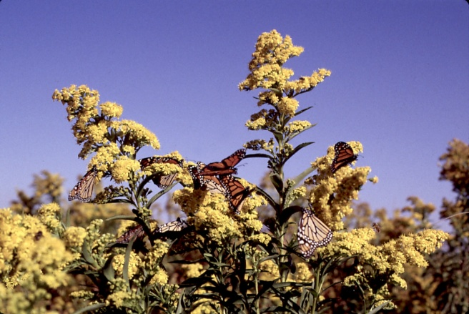

William Skaradek, USDA NRCS

#### **Uses**

*Dune Restoration:* Seaside goldenrod is a beneficial native perennial that may be used to add biodiversity to dune restoration projects.

*Wildlife Habitat:* Seaside goldenrod provides benefits for native wildlife such as butterflies, birds, and small mammals. It is a major food source for the fall migrating monarch butterfly.

*Ornamental:* With showy bright yellow flowers blooming late August to early October, seaside goldenrod is an excellent addition to pollinator gardens, butterfly gardens and ornamental flower beds.

#### **Status**

Please consult the PLANTS Web site and your State Department of Natural Resources for this plant’s current status (e.g., threatened or endangered species, state noxious status, and wetland indicator values).

#### **Description and Adaptation**

Seaside goldenrod is a perennial forb that is a member of the Aster family. The plant may grow up to six feet tall at maturity. The plants alternately arranged leaves are fleshy, dark green, oblong, lance shaped and are produced the entire length of the stem. The leaves at the base of the plant are the largest, up to 20 inches, and become smaller up the stem of the plant. Seaside goldenrod derives its name from the numerous bright

golden yellow flowers it produces from August through October.

Seaside goldenrod is native and well adapted to coastal habitats including the backside of primary dunes, low secondary dunes and edges of salt marshes. It has some tolerance for drought allowing it to survive in the dry conditions of the dunes. Seaside goldenrod often occurs with other native dune plants such as switchgrass, salt meadow cordgrass and American beachgrass. The range of seaside goldenrod extends from Quebec south to Florida and Texas.

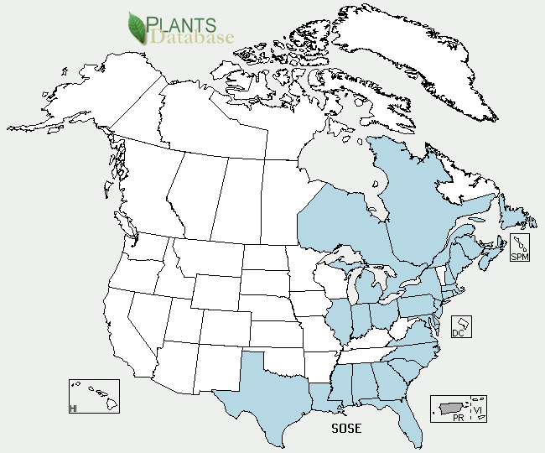

Seaside goldenrod distribution from USDA-NRCS PLANTS Database.

For updated distribution, please consult the Plant Profile page for this species on the PLANTS Web site.

#### **Establishment**

Seaside goldenrod may be grown from seed or division of vegetative parts. Transplants are used for establishing seed production plots and dune restoration plantings. Transplants should be planted in late winter to early spring.

#### **Management**

Little maintenance is needed for seaside goldenrod. It is able to withstand hot and dry conditions minimizing the need for irrigation. In the first growing season irrigation may be need in extended dry periods. Fertilization may increase vigor of seaside goldenrod, but is not a necessary for survival.

#### **Pests and Potential Problems**

There are no known pests or problems associated with seaside goldenrod.

#### **Environmental Concerns**

There are no known environmental concerns associated with seaside goldenrod.

#### **Cultivars, Improved, and Selected Materials (and area of origin)**

Monarch Germplasm developed from native mid-Atlantic populations was released by the USDA NRCS, Cape May Plant Materials Center in 2010.

#### **Prepared By**

*Scott C. Snell*; Cape May, New Jersey.

#### **Citation**

Snell, S. 2010. Plant fact sheet for Seaside Goldenrod (*Solidago sempervirens)*. USDA-Natural Resources Conservation Service, Plant Materials Center. Cape May, NJ.

For more information about this and other plants, please contact your local NRCS field office or Conservation District <<http://www.nrcs.usda.gov/>>, and visit the PLANTS Web site <[http://plants.usda.gov](http://plants.usda.gov/)> or the Plant Materials Program Web site <<http://plant-materials.nrcs.usda.gov>>

*The U.S. Department of Agriculture (USDA) prohibits discrimination in all its programs and activities on the basis of race, color, national origin, age, disability, and where applicable, sex, marital status, familial status, parental status, religion, sexual orientation, genetic information, political beliefs, reprisal, or because all or a part of an individual's income is derived from any public assistance program. (Not all prohibited bases apply to all programs.) Persons with disabilities who require alternative means for communication of program information (Braille, large print, audiotape, etc.) should contact USDA's TARGET Center at (202) 720-2600 (voice and TDD).*

*To file a complaint of discrimination write to USDA, Director, Office of Civil Rights, 1400 Independence Avenue, S.W., Washington, D.C. 20250-9410 or call (800) 795-3272 (voice) or (202) 720-6382 (TDD). USDA is an equal opportunity provider and employer."*

*Read about* [*Civil Rights at the Natural Resources Conservation Service*](http://www.nrcs.usda.gov/about/civilrights/)*.*