|  |
| --- |
| smooth cordgrass |
| *Spartina alterniflora* Loisel. |
| Plant Symbol = SPAL |

Contributed by: USDA NRCS Plant Materials Program

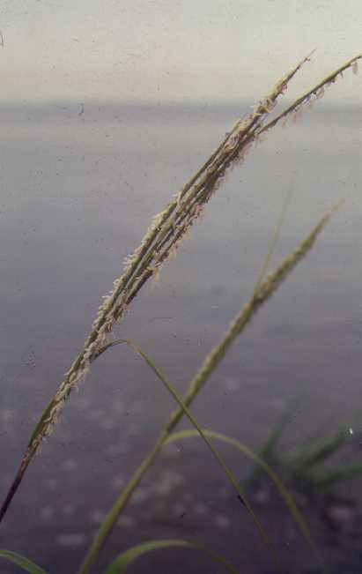

USDA NRCS National Plant Materials Center

Beltsville, MD

**Alternate Names**

Saltmarsh cordgrass, oystergrass, and saltwater cordgrass

Uses

Smooth cordgrass is the dominant emergent grass species found growing along tidal salt marshes of the Atlantic and Gulf coasts. It is utilized extensively for erosion control along shorelines, canal banks, levees, and other areas of soil water interface. Smooth cordgrass is an effective soil stabilizer used on interior tidal mudflats, dredge-fill sites, and other areas of loose and unconsolidated soils associated with marsh restoration. Under natural conditions on tidal marshes, vigorous stands of this grass will absorb wave energy and screen suspended solids from intertidal waters, while uptaking available nutrients in the sediments. As sediments accumulate, this plant will spread away from the bank. It will tolerate petroleum contaminated soils. Smooth cordgrass provides food and cover to a number of marsh birds and mammals and is recognized as an important forage species for livestock producers along the central gulf coast.

Status

Please consult the PLANTS Web site and your State Department of Natural Resources for this plant’s current status (e.g. threatened or endangered species, state noxious status, and wetland indicator values).

Weediness

This species is not native to the west coast of the U.S., where it may become weedy or invasive in some regions or habitats and may displace desirable vegetation if not properly managed. Please consult with your local NRCS Field Office, Cooperative Extension Service office, state natural resource, or state agriculture department regarding its status and use. Weed information is also available from the PLANTS Web site at plants.usda.gov. Please consult the Related Web Sites on the Plant Profile for this species for further information.

Description

This long-lived, warm season perennial typically grows from 2 to 7 feet tall, and spreads extensively by long hollow rhizomes. Soft, spongy stems up to ½ inch in diameter emerge from the rhizomes. The flat leaf blades are typically 12 to 20 inches long, tapering to a long inward-rolled tip.

In September and October seedheads which are 10 to 12 inches long emerge at the end of the stem. Each spike will hold from twelve to fifteen 2 or 3 inch long spikelets. The flowers are wind pollinated. There are approximately 175,000 seeds per pound.

Adaptation and Distribution

Smooth cordgrass colonies tend to grow parallel to and continuous along shorelines; the width and thickness of vegetative colonies are controlled by a number of site specific conditions such as elevation, shoreline slope, and frequency, depth and duration of flooding. It is commonly found growing on open coastal marshes between high and low tides from Newfoundland south to Florida and Texas. This grass can be found growing on sandy aerobic or anaerobic soils with pHs ranging from 3.7 to 7.9. Smooth cordgrass will tolerate regular inundations with 0 to 35 parts per thousand salinity.

For a current distribution map, please consult the Plant Profile page for this species on the PLANTS Website. It is not native along the U.S. west coast.

Establishment

Due to sparse and irregular seed production, smooth cordgrass is usually propagated by vegetative stem divisions. Depending on the energy effecting the planting site, either containerized (for high impact sites) or bare root (for mild impact sites) plants can be utilized. Since most marsh sites are irregular and difficult to access, hand planting is normally employed, using spades, dibbles, or planting bars. If site conditions are adequate, planting can be carried out with a mechanical, tractor drawn transplanter. Plant spacing should be between 18 and 72 inches; 2 to 10 feet of lateral spread can be expected annually. Smooth cordgrass grows at elevations ranging from mean high tide and above. Planting at an excessively low elevation will result in failure due to drowning and/or uprooting where wave energy is too high. Plantings in deeper water have been successful, but plants are slow to anchor and vegetative cover is sparse. Optimum water depths for establishing plants are 1 to 18 inches.

Shoreline plantings are typically planted as a single or double row running parallel to the shoreline. Transplants should be planted at the mid-point between the high and low tide elevation. Plant spacing within the row will vary according to the size of the transplant materials being used and the rate at which full coverage is desired.

Open water area plantings across mudflats and dredge fill sites should be designed to provide the greatest reduction in fetch length. Rows can be placed across shallow water exchange points to create a passive hydrologic barrier that will slow tidal exchange and trap suspended sediments.

In nursery rows, plants of smooth cordgrass should be spaced 12 to 24 inches apart. Under ideal nursery conditions, each planting unit will establish stands containing 25 culms per square foot. Extensive weed control is essential to producing quality nursery grown plants.

Management

Stem and rhizome growth of this grass respond well to applications of a well balanced commercial fertilizers. The addition of 300-500 lbs/acre of 10-10-10 fertilizer to a planting site or nursery bed is adequate to stimulate growth and development. High nitrogen slow-release fertilizer tables may be used with container grown plants and bare root transplants. Plants propagated under nursery conditions are easily under cut and uplifted for distribution.

On field sites there are a number of site-specific elements that should be considered when working with smooth cordgrass. This include; plant smothering from floating debris; herbivore grazing damage; poor water circulation; soil load bearing properties; and shoreline configuration.

Pests and Potential Problems

Non-threatening rust-like fungi (orange fruiting bodies on leaves) are commonly found on smooth cordgrass. Flower beetles may limit seed production. The sugar cane borer can cause the decline and death of stems.

In areas where nutria (*Myocaster coypus*) is a problem new planting may need to be protected from predation.

Cultivars, Improved, and Selected Materials (and area of origin)

There are 2 named varieties available on the commercial market. In 1992, ‘Bayshore’ (Maryland) smooth cordgrass was released for use on Atlantic coastal areas by the Cape May Plant Material Center, in Cape May Court House, New Jersey. In 1989 ‘Vermilion’ (Louisiana) was selected and released by the Golden Meadows Plant Materials Center in Galliano, Louisiana for use in the Gulf coastal areas. Other sources of local ecotypes are available from commercial nurseries.

Prepared By

Tony Bush, USDA NRCS Rose Lake Plant Materials Center, East Lansing, Michigan

##### *Morris Houck*, USDA NRCS, Alexandria, Louisiana (additions 2008)

**Species Coordinator**

Tony Bush, USDA NRCS Rose Lake Plant Materials Center, East Lansing, Michigan

Edited: 05Feb2002 JLK; 24may06jsp; 060817 jsp; 080917 jsp

For more information about this and other plants, please contact your local NRCS field office or Conservation District, and visit the PLANTS Web site<<http://plants.usda.gov>> or the Plant Materials Program Web site <<http://Plant-Materials.nrcs.usda.gov>>

*The U.S. Department of Agriculture (USDA) prohibits discrimination in all its programs and activities on the basis of race, color, national origin, sex, religion, age, disability, political beliefs, sexual orientation, and marital or family status. (Not all prohibited bases apply to all programs.) Persons with disabilities who require alternative means for communication of program information (Braille, large print, audiotape, etc.) should contact USDA's* [*TARGET Center*](http://www.usda.gov/oo/target.htm) *at 202-720-2600 (voice and TDD).*

*To file a complaint of discrimination write USDA, Director, Office of Civil Rights, Room 326-W, Whitten Building, 14th and Independence Avenue, SW, Washington, DC 20250-9410 or call 202-720-5964 (voice or TDD). USDA is an equal opportunity provider and employer.*

*Read about* [*Civil Rights at the Natural Resources Conservation Service*](http://www.nrcs.usda.gov/about/civilrights/)*.*