

Plant Fact Sheet

SPIKE DROPSEED

*Sporobolus contractus* Hitchc.

Plant Symbol = SPCO4

Contributed by: USDA NRCS James E. “Bud” Smith Plant Materials Center, Knox City, Texas

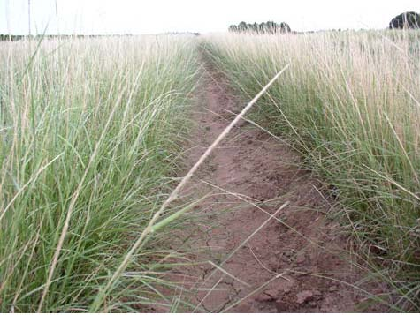USDA/NRCS

**Uses**

*Erosion Control:* Spike dropseed may be used as a component of a seeding mixture for critical area plantings and conservation cover. It is a bunchgrass with very thick vegetation near the soil surface which can be used to stabilize sandy eroding soils.

*Wildlife:* Spike dropseed is utilized as a food source by various wildlife species. Particularly, upland birds feed on the mature seed that is produced. It also provides good cover for birds and small mammals.

*Livestock:* Many species of livestock will graze on spike dropseed. It has a nutritional value of fair. The species has the ability to recover and reseed itself if heavy grazing occurs.

**Status**

Please consult the PLANTS Web site ([http://plants.usda.gov](http://plants.usda.gov/)) and your State Department of Natural Resources for this plant’s current status (e.g. threatened or endangered species, state noxious status, and wetland indicator values).

**Weediness**

This plant may become weedy or invasive in some regions or habitats and may displace desirable vegetation if not properly managed. Please consult your local NRCS Field Office, Cooperative Extension Service office, state natural resource, or state agriculture department regarding its status and use. Weed information is also available from the PLANTS Web site at http://www.plants.usda.gov. Please consult this and Related Web Sites and view the plant profile for this species for further information.

**Description**

Spike dropseed is a native, perennial, warm season bunchgrass with erect stems that grow 3 feet tall. It begins growing in the spring when moisture levels increase and matures to produce seed in October. The leaf blades grow to about 1.5 feet long and ½ inch wide. The leaves are flat when the plant is actively growing, but as the plant begins to dry, they become V-shaped. The sheaths of the leaves are hairy along the margins. The seedhead is ½ inch wide and six inches to approximately 1.5 feet long.

**Adaptation**

Spike dropseed is adapted to a large portion of the southwest United States. It is found from Texas to California, and as far north as Nevada and Colorado. Spike dropseed is adapted to a wide range of soil types, but performs best on loamy fine, silty and sandy loam soils.

*Distribution*: Please consult the Plant Profile page for this species on the PLANTS Web site.

**Establishment**

Spike dropseed should be planted on a clean, firm seedbed. Planting can be done using either a grass drill or broadcast seeding, but grass drills are the most successful method of planting. Seed should be placed less than 1/8 inch deep on fine textured and ½ inch on sandy soils. Spike dropseed should be planted at a rate of 1.0 lb pure live seed (pls) per acre. When planting spike dropseed as a component of a seed mixture, the seeding rate should be adjusted to the desired percent of the mix. Soil samples should be taken before planting to determine the amount of fertilizer needed to bring the fertility level up to a medium range. Nitrogen should be limited to less than ten pounds per acre until a stand is evident.

**Management**

Spike dropseed is commonly found as a component in seed mixtures for range and pastures. Stands of spike dropseed should be well established before livestock grazing is permitted. Once the stand is established, spike dropseed should never be grazed or cut below five to six inches. Grazing can begin the first winter after planting on well established areas. Spike dropseed can reseed itself following overgrazing or drought; however, proper management is required to ensure the plant is not overgrazed or over utilized by livestock or wildlife. Consult your local NRCS Field Office for assistance with planning and applying prescribed grazing.

**Pests and Potential Problems**

None Known

**Control**

Please contact your local agricultural extension specialist or county weed specialist to learn what works best in your area and how to use it safely. Always read label and safety instructions for each control method. Trade names and control measures appear in this document only to provide specific information. USDA NRCS does not guarantee or warranty the products and control methods named, and other products may be equally effective.

**Cultivars, Improved, and Selected Materials (and area of origin)**

Potter County germplasm was released from the James E. “Bud” Smith Plant Materials Center, Knox City, TX in 2000. It was collected originally in 1984 from native plants in the Canadian River bottomland in Potter County, TX, approximately 18 miles north of Amarillo, TX.

Cochise Germplasm was released from the Tucson Plant Materials Center in Tucson, AZ in 2005. Uses include revegetation of denuded range sites, abandoned cropland, and critical areas.

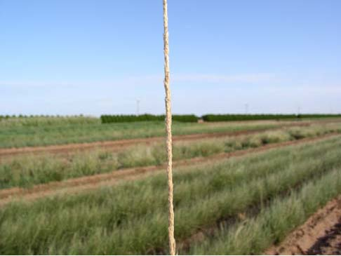

**Prepared By:**

Brandon Carr, USDA NRCS James E. “Bud” Smith Plant Materials Center, Knox City, Texas

**Species Coordinator:**

Published: November, 2009

Edited:

For more information about this and other plants, please contact your local NRCS field office or Conservation District <<http://www.nrcs.usda.gov/>>, and visit the PLANTS Web site <[http://plants.usda.gov](http://plants.usda.gov/)> or the Plant Materials Program Web site <<http://plant-materials.nrcs.usda.gov>>

**USDA IS AN EQUAL OPPORTUNITY PROVIDER AND EMPLOYER**