|  |
| --- |
| sand dropseed |
| ***Sporobolus cryptandrus* (Torr.) Gray** |
| Plant symbol = SPCR |

Contributed By: USDA NRCS National Plant Data

# *Center*

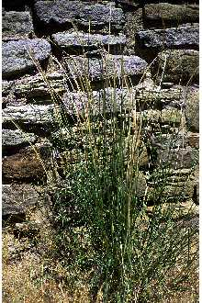

© Robert Soreng

Smithsonian Institution-Botany

@ plants.usda.gov

## Uses

Sand dropseed produces considerable forage that is fairly palatable to all livestock.

## Status

Please consult the PLANTS Web site and your State Department of Natural Resources for this plant’s current status, such as, state noxious status and wetland indicator values.

## Description

Grass Family (Poaceae). Sand dropseed is a warm‑season, weak, perennial bunch grass. The height ranges from 2 to 3 feet. The leaf blade is flat and about 1/8 inch wide; tapering toward tip and rolling inward as the plant matures. The leaf sheath is longer than the internodes and the upper sheath partly or entirely encloses seedhead. The ligule is a conspicuous tuft of long white hair. The seedhead is a open panicle densely flowered and often in pairs, sometimes hairy at axial of branch and stem; spikelets less than 1/8 inch long, lead colored and one glume twice as long as the other.

# Management

This grass increases on ranges that are closely grazed during summer.

# Establishment

It grows best in association with other grasses but may grow in pure stands. Sand dropseed usually produces an abundant seed crop. Many seeds are held between the stem and sheath until the plant deteriorates. Because seeds remain viable for many years, this grass re-seeds itself readily on ranges following overgrazing or drought. It grows best on sandy soils at lower elevations of its range. Also, it grows on coarse, gravelly soils and at elevations to 8,000 feet.

## Cultivars, Improved and Selected Materials (and area of origin)

Please contact your local NRCS Field Office.

**Reference**

Leithead, H.L., L.L. Yarlett, & T.N. Shiflett. 1976. 100 native forage grasses in 11 southern states. USDA SCS *Agriculture Handbook No. 389*, Washington, DC.

## Prepared By & Species Coordinator:

*Percy Magee*

USDA NRCS National Plant Data Center, Baton Rouge, Louisiana

Edited: 13may02 ahv; jul03 ahv; 20sep05 jsp