|  |
| --- |
| saltmeadow cordgrass |
| *Spartina patens* (Ait.) Muhl. |
| Plant Symbol = SPPA |

Contributed by: USDA NRCS Plant Materials Program

Curtis Sharp

USDA NRCS National Plant Materials Center

Beltsville, MD

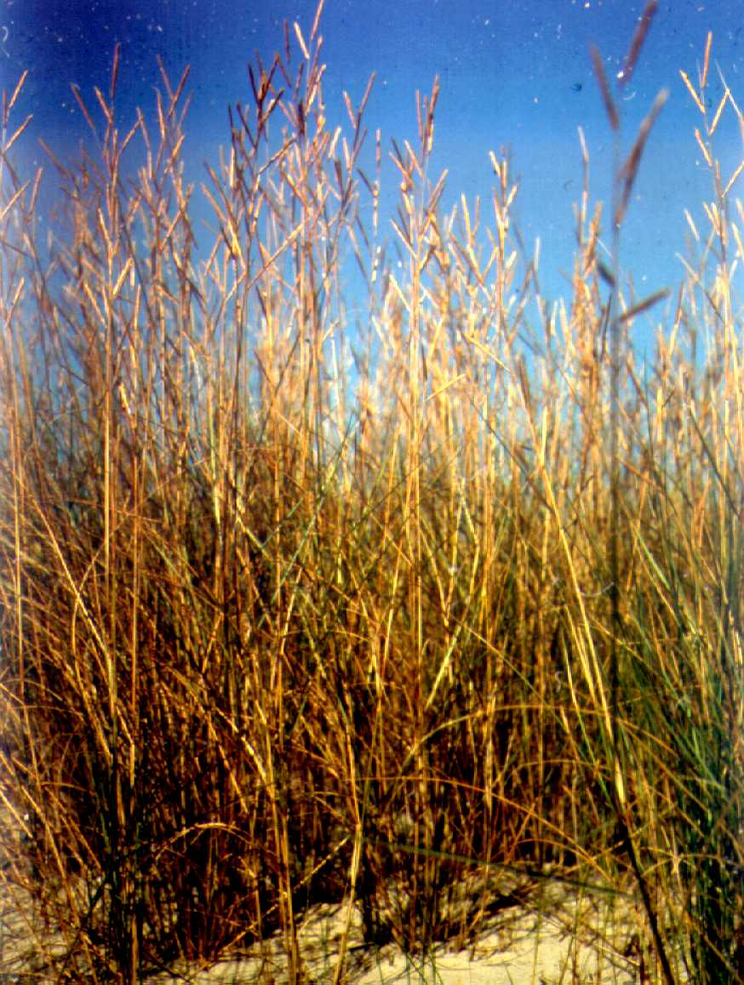

Alternate Names

Marshhay cordgrass

Uses

Saltmeadow cordgrass is used for shoreline protection and tidal marsh restorations, and is often utilized for levee stabilization and dune stabilization plantings near coastal beaches and on barrier islands. Saltmeadow cordgrass is an effective stabilizer used on interior mud flats, dredge fill sites, and other areas of loose and unconsolidated soils associated with marsh restoration. In its natural state on the tidal marshes, dense stands of this grass cause suspended solids to settle out of floodwaters and take up available nutrients. Saltmeadow cordgrass also provides food and cover too many terrestrial and aquatic species of wildlife and is considered an important forage species to livestock producers along the gulf coast. This species is the primary component of salt hay, which is utilized in the landscape and vegetable trade industry as weed seed free mulch.

Status

Please consult the PLANTS Web site and your State Department of Natural Resources for this plant’s current status (e.g. threatened or endangered species, state noxious status, and wetland indicator values).

Weediness

This plant may become weedy or invasive in some regions or habitats and may displace desirable vegetation if not properly managed. Please consult with your local NRCS Field Office, Cooperative Extension Service office, or state natural resource or agriculture department regarding its status and use. Weed information is also available from the PLANTS Web site at plants.usda.gov.

Description

This warm season, native, perennial grows from 1 to 4 feet tall, and spreads extensively by long slender rhizomes. Dark green stems emerge from the rhizomes. The rolled leaf blades are typically 1/2 to 1 foot long, and 0.1 to 0.2 inches wide. Leaf blades are shiny, dark green on the upper surface and rough with prominent veins on the lower surface. Leaves are drooping and wiry in appearance. From late June to October an inflorescence emerges at the end of the stem, which is composed of 2 to 10 two-inch-long spikelets. The numerous florets are 0.3 to 0.4 inches long and arranged in an overlapping scale-like fashion on each spikelet. The flowers are wind pollinated.

Adaptation and Distribution

Saltmeadow cordgrass is commonly found growing in saline to brackish marshes, sandy beaches and low dunes, tidal flats and marsh ridges from normal high tide to about 13 feet above sea level, from Newfoundland to Quebec, south to Florida and along the Gulf Coast into south Texas; it can also be found along the shores of the Great Lakes. This grass is adapted to a wide range of soils from coarse sands to silty clay sediments with pHs ranging from 3.7 to 7.9. Saltmeadow cordgrass will tolerate irregular inundations with 0 to 35 parts per thousand salinity.

For a current distribution map, please consult the Plant Profile page for this species on the PLANTS Website.

Establishment

Due to sparse seed production, saltmeadow cordgrass is usually propagated by vegetative stem divisions. Depending on the energy effecting the planting site, either containerized (high impact sites) or bare root (mild impact sites) plants can be utilized. Bare root material should contain 3 to 5 stems per planting unit, while containers should have at least 5 to 8 healthy stems. Bare root plugs are generally limited to planting sites that are exposed to little or no wave energy. Since most marsh sites are irregular and difficult to access, hand planting is normally employed, using spades, dibbles, or planting bars. If site conditions are right, planting can be carried out with a mechanical, tractor drawn transplanter. Plant spacing should be between 18 and 36 inches; up to 2 feet of lateral spread can be expected annually.

In nursery rows, plants of saltmeadow cordgrass should be spaced 6 to 12 inches apart. Under ideal nursery conditions, each planting unit should be able to yield up to 50 stems in a single growing season. Effective weed control is essential to producing quality plants.

Management

Stems and rhizomes of this grass respond well to applications of well balanced commercial fertilizers. Plants propagated under nursery conditions may need to be irrigated if the site is not moist year round to encourage good growth and spread. Plants in production are usually placed on sandy textured soils and allowed to spread by rhizomes for 1 to 3 years, after which they are under-cut and uplifted for distribution.

Pests and Potential Problems

There are no detrimental pests documented to impact this species. Non-threatening rust-like funguses (orange fruiting bodies on leaves) are commonly found on *S. patens* plants.

Cultivars, Improved, and Selected Materials (and area of origin)

There are several named cultivars available on the commercial market. In 1986, ‘Avalon’ (New Jersey) saltmeadow cordgrass was released for use in the coastal area north of the Carolinas by the Cape May Plant Material Center (PMC), in Cape May Court House, New Jersey. Soon after, ‘Flageo’ (North Carolina) was released by the Americus, Georgia and Brooksville, Florida PMCs for use on southern Atlantic and Gulf coasts. ‘Sharp’ (Louisiana) was released in 1994 by the Florida and Georgia PMCs for coastal back dune stabilization in the southern Atlantic and Gulf coast counties from Florida to Texas. It is also suited for use in inland areas from southern Georgia to southern Arkansas to stabilize shorelines, gullies, road banks, mine spoils, saline oil seep areas, and for nutrient reclamation in agricultural and municipal waste water irrigated fields. In 2003, ‘Gulf Coast’ marshhay cordgrass was released from the Golden Meadow PMC near Galliano, Louisiana for marsh restoration, shoreline and levee stabilization, stabilizing dredge fill sites, and restoration of coastal beaches and dunes. ‘Gulf Coast’ is found to be adapted to the coastal areas of Louisiana, Mississippi, and Texas.

Prepared By

Tony Bush, USDA NRCS Rose Lake Plant Materials Center, East Lansing, Michigan

*Morris Houck*, USDA NRCS Louisiana State Office, Alexandria, Louisiana (additions 2008)

Species Coordinator:

USDA NRCS Plant Materials Program

Tony Bush, USDA NRCS Rose Lake Plant Materials Center, East Lansing, Michigan

05Feb2002 JLK; 24may06jsp; 15jun07 jmg; 29jun07 jsp; 080913mjh; 080916jsp

For more information about this and other plants, please contact your local NRCS field office or Conservation District, and visit the PLANTS Web site<<http://plants.usda.gov>> or the Plant Materials Program Web site <<http://Plant-Materials.nrcs.usda.gov>>

*The U.S. Department of Agriculture (USDA) prohibits discrimination in all its programs and activities on the basis of race, color, national origin, sex, religion, age, disability, political beliefs, sexual orientation, and marital or family status. (Not all prohibited bases apply to all programs.) Persons with disabilities who require alternative means for communication of program information (Braille, large print, audiotape, etc.) should contact USDA's* [*TARGET Center*](http://www.usda.gov/oo/target.htm) *at 202-720-2600 (voice and TDD).*

*To file a complaint of discrimination write USDA, Director, Office of Civil Rights, Room 326-W, Whitten Building, 14th and Independence Avenue, SW, Washington, DC 20250-9410 or call 202-720-5964 (voice or TDD). USDA is an equal opportunity provider and employer.*

*Read about* [*Civil Rights at the Natural Resources Conservation Service*](http://www.nrcs.usda.gov/about/civilrights/)*.*