

Plant Fact Sheet

# TEXAS DROPSEED

***Sporobolus texanus* Vasey**

Plant Symbol = SPTE5

Contributed by: USDA NRCS James E. “Bud” Smith Plant Materials Center, Knox City, Texas

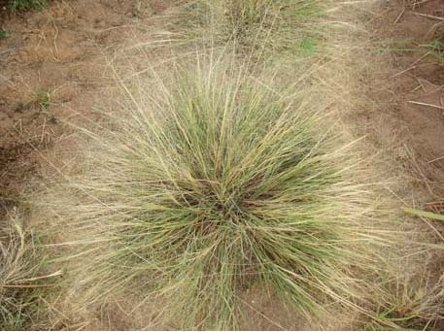USDA NRCS 2009

**Uses**

*Revegetation:* Texas dropseed has the ability to tolerate higher levels of salinity and alkalinity in the soil. It can be used to revegetate areas such as oil well pads and on other saline soils.

*Erosion Control:* Texas dropseed is a bunchgrass with very thick vegetation near the soil surface which can be used to stabilize soils that have a tendency to erode.

*Wildlife:* Texas dropseed provides dense cover for birds and small mammals. The foliage is browsed by deer and small mammals. The seed can be eaten by birds and small mammals.

**Status**

Please consult the PLANTS Web site ([http://plants.usda.gov](http://plants.usda.gov/)) and your State Department of Natural Resources for this plant’s current status (e.g. threatened or endangered species, state noxious status, and wetland indicator values).

**Weediness**

This plant may become weedy or invasive in some regions or habitats and may displace desirable vegetation if not properly managed. Please consult your local NRCS Field Office, Cooperative Extension Service office, state natural resource, or state agriculture department regarding its status and use. Weed information is also available from the PLANTS Web site at http://www.plants.usda.gov. Please consult this and Related Web Sites and view the plant profile for this species for further information.

**Description**

Texas dropseed is a warm-season perennial bunchgrass that grows close to the soil surface. The culms of the plant range from twelve to twenty inches long. The leaf blades range from 1 ½ to 5 inches long and less than 1 ½ inches wide. They are smooth on the bottom side, but scabrous on the top. The seed head is a panicle-type with many spreading branches and branchlets. The seed head is between four to twelve inches long and almost the same wide. Once the seed matures, from June to August, the seed head breaks away from the plant.

**Adaptation**

Texas dropseed is found from Texas north to Nebraska, and west from Utah to Arizona. The plant is adapted to soils with higher saline and alkaline levels.

*Distribution*: Please consult the Plant Profile page for this species on the PLANTS Web site.

**Establishment**

Texas dropseed should be planted on a clean, firm seedbed. Planting can be done using either a grass drill or broadcast seeding. Seed is planted less than ½ inch deep at a rate of 1.0 lbs pure live seed (pls) per acre. When planting this as a component of a seed mixture, the seeding rate should be adjusted to the desired percent of the mix. Soil samples should be taken before planting to determine the amount of fertilizer needed to bring the fertility level up to a medium range.

**Management**

Texas dropseed is used as a component in seed mixtures for ranges and pastures. Stands of Texas dropseed should be well established before livestock is permitted to graze. Proper management is required to ensure the plant is not overgrazed or over utilized by livestock or wildlife. Consult your local NRCS Field Office for assistance with planning and applying prescribed grazing

**Pests and Potential Problems**

None Known

**Environmental Concerns**

None Known

**Cultivars, Improved, and Selected Materials (and area of origin)**

Duck creek germplasm was released from the James E. “Bud” Smith Plant Materials Center, Knox City, TX in 2000. The germplasm was originally collected in 1982 from native plants located along an intermittent stream flowing into Duck Creek north of Spur in Dickens County, Texas. The potential use of Duck Creek Germplasm is for range seeding and revegetation on disturbed or damaged sites that have saline problems.

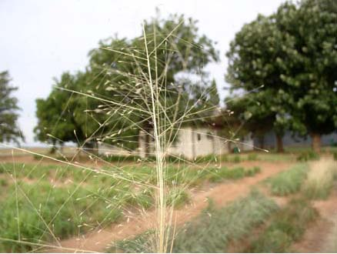USDA NRCS 2009

**Prepared By:**

Brandon Carr, USDA NRCS James E. “Bud” Smith Plant Materials Center, Knox City, Texas

Published November 2009

Edited:

For more information about this and other plants, please contact your local NRCS field office or Conservation District <<http://www.nrcs.usda.gov/>>, and visit the PLANTS Web site <[http://plants.usda.gov](http://plants.usda.gov/)> or the Plant Materials Program Web site <<http://plant-materials.nrcs.usda.gov>>

**USDA IS AN EQUAL OPPORTUNITY PROVIDER AND EMPLOYER**