|  |
| --- |
| SEASHORE DROPSEED |
| *Sporobolus virginicus (L.) Kunth* |
| Plant Symbol = SPVI3 |

Contributed by: USDA NRCS Hawaii PMC and National Plant Data Center

[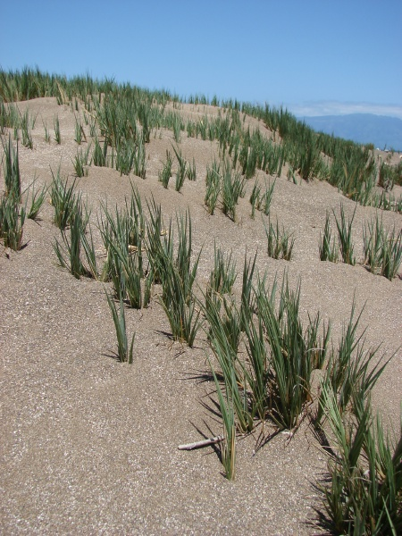](http://www.hear.org/starr/hiplants/images/hires/html/starr_070404_6606_sporobolus_virginicus.htm)Forest & Kim Starr, Keomoku Beach Lanai, Hawaii

From [www.hear.org](http://www.hear.org), Plants of Hawaii

Alternate Names

Aki aki, aki, mahiki, mahikihiki, manienie, manienie aki aki, manienie mahikihiki, manienie maoli, seashore rushgrass, marshgrass, crabgrass, beach dropseed.

Uses

*Conservation:*

*Sporobolus virginicus* does very well as a dune stabilizer. It has potential for stream bank stabilization and also roadside slope stabilization.

*Cultural:*

In some places *S. virginicus* is medicinally used to relieve urinary irritation and throat irritation.

*Wildlife:*

Many native seabirds find shelter and build nests in coastal stands of *S. virginicus*. It also provides excellent winter food for wild geese.

*Forage:*

*S. virginicus* has high protein and mineral content and is readily grazed by cattle.

Status

Please consult the PLANTS Web site and your State Department of Natural Resources for this plant’s current status (e.g. threatened or endangered species, state noxious status, and wetland indicator values).

Description

*Sporobolus virginicus* is a low-growing vigorous perennial grass that spreads by rhizomes. The height ranges from 4 to 8 inches tall. Roots can grow down to 18” deep. Leaves are 1-4” long and 0.04-0.12” wide with distinctly two‑ranked and salt crystals common on leaves and stems. The leaf sheath is overlapping and hairy at the throat. Its inflorescence is dense and spike-like. The panicle, 3” long, is shorter than other Sporobolus species.

Adaptation and Distribution

*S. virginicus* is commonly found in coastal dune habitats and it does best if sea water level fluctuates from 2 inches above soil surface to 6 inches below. It also does well in a variety of different soils from clays to sands. Being a plant that is adapted to low rainfall and high salinity, *S. virginicus* is fairly wide spread throughout the tropical regions and is native to the Pacific Islands Region as well as the continental United States. It also occurs in Africa, western seaboard of India, Sri Lanka, and Australia.

Establishment

Although *S. virginicus* does produce seed, very little of it is viable. The only practical way to propagate it is by vegetative rhizomatous slips. Actively growing slips should be selected for propagation. Cut back increase-plots to initiate active growth. Cut rhizomatous slips 3-4’ long and plant in sterile, well drained medium such as Sunshine4TM potting mix which has worked well. Place propagules under 50% shade and keep planting medium moist. Once the slips begin to take, it is recommended that time-release fertilizer supplements be added. After 2 months, place propagules in full sunlight to harden off. Propagules should be ready to plant within 3-4 months.

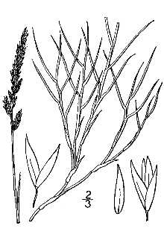

Britton & Brown (1913); from plants.usda.gov

Management

*Sporobolus virginicus* is a low maintenance conservation plant. Because it is very drought tolerant, water requirements are relatively low. It is recommended, though, that irrigation be applied during the first 1-2 months after transplanting to help establish plots. *S. virginicus* is also adapted to low fertility soils, although nutrient amendments according to soil tests would be beneficial for rapid establishment.

If forage production is desired, no more than half of the growth should be removed by grazing. Summer grazing deferments of at least 120 days are important to maintain good vigor. Controlled burning of this grass will result in lush, tender forage for winter grazing. Burning should be done no more than every 2 years. Allow 4inches of re-growth after burning before grazing.

Pests and Potential Problems

Despite its wide range throughout subtropical and tropical regions of the world, *S. virginicus* it believed to be pest free.

Environmental Concerns

None.

Cultivars, Improved, and Selected Materials

None available at this time. No known commercial source.

**Reference**

Leithead, H.L., L.L. Yarlett, & T.N. Shiflett. 1976. 100 native forage grasses in 11 southern states. USDA SCS *Agriculture Handbook No. 389*, Washington, DC.

**Prepared By:**

*David Duvauchelle*, USDA NRCS Hawaii Plant Materials Center, Hoolahua, Hawaii and *Percy Magee*, USDA NRCS National Plant Data Center, Baton Rouge, Louisiana

**Species Coordinator:**

*David Duvauchelle*, USDA NRCS Hawaii Plant Materials Center, Hoolahua, Hawaii

Edited: may02 ahv; jul03 ahv; sep05 jsp; jan07 jsp;

aug07 D. Duvauchelle; 070810 jsp

For more information about this and other plants, please contact your local NRCS field office or Conservation District, and visit the PLANTS Web site<<http://plants.usda.gov>> or the Plant Materials Program Web site <<http://Plant-Materials.nrcs.usda.gov>>

*The U.S. Department of Agriculture (USDA) prohibits discrimination in all its programs and activities on the basis of race, color, national origin, sex, religion, age, disability, political beliefs, sexual orientation, and marital or family status. (Not all prohibited bases apply to all programs.) Persons with disabilities who require alternative means for communication of program information (Braille, large print, audiotape, etc.) should contact USDA's* [*TARGET Center*](http://www.usda.gov/oo/target.htm) *at 202-720-2600 (voice and TDD).*

*To file a complaint of discrimination write USDA, Director, Office of Civil Rights, Room 326-W, Whitten Building, 14th and Independence Avenue, SW, Washington, DC 20250-9410 or call 202-720-5964 (voice or TDD). USDA is an equal opportunity provider and employer.*

Read about [*Civil Rights at the Natural Resources Conservation Service*](http://www.nrcs.usda.gov/about/civilrights/).