

Plant Fact Sheet

|  |
| --- |
| big sacaton |
| *Sporobolus wrightii* Munro ex Scribn. |
| Plant Symbol = SPWR2  Contributed by: USDA NRCS Kika de la Garza Plant Materials Center  © W.L. Wagner Smithsonian Institution @ USDA NRCS PLANTS |

### Alternate Names

*Sporobolus airoides* (Torr.) Torr. var. *wrightii* (Munro ex Scribn.) Gould

### Uses

Big sacaton may be used in pure stands or as part of a rangeland seeding mix for highly alkaline soils. It is useful for revegetating saline soils throughout the Southwest. It performs well as a grass hedge terrace or windstrip for erosion control. It helps stabilize watershed structures, stream banks and flood plain areas. Big sacaton is also useful for wildlife cover.

### Status

Please consult the PLANTS Web site and your State Department of Natural Resources for this plant’s current status (e.g. threatened or endangered species, state noxious status, and wetland indicator values).

Please consult the PLANTS Web site and your State Department of Natural Resources for this plant’s current status (e.g., threatened or endangered species, state noxious status, and wetland indicator values).

### Description and Adaptation

Big sacaton (*Sporobolus wrightii*) is a native, warm-season grass that forms dense clumps. It is a coarse, upright bunch grass that can grow from 3 to 8 feet tall. Leaves are anywhere from 1 to 2½ inches wide and up to 1 foot long. The pale flowers of big sacaton form in stiff, upright clusters 1 to 2 feet long.

Big sacaton grows primarily on heavier soils in lowland or wetland sites. It is tolerant of highly alkaline and saline soil, and can tolerate poorly drained soils and seasonally flooded areas. The plant is also found on open areas such as rocky slopes, plateaus, and mesas.

Big sacaton is distributed throughout much of the Southwest. For a current distribution map, please consult the Plant Profile page for this species on the PLANTS Website.

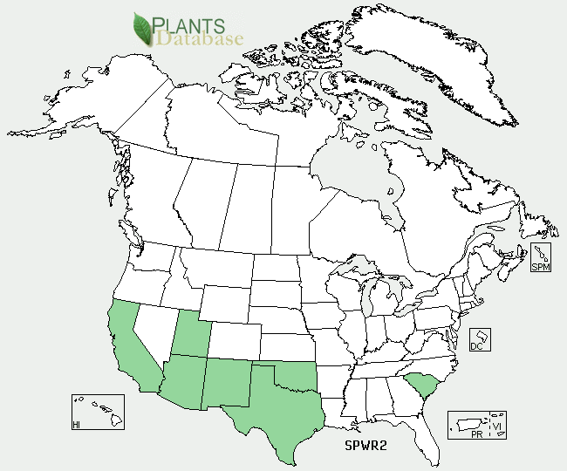

Big sacaton distribution from USDA-NRCS PLANTS Database.

For updated distribution, please consult the Plant Profile page for this species on the PLANTS Web site.

### Establishment

Seedbed preparation should begin well in advance of planting. Planting can be scheduled for early spring or where there is minimal cool-season weeds, big sacaton can also be planted in the fall.

Establish a clean, weed-free seedbed by either tillage or herbicides. Prior to planting, the site should be firm and have accumulated soil moisture.

Big sacaton seed can be drilled or broadcast. Seed should be planted at 1/8 to 1/4 inch depth. It is better to plant too shallow than too deep. A seeding rate of 1/2 to 1 pound of pure live seed per acre is recommended. Plants can also be grown in small paper containers and then transplanted for establishment of grass hedges and wind barriers. On saline soils, weed-free mulch can be used to improve establishment. Establishment is highly dependent on good rainfall or irrigation.

Soil analysis should be performed prior to planting to determine salinity levels and necessary levels of nitrogen, phosphorus and potassium. Nitrogen should not be applied until the stand is established. Evaluate the stand after 60 days. If 1 plant per square foot is present than the planting has been successful.

### Management

Big sacaton should not be grazed the first year. After stands are established, either continuous or rotational grazing can be used. It is recommended that a minimum 12-inch stubble height be maintained under continuous grazing. For rotational grazing, forage height should be utilized between 8 to 16 inches. Big sacaton will benefit from an annual mowing at an 18-24 inch height when used as a grass hedge or wind barrier.

### Pests and Potential Problems

None

### Environmental Concerns

None

### Cultivars, Improved, and Selected Materials (and area of origin)

The Falfurrias Germplasm release of big sacaton was chosen because of its ability to produce abundant forage, especially on droughty, alkaline and saline sites. It also produces nutritious, green forage throughout the winter months in south Texas. This selected collection came from Falfurrias, TX. It was evaluated at both the Kika de la Garza Plant Materials Center and the Knox City Plant Materials Center.

‘Windbreaker’ big sacaton was released by the USDA Natural Resources Conservation Service Los Lunas Plant Materials Center (LLPMC) and the New Mexico State University Los Lunas Agricultural Science Center in 2011

for use in controlling wind induced soil erosion, forage and cover for livestock and wildlife, and use in low water use landscapes. It is adapted to the southwestern United States and other semi-arid temperate environments.

### Prepared By

*John Lloyd-Reilley*, Manager

*Elizabeth Kadin*, Research Assistant

Kika de la Garza Plant Materials Center, Kingsville, TX

### Citation

Lloyd-Reilly, J. 2011, Plant Fact Sheet for big sacaton (*Sporobolus wrightii)*, USDA-Natural Resources Conservation Service, Kika de la Garza Plant materials Center, Kingsville, TX.

Published February 2002

Edited: [06Feb2001 jlk; 17Aug2006 jgp;07Sept2011 ds;08Sept2011 jab]

For more information about this and other plants, please contact your local NRCS field office or Conservation District <<http://www.nrcs.usda.gov/>>, and visit the PLANTS Web site <[http://plants.usda.gov](http://plants.usda.gov/)> or the Plant Materials Program Web site <<http://plant-materials.nrcs.usda.gov>>

**USDA IS AN EQUAL OPPORTUNITY PROVIDER AND EMPLOYER**