

Plant Fact Sheet

# Sago Pondweed

## Stuckenia pectinata (L.) Böerner

Plant Symbol = STPE15

Contributed by: USDA NRCS Kansas Plant Materials Center, Manhattan, Kansas

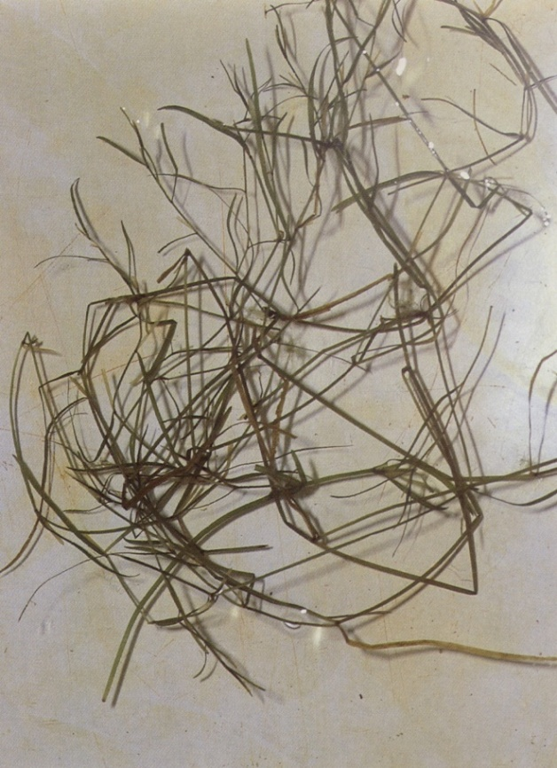

Figure 1. Sago pondweed. Robert H. Mohlenbrock. USDA NRCS. 1992. Western wetland flora: Field office guide to plant species. West Region, Sacramento. Courtesy of USDA NRCS Wetland Science Institute.

### Alternate Names

Previously known as *Potamogeton pectinatus* and *Stuckenia pectinatus,* the currently accepted name is *Stuckenia pectinata*.

*Coleogeton pectinatus*; *Potamogeton interruptus*; *Potamogeton latifolius*; *Potamogeton flabellatus*; *Potamogeton columbianus*; broadleaf pondweed; duck grass; eelgrass, fennel pondweed; foxtail; Indian grass, old-fashioned bay grass; pondgrass; potato moss; wild celery; fennel-leaved water milfoile; poker grass; pochard grass; string weed

### Uses

*Wildlife*: Waterfowl extensively use and rely on sago pondweed as a food source. The whole plant can be consumed, and parts are utilized by diving, dabbling, whistling ducks, many types of geese, swans, coots and the long-billed dowitchers.

*Bioremediation and bioindication*: May be used to suppress phytoplankton blooms by taking up phosphorus from the water and to monitor heavy metal pollution in rivers.

*Erosion control*: The wave dampening action of sago pondweed can be used for erosion control of shores and dams.

### Status

Please consult the PLANTS Web site and your State Department of Natural Resources for this plant’s current status (e.g., threatened or endangered species, state noxious status, and wetland indicator values). Sago pondweed is an obligate wetland species.

### Weediness

This plant may become weedy or invasive in some regions or habitats and may displace desirable vegetation if not properly managed. Please consult with your local NRCS Field Office, Cooperative Extension Service office, state natural resource, or state agriculture department regarding its status and use. Weed information is also available from the PLANTS Web site at [http://plants.usda.gov](http://plants.usda.gov/). Please consult the Related Web Sites on the Plant Profile for this species for further information. Sago pondweed is considered a nuisance weed or noxious weed in some waters that are used for recreational purposes and in irrigation canals.

### Description and Adaptation

*General*:Pondweed Family (Potamogetonaceae). Sago pondweed is an aquatic herbaceous plant up to 3 feet tall. Sago pondweed is generally completely submersed except the reproductive stalk that peaks above the water that flowers June – September. It is nearly un-branched at the base, becoming freely branched towards the top. The leaves are ¾ -4.5 inches long and up to ½ inch wide. The flower stalk can be up to 2 inches long. Fruits are yellowish to brown.

Sago pondweed occurs nearly worldwide and is found submerged in semi-permanent to permanently flooded areas where the water is less than 8 feet deep. It can be found from sea level to almost 16,000 feet above sea level. Sago pondweed can grow in nearly all bottom substrates and can tolerate high salinity, pH, and alkaline water.

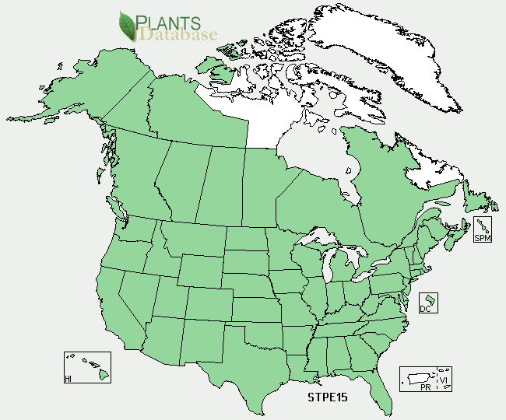

Figure . Sago pondweed distribution from USDA-NRCS PLANTS Database

For updated distribution, please consult the Plant Profile page for this species on the PLANTS Web site.

### Establishment

Sago pondweed can be cultured in liquid media for experimental purposes from drupelets, turions, rhizomes, leafy tops, or cuttings. Drupelets can be stored in wet or dry conditions. Turions can be harvested and stored for a period of up to four years, if dipped in paraffin. Turions can also be stored in water at low temperatures or packed in layers of straw or moss.

### Management

Managers have tried to manipulate populations of sago pondweed for use by waterfowl and wildlife by adjusting the water levels. However, results from these trials are variable and depend on water chemistry, water levels, geography, and other plant competitors.

### Pests and Potential Problems

Although not conclusive, there are bacteria and fungi that may cause diseases in sago pondweed and could be responsible for a decline in sago populations or deformities of the plants.

### Environmental Concerns

Sago pondweed has been considered a noxious weed in waters used for recreational purposes and irrigation. Dense formations of sago beds may also limit movement of predator fish and inhibit fishing.

### Control

Please contact your local agricultural extension specialist or county weed specialist to learn what works best in your area and how to use it safely. Always read label and safety instructions for each control method. Trade names and control measures appear in this document only to provide specific information. USDA NRCS does not guarantee or warranty the products and control methods named, and other products may be equally effective. Many chemical, biological, and physical methods have been used to attempt to control growth or numbers of sago pondweed.

### Cultivars, Improved, and Selected Materials (and area of origin)

Theses plant materials are somewhat readily available from commercial sources. There are no known cultivars, improved, or selected materials at this time.

### Prepared By

P. Allen Casey, USDA NRCS Plant Materials Center, Manhattan, Kansas

### Citation

Casey, P.A. 2010. Plant Fact Sheet for Sago Pondweed (*Stuckenia pectinata* (L.) Böerner). USDA-Natural Resources Conservation Service, Kansas Plant Materials Center. Manhattan, KS 66502.

Published *November 2010*

For more information about this and other plants, please contact your local NRCS field office or Conservation District <<http://www.nrcs.usda.gov/>>, and visit the PLANTS Web site <[http://plants.usda.gov](http://plants.usda.gov/)> or the Plant Materials Program Web site <<http://plant-materials.nrcs.usda.gov>