

Plant Fact Sheet

# pacific aster

## Symphyotrichum chilense (Nees) G.L. Nesom

Plant Symbol = SYCH4

Contributed by: USDA NRCS Corvallis Plant Materials Center, Oregon

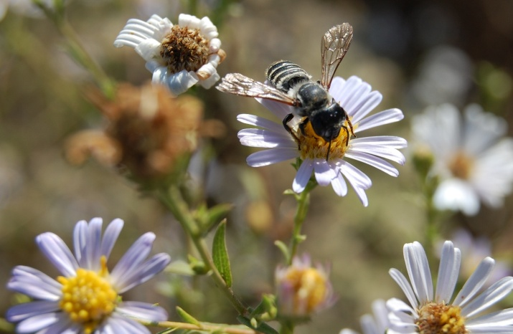

Photo by Annie Young-Mathews, NRCS, 2010

### Alternate Names

Previously known as *Aster chilensis* Nees, the currently accepted name is *Symphyotrichum chilense*. Other common names include coast aster, Pacific American-aster, and common California aster. When it was named it was mistakenly thought to occur in Chile, but in fact is limited to North America. There are currently three recognized varieties of Pacific aster: *S. chilense* var. *chilense*, var. *invenustum*, and var. *medium*.

### Uses

Pacific aster can be used in wildlife or pollinator enhancement plantings, native prairie restoration, meadow gardens, and erosion control or critical area plantings. Its deep, extensive, fibrous root system can help stabilize slopes.

Native aster species (including *Symphyotrichum* spp.) are good late-season pollinator plants, providing a critical pollen source for bees active in the late fall, including new bumble bee queens building up their energy reserves before winter dormancy. They also serve as nectar sources and host plants for checkerspot and crescent butterflies.

### Status

Pacific aster is considered a facultative plant within its native range, meaning it is equally likely to occur in wetlands or non-wetlands. Please consult the PLANTS Web site and your State Department of Natural Resources for this plant’s current status (e.g., threatened or endangered species, state noxious status, and wetland indicator values).

### Description and Adaptation

Pacific aster is a common, native, rhizomatous, herbaceous perennial that grows 1 to 4 ft tall. Plants can be clumped or spreading, with one to many ascending or erect stems that are hairy towards the tips. Basal leaves are usually hairless, stalked, thin (generally 1 to 8 inches long by 0.2 to 1.5 inches wide), and wither by the time the plant flowers. Leaves along the stems are arranged alternately, stalkless, and are 1 to 3.5 inches long by 0.2 to 1.2 inches wide. Flower heads are arranged in open, flat-top or round-top, branched clusters (cymes), with violet to pink or white ray flowers (petal-like outer part of the aster flower) and yellow disk flowers (centers). Bloom time varies by latitude and elevation, but can extend from June to October.

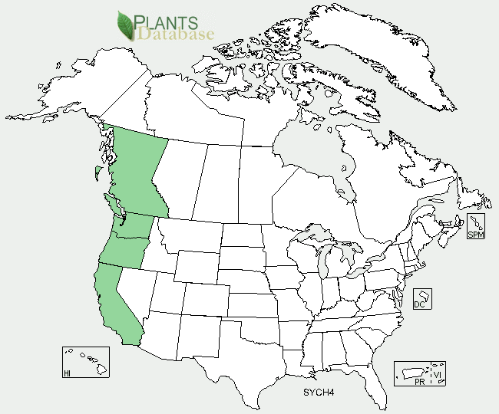

Pacific aster distribution from USDA-NRCS PLANTS Database.

Pacific aster grows in a variety of habitats including grasslands, meadows, salt marshes, coastal dunes and bluffs, coastal scrub, and open or disturbed areas. It is adapted to fine- to medium-textured soils, full sun to partial shade, is relatively drought tolerant, and has a high salinity tolerance. Pacific aster is distributed in coastal regions from southwest British Columbia to Southern California at elevations below 1600 ft. For updated distribution, please consult the Plant Profile page for this species on the PLANTS Web site.

### Establishment

Pacific aster does not possess seed dormancy, so untreated seed can be sown any time of year, but will generally germinate in the spring when soils are moist and temperatures reach 60°F. Standard site preparation should include treatment and/or removal of weeds for one to two years prior to seeding, and preparation of a clean, firm seed bed. Typical seeding rates for pollinator enhancement or restoration plantings are 1 to 2 pounds per acre for a single species planting, but would be substantially less as part of a mix. There are 800,000 to 1,300,000 seeds per pound.

Plants are also easily established from transplanted plugs in the fall or spring. If seed is not available, plants can be propagated from divisions of the rhizome or root crown in early spring, but this method is time consuming and generally not preferable if other methods are available.

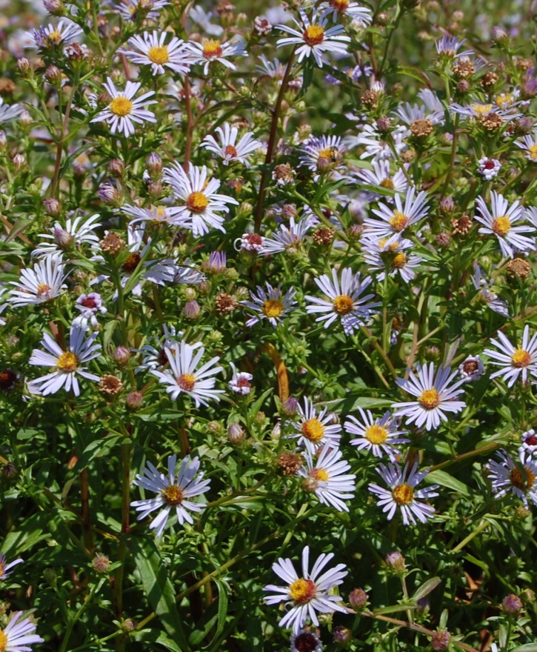

Photo by Amy Bartow, NRCS, 2010

### Management

Pacific aster generally does not require watering, fertilization, or other management once established. Plants can be cut or mowed to ground level in the late fall or winter following the first hard frost and will re-sprout in the spring.

### Pests and Potential Problems

There are no known pests or problems associated with Pacific aster.

### Environmental Concerns

Under optimal conditions (full sun and moist, well-drained soil), Pacific aster can develop long, vigorous rhizomes that allow the plants to spread into thick clumps that may outcompete weaker neighboring plants. Plants also produce prolific amounts of wind-born seed that can spread and establish in neighboring areas. Once established, Pacific aster plants can be difficult to completely remove from an area.

### Cultivars, Improved, and Selected Materials (and area of origin)

There are no developed cultivars of Pacific aster, but container plants and seed of local ecotypes are readily available from commercial sources throughout the west.

### Prepared By

*Annie Young-Mathews*, Corvallis Plant Materials Center, Oregon

### Citation

Young-Mathews, A. 2012. Plant fact sheet for Pacific aster (*Symphyotrichum chilense)*. USDA-Natural Resources Conservation Service, Corvallis Plant Materials Center, Corvallis, OR.

Published February 2012

Edited: 22Nov2011 dcd; 28Nov2011 ab; 22Dec2011 jab; 18Jan2012 gm

For more information about this and other plants, please contact your local NRCS field office or Conservation District <<http://www.nrcs.usda.gov/>>, and visit the PLANTS Web site <[http://plants.usda.gov](http://plants.usda.gov/)> or the Plant Materials Program Web site <<http://plant-materials.nrcs.usda.gov>>

**USDA IS AN EQUAL OPPORTUNITY PROVIDER AND EMPLOYER**