

Plant Fact Sheet

# pale false mannagrass

## Torreyochloa pallida (Torr.) Church var. pauciflora (J. Presl) J.I. Davis

Plant Symbol = TOPAP3

Contributed by: USDA NRCS Plant Materials Center, Corvallis, Oregon

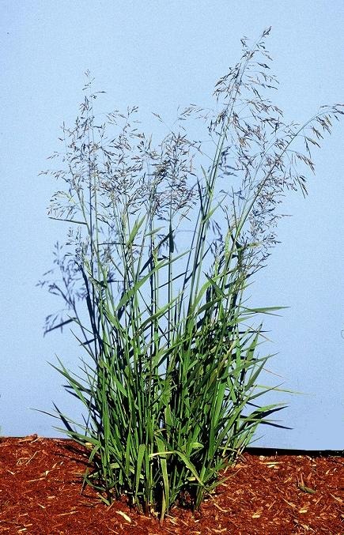

*Photo by Dale Darris, Corvallis Plant Materials Center.*

**Alternative Names**

*Alternate Common Names:* alkaligrass, weak mannagrass, weak false manna

*Alternate Scientific Names: Glyceria pauciflora, Glyceria otisii, Pucinellia pauciflora, Torreyochloa pauciflora*

Uses

Pale false mannagrass has potential for restoration and enhancement of forested, prairie, and riparian wetlands, as well as other non tidal wetland plant communities. Its underground creeping stems (rhizomes) improve the plant’s ability to stabilize soils along faster moving streams and watercourses. The seeds are probably eaten by waterfowl and other birds, while the foliage provides cover for wildlife. The forage value of false mannagrass for livestock, large game, and small mammals is not known. It may have potential for use in ditches or swales designed to filter agricultural or stormwater runoff. Strong rhizome production coupled with low-lying, curved stems that root from the joints makes this species a good candidate for streambank, channel, and shoreline stabilization.

Status

Please consult the PLANTS Web site and your State Department of Natural Resources for this plant’s current status (e.g. threatened or endangered species, state noxious status, and wetland indicator values).

Description and Adaptation

Pale false mannagrass is a native, perennial, cool season grass that grows 30 to 150 cm tall. The stems are erect to decumbent (low lying and bent upward) and may root where the nodes (joints) touch the ground. It actively spreads by rhizomes (underground shoots). Leaf blades are rolled when young, flat when mature, 3-15 mm wide, and slightly rough to the touch on one or both sides. The flower head (panicle) is loose and open, 7 to 20 cm long, with ascending or drooping branches. Pale false mannagrass occurs from Alaska to California and east to South Dakota and New Mexico. It can be found from near sea level to timberline.

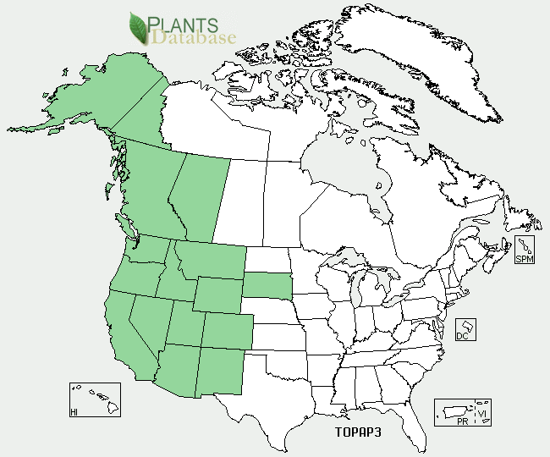

*Pale false mannagrass distribution from USDA NRCS PLANTS Database.*

*Key to identification:*Pale false mannagrass is easily confused with true mannagrasses (*Glyceria* spp.), with which it was once classified. However, its leaf sheaths (lower part of the leaf surrounding the stem) are open rather than closed and have cross- markings. The species is also similar to true alkaligrasses (*Pucinellia* spp.). Consult with a botanical key for distinguishing traits.

*Relative abundance in the wild:* Scattered in Oregon and Washington in marshy areas and roadside ditches where reed canarygrass (*Phalaris arundinacea*) does not dominate. Its abundance elsewhere is unknown. Seed retention is fair to good, production is high, and seed fill is excellent. Pale false mannagrass ripens over several weeks in late summer wherever soil moisture is non-uniform. These features make wild collection easy.

*Adaptation:* Pale false mannagrass is found in freshwater marshes, swamps, wet forest openings,wet meadows, ditches and other depressions.Itgrows in acid soils comprised of loamy, organic, or sandy substrates. The species tolerance to salinity, alkalinity, and high acidity is not well reported. It typically occurs on continuously moist, saturated, and shallow flooded areas. At moderate elevations in Oregon, pale false mannagrass can form its own plant association where it comprises 30 to 80% of the total cover. Most of the surface area between plants is mud or open water. This species is found in full sun to intermediate shade, but may prefer the latter.

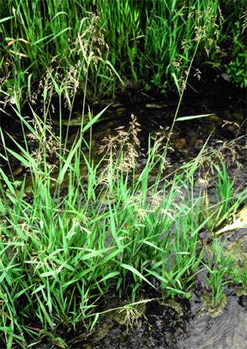

*Photo by Dale Darris, Corvallis Plant Materials Center.*

Establishment

The seed has no dormancy and germinates when fall or spring sown. It has a weak hull and requires no special conditioning. Establishment rate is moderate as is rhizome spread. There are approximately 1,955,000 seeds per pound (± 30%). A seeding rate of one pound per acre of pure live seeds will result in about 45 seeds per square foot. Suggested seeding rates are 1 to 4 lbs/acre when sown as a single species. Rhizomes and plugs may also be used. Recommended spacing is 8 to 16 inches (20 to 40 cm) for uniform aerial coverage within one to two years, respectively.

Management

There is a lack of information about the management of this species for livestock or other uses. When cultivated for seed, poorly drained soil or summer irrigation is required along with moderate soil fertility levels. Tolerance to wildfire or prescribed burning is not well documented.

Environmental Concerns

In some situations pale false mannagrass can form dense stands that may limit diversity, but it is not known to be weedy.

Cultivars, Improved, and Selected Materials (and area of origin)

This species is rarely sold as seed or plants. Availability depends on wild harvests, hand collections, or contract growing with producers who specialize in native herbaceous seed.

Prepared By:

*Dale Darris*, USDA NRCS Plant Materials Center, Corvallis, Oregon

**Citation**

Darris, D. 2004. Plant fact sheet for pale false mannagrass (*Torreyochloa pallida* var*. pauciflora*). USDA-Natural Resources Conservation Service, Plant Materials Center, Corvallis, OR.

Published December 2004

Edited: 23Mar2006 jsp; 17Sep2008 dcd; 19Sep2008jsp; 21Feb2012 aym

For more information about this and other plants, please contact your local NRCS field office or Conservation District <<http://www.nrcs.usda.gov/>>, and visit the PLANTS Web site <[http://plants.usda.gov](http://plants.usda.gov/)> or the Plant Materials Program Web site <<http://plant-materials.nrcs.usda.gov>>

**USDA IS AN EQUAL OPPORTUNITY PROVIDER AND EMPLOYER**