

Plant Fact Sheet

# Eastern gamagrass

## Tripsacum dactyloides L.

Plant Symbol = TRDA3

Contributed by: USDA NRCS East Texas PMC

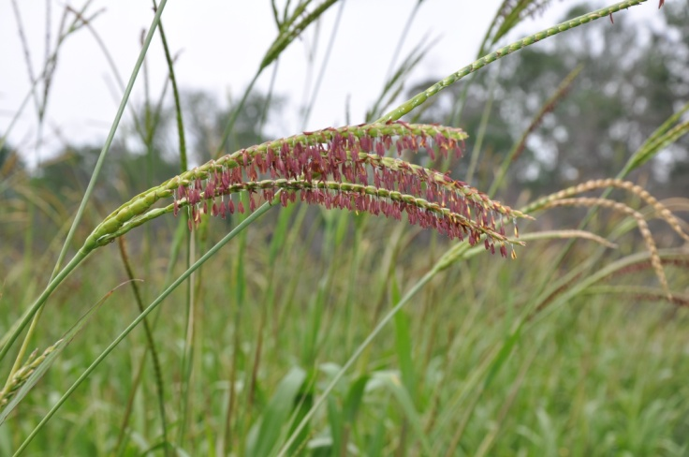

Figure Eastern gamagrass seed head during pollination

**Alternative Names**

*Common Alternate Names:* bullgrass, capim gigante, eastern mock gama, fakahatchee grass, Gamagrass, herbe grama, maicillo oriental, pasto Guatemala, wild corn, zacate maicero

*Scientific Alternate Names:* Tripsacum dactyloides (L.) L. var. occidentale Cutler & Anders., Coix dactyloides L.

### Uses

Eastern gamagrass is primarily used as livestock forage. It is extremely palatable to all classes of livestock, and will decrease due to selective grazing if not managed correctly. It may also be cut for hay or used as silage. It is important to allow proper recovery time between grazing or cutting events to maintain stand health and longevity. Eastern gamagrass is also important in conservations plantings and can be used to improve wildlife habitat, as filter strips to remove excess nutrients from agricultural areas, and in prairie restoration plantings.

### Status

Please consult the PLANTS Web site and your State Department of Natural Resources for this plant’s current status (e.g., threatened or endangered species, state noxious status, and wetland indicator values).

### Description and Adaptation

Eastern gamagrass, is a native, warm season, perennial, bunch grass. It is a distant relative of corn that may reach up to 8 feet in height. Seed is produced from May to July. The seed heads are 6 to 10 inches long and are made up of one to several spikes. The leaves are 3/8 to 3/4 inch wide and 12 to 24 inches long, with a well defined midrib. Eastern gamagrass is distributed across the eastern half of the United States in areas that receive at least 25 inches of annual rainfall. It is adapted to a wide variety of soil textures and favors moist sites. It is classified as a facultative wetland plant and will tolerate brief periods of flooding.

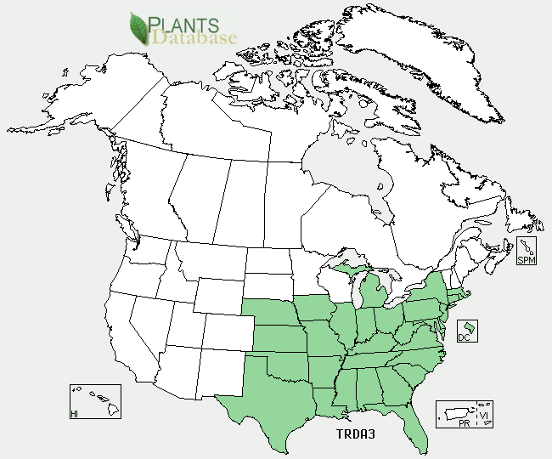

Eastern gamagrass distribution from USDA-NRCS PLANTS Database.

For updated distribution, please consult the Plant Profile page for this species on the PLANTS Web site.

### Establishment

Plant into a well prepared, firm, weed free seed bed. Sites formerly in cool season pastures or hayland should be sown without tillage to avoid exposing weed seeds to favorable germination conditions.

The seeds must first be stratified (exposed to cold, wet conditions) before sowing. To stratify artificially, place the seeds in a burlap bag until the bag is about 1/2 full. Soak this in a 1% solution of fungicide for 10‑12 hours. Afterwards, drain the seeds and seal them, along with the sack, in a plastic bag. Store them this way for 8 weeks at 35-45 °F. Stratification may also be achieved by planting in the fall and allowing the seed to over winter in the soil. Fall plantings do not typically yield stands as even as spring plantings with stratified seed.

Planting dates follow those of corn and should be done when the soil is at least 55 °F. Follow recommended seeding rates for the cultivar or variety being used. Grain drills make the most efficient use of seed, but seed may also be broadcast planted. Seed should be covered to a depth of 1 inch.

In the northeast, gamagrass is prone to frost heaving the first winter after planting on some soils. The use of moderately well drained or well drained soils makes this possibility less likely. On soils with poor drainage, use all strategies to produce the largest possible plants by the end of the first season. Plants with 15 to 20 culms seem to be very resistant to frost heaving, while those with less than 10 culms are vulnerable.

### Management

Weeds may be controlled via selective herbicides, cultivation, mowing, and timely controlled burns. Cultivation can release new weed seed by bringing deeply buried seed to favorable conditions for germination near the surface. Shielded or hooded sprayers using non- selective herbicides drastically reduce weed competition between rows of production style plantings. Timely applications of pre-emergent herbicides are also very helpful at reducing weed pressure. If chemicals are not an option, mowing maybe used to control annual weed species. Mowing should be timed so that it remove or destroy weed seed heads before they produce viable seed.

Eastern gamagrass should not be cut or grazed below 8 inches. Cutting or grazing too low will reduce stand vigor and health; eventually leading to stand loss. Stands require at least 28 days of recovery time between cutting and/or grazing events. 45 days of recovery is optimal and all cutting or grazing should be stopped within 45 days of the first killing frost.

Eastern gamagrass is an efficient user of nitrogen, and responds well to fertility amendments up to 250-350 lbs.N/acre. However, this species evolved in a low nutrient cycling system and satisfactory production may be produced at much lower nitrogen rates. For seed production 50 to 75 lbs.N/acre is recommended. Only fertilize mature stands as fertility amendments increase weed pressure in young plantings. Fertilizers should be applied in split applications if possible.

### Pests and Potential Problems

Eastern gamagrass is susceptible to some fungal plant disease such as leaf rust. There have been reports of stand loss due to the “Take- All” fungal pathogen that attacks lawns and turf grass. Two viruses, “sugarcane mosaic virus strain maize dwarf mosaic virus B” and “maize dwarf mosaic virus” can infect eastern gamagrass. It is also susceptible to some of the same insect pests as corn.

### Environmental Concerns

There are no known environmental concerns with this species.

### Control

Please contact your local agricultural extension specialist or county weed specialist to learn what works best in your area and how to use it safely. Always read label and safety instructions for each control method. Trade names and control measures appear in this document only to provide specific information. USDA NRCS does not guarantee or warranty the products and control methods named, and other products may be equally effective.

### Cultivars, Improved, and Selected Materials (and area of origin)

There are several cultivars and improved strains of eastern gamagrass available in the commercial seed market. A list includes: Pete (Manhattan, KS), IukaIV (Woodward, OK), Nacogdoches, Jackson, Median (Nacogdoches, TX), San Marcos (Knox City, TX), Highlander (Coffeeville, MS), Bumpers (Boonville, AR), St. Lucia (Brooksville, FL), and Verl (Oklahoma). Detailed information about these cultivars and germplasms maybe found in the plant guide.

### Prepared By USDA NRCS Plant Materials Program

### Citation

Shadow, Robert A. 2012. Plant fact sheet for Eastern Gamagrass (Tripsacum dactyloides*)*. USDA-Natural Resources Conservation Service, Plant Materials Center. Nacogdoches, TX 75964.

Published Feb, 5, 2002

Edited: 05Feb2002 jlk; 30may06jsp; 14Jun2012 ras

For more information about this and other plants, please contact your local NRCS field office or Conservation District <<http://www.nrcs.usda.gov/>>, and visit the PLANTS Web site <[http://plants.usda.gov](http://plants.usda.gov/)> or the Plant Materials Program Web site <<http://plant-materials.nrcs.usda.gov>>

**USDA IS AN EQUAL OPPORTUNITY PROVIDER AND EMPLOYER**