|  |
| --- |
| purpletop |
| *Tridens flavus* (L.) Hitchc. |
| Plant Symbol = TRFL2 |

Contributed by: USDA NRCS Plant Materials Program

Alternate Names

greasegrass

Uses

Purpletop is a perennial, warm season grass that is consumed by all grazing livestock. It is well adapted to shallow, droughty, infertile soil and provides forage in the summer and on sites where cool season forages do not produce well. It can be planted alone or in mixes with other warm season grasses.

Status

Please consult the PLANTS Web site and your State Department of Natural Resources for this plant’s current status (e.g. threatened or endangered species, state noxious status, and wetland indicator values).

Description

*Tridens flavus* (L.) Hitchc., purpletop, is a bunchgrass with erect tufted culms. It is 35 to 75 inches tall. Leaf blades are flat, often less than 1/2 inch wide and 10 to 27 inches long, lax, smooth, and glossy green. The leaf sheath is flattened near the base, keeled (has a central rib), and overlapping. The ligule (projection up from inside leaf sheath where sheath meets blade) is a ring of short hairs. The seedhead is an open cluster, 8 to 14 inches long, spreading, pyramid shaped, usually purple, sometimes nearly black. The seedheads droop and are covered with an oily or grease-like substance. There are 465,000 seeds per pound.

Adaptation and Distribution

Purpletop is adapted to areas of the eastern United States with more than 30 inches of rainfall, from Maine to eastern Nebraska to eastern Texas to Florida. It is not common in northern New England or New York, especially on inland sites, where poor winter hardiness is a problem.

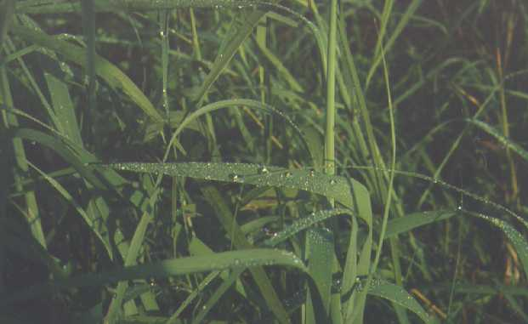

USDA NRCS National Plant Materials Center

Beltsville, MD

Purpletop is adapted to soils that are well-drained to droughty, shallow and rocky, fertile to sterile. It is tolerant of road salt and often colonizes roadside sites, especially in Pennsylvania and south.

For a current distribution map, please consult the Plant Profile page for this species on the PLANTS Website.

Establishment

Purpletop should be seeded in spring, when soil moisture and temperatures are conducive to germination. Seeding depth should be 1/4 inch. Ten to fifteen pounds PLS (pure live seed) per acre is sufficient for drill seedings. For broadcast seedings, the seeding rate should be 20 to 25 pounds PLS per acre.

Purpletop seedlings are slow to develop and competition from weeds and/or cool season grass may overwhelm the stand on the better soils. Stands should be established using a no till drill to minimize the number of weed seeds exposed. The cool season grasses must be thoroughly killed with contact herbicide before seeding. Purpletop is tolerant of most broadleaf herbicides. (Read labels for application amounts and grazing restrictions.)

The most common cause of purpletop establishment failures is a loose seedbed. Conventionally tilled plantings should be packed before and especially after the seeding. The seedbed should be firm, showing only a slight imprint when stepped on. When using a no till drill, be sure the furrows are closed to avoid seed exposure and drying. This is effectively done by cultipacking after drilling.

Management

Fertilization to maintain moderate levels of phosphorus and potassium are recommended for establishment. Nitrogen fertilization is not recommended until the purpletop is established and above the competition. It may be applied late in the first summer at 20 to 40 pounds per acre or early in the second summer at 40 to 80 pounds per acre. Fertilizer should be applied in subsequent years to maintain vigor and enhance production. Mature stands resist weed and brush encroachment, but are tolerant of mowing or burning for control. Cool season grasses and legumes can be controlled with a contact herbicide or overgrazing before the purpletop emerges. Rotational grazing of purpletop that removes half the above ground growth (6 to 12 inches down to 3 to 6 inches) will provide the best forage and maintain the stand. With care, a stand will last indefinitely.

Pests and Potential Problems

This section is under development.

Cultivars, Improved, and Selected Materials (and area of origin)

No improved cultivars have been released.

Prepared By & Species Coordinator:

USDA NRCS Plant Materials Program

Edited: 05Feb2002 JLK 060818 jsp

For more information about this and other plants, please contact your local NRCS field office or Conservation District, and visit the PLANTS Web site<<http://plants.usda.gov>> or the Plant Materials Program Web site <<http://Plant-Materials.nrcs.usda.gov>>

*The U.S. Department of Agriculture (USDA) prohibits discrimination in all its programs and activities on the basis of race, color, national origin, sex, religion, age, disability, political beliefs, sexual orientation, and marital or family status. (Not all prohibited bases apply to all programs.) Persons with disabilities who require alternative means for communication of program information (Braille, large print, audiotape, etc.) should contact USDA's* [*TARGET Center*](http://www.usda.gov/oo/target.htm) *at 202-720-2600 (voice and TDD).*

*To file a complaint of discrimination write USDA, Director, Office of Civil Rights, Room 326-W, Whitten Building, 14th and Independence Avenue, SW, Washington, DC 20250-9410 or call 202-720-5964 (voice or TDD). USDA is an equal opportunity provider and employer.*

*Read about* [*Civil Rights at the Natural Resources Convervation Service*](http://www.nrcs.usda.gov/about/civilrights/)*.*