|  |
| --- |
| alsike clover |
| *Trifolium hybridum* L. |
| Plant Symbol = TRHY |

Contributed by: USDA NRCS Plant Materials Program

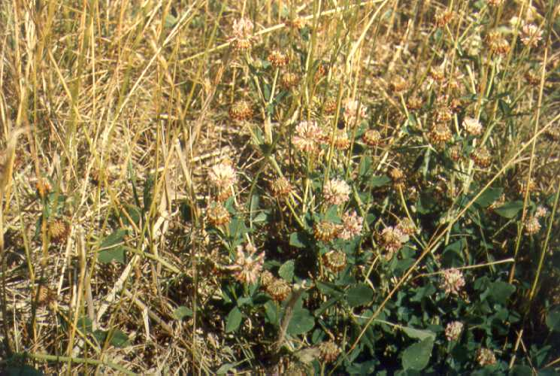

USDA NRCS National Plant Materials Center

Beltsville, MD

Alternate Names

*Trifolium elegans* Savi

Uses

Alsike clover is used for hay, pasture, and soil improvement, and is preferred where wetter or acid soils are encountered. It is generally out produced by other clover species for particular uses. Note: alsike clover can be toxic to horses under some conditions.

Status

Please consult the PLANTS Web site and your State Department of Natural Resources for this plant’s current status (e.g. threatened or endangered species, state noxious status, and wetland indicator values).

Description

Alsike clover has smooth stems and leaves, reaching a height of 2-4 feet. This introduced plant tends to recline or lodge unless companion plants hold the stem upright. The flowers are pink to white, and are borne along the length of the stem. The flower heads are much smaller than red clover, and the stems do not terminate in a flower as they do in red clover.

Adaptation and Distribution

Alsike is best adapted to the cool climate of the Northeast. It will tolerate wetter soils better than other clovers, and also acid conditions. It prefers silty clay loams, and does not tolerate droughty sites.

Alsike clover is distributed throughout the United States. For a current distribution map, please consult the Plant Profile page for this species on the PLANTS Website.

Establishment

Alsike clover is always seeded with grass, or can be overseeded into grass in the spring. For conventional plantings, spring and fall seedings will work. Alsike seed should always be inoculated due to the infrequent use of the species. Plant alsike at 2-4 pounds per acre, at a depth of 1/4 to 1/2 inch. Pre-plant fertilize according to soil test.

Management

Pasture management varies depending upon the forages in use, but should be based upon the grasses involved since they are the “meat and potatoes” of the mix. High rates of nitrogen fertilizer will damage the alsike component. In hayfields, cutting below 2 inches will damage the stand.

Animal management note: on pasture high in alsike clover content, take steps to introduce animals gradually to the forage or risk of bloat can be high. Horses have done poorly on pastures that have significant alsike components.

Pests and Potential Problems

Unknown.

Cultivars, Improved, and Selected Materials (and area of origin)

Common seed is available from commercial seed sources.

Prepared By & Species Coordinator:

USDA NRCS Plant Materials Program

Edited: 05Feb2002 JLK; 30may06jsp

For more information about this and other plants, please contact your local NRCS field office or Conservation District, and visit the PLANTS Web site<<http://plants.usda.gov>> or the Plant Materials Program Web site <<http://Plant-Materials.nrcs.usda.gov>>

*The U.S. Department of Agriculture (USDA) prohibits discrimination in all its programs and activities on the basis of race, color, national origin, sex, religion, age, disability, political beliefs, sexual orientation, and marital or family status. (Not all prohibited bases apply to all programs.) Persons with disabilities who require alternative means for communication of program information (Braille, large print, audiotape, etc.) should contact USDA's* [*TARGET Center*](http://www.usda.gov/oo/target.htm) *at 202-720-2600 (voice and TDD).*

*To file a complaint of discrimination write USDA, Director, Office of Civil Rights, Room 326-W, Whitten Building, 14th and Independence Avenue, SW, Washington, DC 20250-9410 or call 202-720-5964 (voice or TDD). USDA is an equal opportunity provider and employer.*

*Read about* [*Civil Rights at the Natural Resources Convervation Service*](http://www.nrcs.usda.gov/about/civilrights/)*.*