

Plant Fact Sheet

# Crimson clOver

*Trifolium incarnatum* L.

Plant Symbol = TRIN3

Contributed by: USDA NRCS Georga Plant Materials Center

*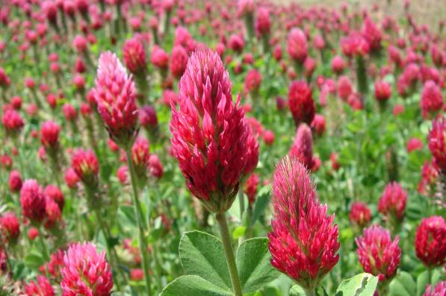USDA NRCS Jimmy Carterl Plant Materials Center*

*Americus, GA*

##### Animal Management Note

##### On pasture or hay high in clover content, take steps to introduce animals gradually to the forage or the risk of bloat can be high.

Uses

Crimson clover, as a winter annual, is usually planted in the late summer to early fall. It can be utilized in pasture, hay, organic farming, pollinator enhancement, silage mixes, or used as a winter cover for soil protection or green manure crop for soil improvement.

Status

Please consult the PLANTS Web site and your State Department of Natural Resources for this plant’s current status (e.g. threatened or endangered species, state noxious status, and wetland indicator values).

Weediness

This plant may become weedy or invasive in some regions or habitats and may displace desirable vegetation if not properly managed. Please consult with your local NRCS Field Office, Cooperative Extension Service office, or state natural resource or agriculture department regarding its status and use. Weed information is also available from the PLANTS Web site at plants.usda.gov.

Description

Crimson clover is an introduced winter annual and herbaceous legume. The leaves and stems of crimson clover resemble those of red clover, but the leaves are round-tipped with more hair on the stems and leaves. Seedlings grow rapidly from the crown forming a rosette. This rosette enlarges as weather becomes favorable. In the spring, the flower stems develop rapidly and end their growth with long, pointed conical flower heads comprised of 75 to 125 florets. Florets are a bright crimson color and open in succession from the bottom to the top.

Adaptation and Distribution

Crimson clover will grow on soils of poorer quality than most other clovers, thriving on both well-drained sandy and clayey soils. It does not do well in extreme cold or heat. The preferable pH range is 6.0 to 7.0. After seedling establishment, growth at lower temperatures is superior to other clovers. Crimson clover has been used for a cover crop as far north as northern Maine. The primary growing areas are the Southeast and southern Atlantic coastal states.

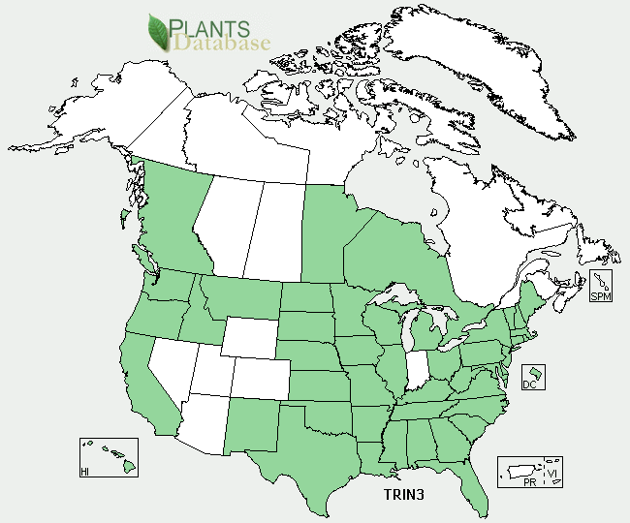Distribution map of Trifolium incarnatum L.

For a current distribution map, please consult the Plant Profile page for this species on the PLANTS Website.

Establishment

Crimson clover seed should be inoculated for planting on critical areas where bacteria may have been lost. On sites that have been in pasture or hay, this is probably not necessary.

Soils should contain moderate to high levels of phosphorus and potash prior to planting, but nitrogen should not be applied unless planting sites are degraded. Plant in the spring or late summer. Clovers may be frost seeded in late winter. This seeding method broadcasts seed on existing grass pastures when the ground is frozen, freezing, thawing, and early spring rain cover the seed.

The best planting method is to drill the seed into a firm, weed free seedbed. No-till methods can be used successfully if effective weed control is employed.

Seeding rates range from 10 to 15 lb/acre when seeded alone and 5 to 10 lb/acre when seeded in a mixture. Seed should be planted at about a ¼ inch depth.

Management

Pasture and hayland management varies depending upon the forage and/or forage mix. In grass legume mixtures management is based upon the grasses rather than the legumes. Graze or cut crimson clover for hay when in the early bloom stage (¼ to ½ in bloom). When used as a winter pasture, grazing too closely will affect the stand and the seed and forage yields the following spring. Grazing or hay cutting at or near maturity may be harmful. Hairs of stems and heads become hard and tough. If used as a green manure, manage the crop so it is plowed under about 2 to 3 weeks before the next crop is planted.

Clover needs a high level of phosphorous. High inputs of nitrogen fertilizer will damage clover and other legumes by reducing their vigor and give a boost to the grass.

Cultivars, Improved, and Selected Materials (and area of origin)

Most crimson clover types used in the past were common types. However, more recent introductions featured reseeding types such as ‘Dixie’, ‘Tibbee’, and ‘AU Robin’. ‘AU Sunrise’ and ‘AU Sunup’ are reseeding cultivars from the Jimmy Carter Plant Materials Center in Americus, Georgia and Auburn University in Auburn, Alabama. The ‘AU Sunrise’ and ‘AU Sunup’ releases are well-adapted to Alabama and Georgia, and can grow into Florida and Mississippi.

Control

Please contact your local agricultural extension specialist or county weed specialist to learn what works best in your area and how to use it safely. Always read label and safety instructions for each control method. Trade names and control measures appear in this document only to provide specific information. USDA, NRCS does not guarantee or warranty the products and control methods named, and other products may be equally effective.

Prepared By & Species Coordinator:

USDA NRCS Jimmy Carter Plant Materials Center

Published May, 2009

Edited: 05Feb2002 JLK; 30may06jsp; 20feb09 mo&erg; 090225 jsp

For more information about this and other plants, please contact your local NRCS field office or Conservation District <<http://www.nrcs.usda.gov/>>, and visit the PLANTS Web site <[http://plants.usda.gov](http://plants.usda.gov/)> or the Plant Materials Program Web site <<http://plant-materials.nrcs.usda.gov>>

.

**USDA IS AN EQUAL OPPORTUNITY PROVIDER AND EMPLOYER**