

Plant Fact Sheet

# arrowleaf clover

## Trifolium vesiculosum Savi.

Plant Symbol = TRVE

Contributed by: USDA NRCS Jamie L. Whitten Plant Materials Center, Coffeeville, MS

*Meechee clover in flower.*

*Figure 1 'Meechee' arrowleaf clover in flower.*

### Alternate Names

None

### Uses

Arrowleaf clover is a cool season, reseeding annual legume. It is a multiple purpose plant material that can be used for grazing, hay production, a wildlife food source, soil improvement and a winter cover crop. Forage quality is high with digestibility generally superior to crimson clover at all stages of maturity. Deer and turkey readily feed on arrowleaf clover.

### Status

Please consult the PLANTS Web site and your State Department of Natural Resources for this plant’s current status (e.g., threatened or endangered species, state noxious status, and wetland indicator values).

### Description and Adaptation

Arrowleaf clover is an upright, cool-season, annual legume that can grow to a height of 40-50 inches under good conditions. Seeds germinate in the fall and plants grow slowly during the winter. Leaflets are large, rounded at the base, pointed at the tip, and they generally have white, V-shaped markings. Individual flowers are arranged in a cluster or head up to 2 inches long. Initially, the flowers are white to pinkish, turning brown when mature. Flowering and seed production occurs over a long period of time in late spring and summer. A majority of the growth is between February and May. This clover is capable of large seed yields ranging from 200 to 300 lbs per acre with approximately 75% hard seed. This hard-seededness allows arrowleaf clover to maintain long term stands. Arrowleaf clover can produce volunteer stands for up to five years if allowed to reseed periodically. This clover grows well in the area from about the middle of Alabama westward through Mississippi, Louisiana, and Arkansas except for higher elevations in the Ozarks. It also grows well in the blacklands of Texas and into southeastern Oklahoma.

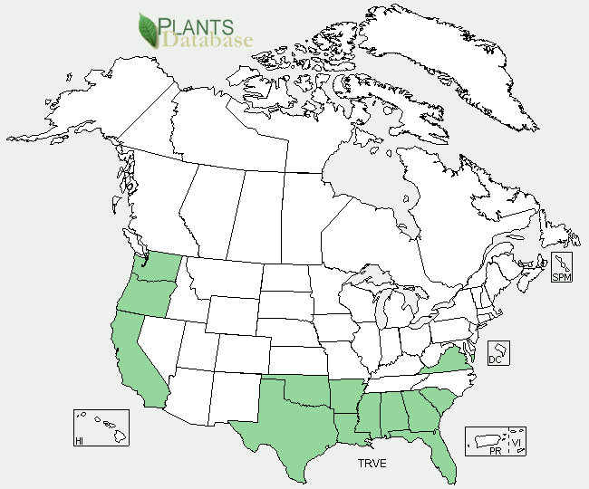

*Arrowleaf clover distribution from USDA-NRCS PLANTS Database*

For updated distribution, please consult the Plant Profile page for this species on the PLANTS Web site.

### Establishment

Best results are obtained by planting on prepared seedbeds in the fall at the accustomed season for seeding winter legumes. Arrowleaf clover is established by seed from September to mid-October. Seed can be drilled at 10 lbs/acre or broadcast at 15 lbs/acre with proper inoculant.

### Management

Arrowleaf clover will continue to develop new leaves and remain productive longer in the spring when grazed to a height of 2 to 4 inches. If managed for a hay crop, clover should be grazed until early- to mid-April, and then harvested at early to mid-bloom in May.

### Pests and Potential Problems

Arrowleaf clover is susceptible to crown rot (Schlerotinia trifolium). Damage to from alfalfa weevils and aphids has also been observed.

### Environmental Concerns

There are no known environmental concerns associated with arrowleaf clover.

### Cultivars, Improved, and Selected Materials (and area of origin)

‘Meechee’ was released by the USDA-NRCS Jamie L. Whitten Plant Materials Center, Coffeeville, MS in 1966.**Prepared By**

*Thomas C. Moss*, USDA NRCS Jamie L. Whitten Plant Materials Center, Coffeeville, MS

### Citation

Moss, T. C. 2011. Plant fact sheet for arrowleaf clover (*Trifolium vesiculosum)*. USDA-Natural Resources Conservation Service, Jamie L. Whitten Plant Materials Center, Coffeeville, MS. 38922

Published: September 2011

Edited: 09Sep2011 tm

For more information about this and other plants, please contact your local NRCS field office or Conservation District <<http://www.nrcs.usda.gov/>>, and visit the PLANTS Web site <[http://plants.usda.gov](http://plants.usda.gov/)> or the Plant Materials Program Web site <<http://plant-materials.nrcs.usda.gov>>

**USDA IS AN EQUAL OPPORTUNITY PROVIDER AND EMPLOYER**