

Plant Guide

## PRAIRIE ACACIA

## Acacia angustissima

## (Mill.) Kuntze var. hirta

## (Nutt.) B.L. Rob.

Plant Symbol = ACANH

*Contributed by*: USDA NRCS E. “Kika” de la Garza Plant Materials Center

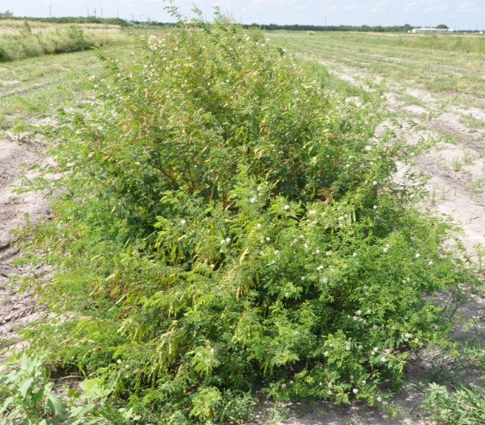

Prairie acacia plant, Shelly D. Maher USDA NRCS

### Alternate Names

Fern acacia, white-ball acacia, and Texas acacia

### Uses

*Livestock:* Prairie acacia produces high quality forage for all types of grazing livestock. Crude protein of prairie acacia leaves have ranged from 16 to 29% with good digestibility (Muir et al.2005). The literature reports some toxicity to sheep and other animals when fed at high concentrations.

*Wildlife*: Prairie acacia provides good forage for wildlife. It also provides seed and cover for fawns and upland game birds (Everitt and Drawe 1993).

### Status

Please consult the PLANTS Web site and your State Department of Natural Resources for this plant’s current status (e.g., threatened or endangered species, state noxious status, and wetland indicator values).

### Description

*General*: Prairie acacia is a native, perennial, rhizomatous legume (Correll and Johnston 1996; Diggs et al. 1999). It ranges from an herbaceous plant with delicate fern-like foliage to a semi-woody sub-shrub which grows 3-4 feet tall. Leaves are alternate, bipinnate with leaflets 3-6 mm long. White to cream flowers occur in 1-2 cm wide heads and those are formed into terminal clusters on long stalks arising from upper leaf axils. Fruit is a brownish flat seedpod 4-7 cm long and 6-8 mm wide.

*Distribution*: Prairie acacia’s range extends from Kansas and Missouri south into the eastern two-thirds of Texas. For current distribution, please consult the Plant Profile page for this species on the PLANTS Web site.

*Habitat*: It is located on shallow sandy loam and claypan prairie range sites. It is associated with false Rhodesgrass, pink pappusgrass, plains bristlegrass, and Arizona cottontop.

**Adaptation**Prairie acacia grows best on sandy loam to calcareous clay loam soils.

### Establishment

### Seedbed preparation should begin well in advance of planting. Planting can be scheduled for early spring or where there are few cool-season weeds, it can be planted in the fall. Establish a clean, weed-free seedbed by either tillage or herbicides. Prior to planting, the site should be firm and have accumulated soil moisture.

### Prairie acacia is best seeded using a native-grass drill to ensure a good planting of the seed on rough, irregular rangeland. Broadcast seeding may be used in areas not easily planted with a drill, but some type of additional coverage such as culti-packing or light dragging will be beneficial to ensure good seed to soil contact.

### Seed should be planted 1/4 to 1/2 inch deep. A brief mechanical scarification will improve seed germination of its hard seed. For calibration purposes, Rio Grande Germplasm prairie acacia contains approximately 31,000 seeds per bulk pound. A seeding rate of five pounds of pure live seed (PLS) per acre is recommended. In planting mixtures reduce the rate according to the percent of prairie acacia in the mixture. If one plant per square foot has become established than the planting has been successful.

### Soil analysis should be performed prior to planting to determine the necessary levels of phosphorus and potassium. No nitrogen fertilizer is necessary since prairie acacia is a legume. It forms a symbiotic relationship with rhizobial bacteria to fix atmospheric nitrogen for use by the plant. However, prior to seeding prairie acacia, the seed must be coated with the appropriate inoculant in order to establish the symbiotic relationship.

### Management

Prairie acacia should not be grazed the first year. After a stand is established, either continuous or rotational grazing can be used. It is recommended that a minimum 24 inch stubble height be maintained under continuous grazing. For rotational grazing, forage height should be utilized between 18 to 24 inches. Plants should be allowed to produce seed annually to insure stand health. Prairie acacia is a long-lived perennial that is extremely drought tolerant once established.

### Pests and Potential Problems

Control of the pests may be necessary in order to produce seed crops in dry years under irrigation.

### Environmental Concerns

There are no known environmental concerns with prairie acacia.

### Seeds and Plant Production

Seed increase plots have been planted on 36” bedded rows. Prairie acacia can also be established with vegetative transplants. Rapid spread and growth has been observed in transplant established stands providing seed harvests within the first year. Furthermore transplants stands facilitate better weed control in the seed production fields.

Prairie acacia produces seed usually twice a year, once in the early summer and again in the late fall. Seed is harvested with a combine. The use of slow travel and RPM speeds while harvesting results in relatively clean seed, needing little cleaning or processing. The use of a hammer-mill or flake-breaker is required to get the seed out of its pod. To clean stems and chaff from harvests, a Clipper seed cleaner has been used following the hammer-mill treatment.

Well managed seed fields have produced from 300-500 bulk pounds of clean seed. Purity of the seed is usually around 80-90% and germination rates for scarified seed ranges from 50 to 80%. Adequately stored seed in humidity and temperature controlled facilities can be expected to stay viable for over 10 years.

### Cultivars, Improved, and Selected Materials (and area of origin)

Plains Germplasm prairie acacia was released by the USDA NRCS Knox City Plant Materials Center in 2008. It was developed as a broad-based release consisting of 17 different accessions from several different ecoregions of north and central Texas. It is adapted to clay, gravelly and clay loam soils. Breeder seed is maintained by USDA NRCS Knox City Plant Materials Center.

Rio Grande Germplasm prairie acacia was released by the USDA NRCS E. “Kika” de la Garza Plant Materials Center and the *South Texas Natives* Project of the Caesar Kleberg Wildlife Research Institute at Texas A&M University-Kingsville in 2012. It was selected for its survivability, plant vigor, forage production and seed production characteristics. It is predominantly adapted to shallow sandy loam and claypan prairie range sites in south Texas. Breeder seed is maintained by USDA NRCS E. “Kika” de la Garza Plant Materials Center.

### References

Correll, D.V., and M.S. Johnston. 1996. Manual of the Vascular Plants of Texas. The University of Texas at Dallas. Dallas, Texas. Fourth Printing.

Diggs, Jr., G.M., B.L. Lipscomb, and R.J. O’Kennon. 1999. Shinners and Mahler’s illustrated flora of North Central Texas. Botanical Research Institute of Texas, Fort Worth, TX.

Everitt, J.H., and D.L. Drawe. 1993. Trees, Shrubs & Cacti of South Texas. Texas Tech University Press, Lubbock, TX.

Muir, J.P., J. Taylor, and S.M. Interrante. 2005. Herbage and seed from Texas native perennial herbaceous legumes. Rangeland Ecol. Manage. 58:643-651.

**Prepared By**:

*John Lloyd-Reilley*, Manager

USDA NRCS E. ‘Kika’ de la Garza Plant Materials Center, Kingsville, Texas

### Citation

Lloyd-Reilley, J. 2011. Plant guide for prairie acacia (*Acacia angustissima* var. *hirta)*. USDA Natural Resources Conservation Service, E. “Kika” de la Garza Plant Materials Center. Kingsville, TX 78363.

Published August 2007

Edited: 11July2012 jlr

For more information about this and other plants, please contact your local NRCS field office or Conservation District at <http://www.nrcs.usda.gov/> and visit the PLANTS Web site at <http://plants.usda.gov/> or the Plant Materials Program Web site <http://plant-materials.nrcs.usda.gov>.

PLANTS is not responsible for the content or availability of other Web sites.

**USDA IS AN EQUAL OPPORTUNITY PROVIDER AND EMPLOYER**