|  |
| --- |
| western yarrow |
| *Achillea millefolium* L. var. *occidentalis* DC. |
| Plant Symbol = ACMIO |

Contributed by: USDA NRCS Bridger (MT) Plant Materials Center

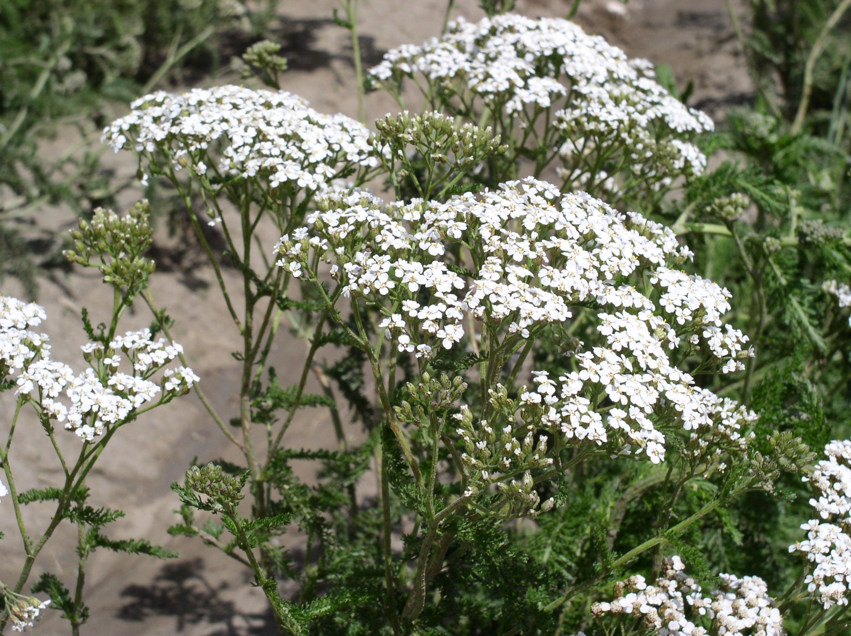

Susan R. Winslow

USDA NRCS Bridger Plant Materials Center

Alternate Names

Woolly yarrow; *Achillea millefolium* L. ssp. *occidentalis* (DC.) Hyl, *Achillea millefolium* L. var. *lanulosa* (Nutt.) Piper; *Achillea millefolium* L. ssp. *lanulosa* (Nutt.) Piper

Uses

*Conservation:* Western yarrow is an early successional species that readily establishes on disturbed sites. It is recommended for adding species diversity in native seed mixtures for rehabilitation of disturbed sites such as rangelands, mined lands, roadsides, park and restoration areas, prairie reconstruction projects, and farm bill program conservation plantings. Secondary use is for ornamental application in pollinator friendly, low maintenance, or naturalized landscapes.

*Forage:* Western yarrow is a food source for bighorn sheep, pronghorn antelope, and deer. Sage-grouse, especially chicks, and other upland birds rely heavily on the foliage of western yarrow as a food source. Sage-grouse chicks also benefit from eating the insects associated with yarrow. In Montana, domestic sheep and goats derive approximately 40 percent of their summer diet from western yarrow, while it constitutes 20 percent of cattle and horse diets (Reitz and Morris, 1939). The leaves and flowers contain volatile oils, alkaloids, and glycosides that are considered toxic, but the plant is seldom overgrazed and eaten in large enough quantities to be harmful to foraging animals.

*Ethnobotanic:* Native Americans used western yarrow for many purposes, such as a tea to cure stomach ailments, a poultice on infected wounds, and as a mosquito repellant.

Status

Please consult the PLANTS Web site and your State Department of Natural Resources for this plant’s current status (e.g., threatened or endangered species, state noxious status, and wetland indicator values).

Weediness

Western yarrow is not to be confused with the introduced, invasive plant, common yarrow (*Achillea millefolium* var. *millefolium*). Common yarrow has origins in central Asia, the European continent, and the islands of Scandinavia. It is considerably different from western yarrow in that it has a much taller stature, aggressive vigor, and weedy characteristics. Common yarrow also initiates a later sequence of flowering and seed ripening (Callan, 2002).

Western yarrow is a common component of western rangelands and only under definite conditions of overgrazing and disturbance could it become locally abundant (USDA FS, 1937). Yarrow is seldom regarded as a problem weed (Whitson et al., 1991) except on heavily disturbed, arable sites with favorable environmental conditions (Kannangara and Field, 1985).

Description

*General*: Western yarrow is a member of the Asteraceae (Sunflower) family that is commonly found in natural and disturbed habitats throughout the western U.S. (Hitchcock and Cronquist, 1973). It is a self-incompatible, insect-pollinated species (Clausen et al., 1958) occurring as native forms that may differ in chromosome number (n=18 or n=27); native races originating in the western U.S. (except the Pacific coast) are mostly tetraploid and introduced races mostly hexaploid (Hitchcock et al 1955). Botanists currently acknowledge genetic and ecological differentiation among native ecotypes at the local and regional level (Lavin, 2002; Lesica, 2001).

*Taxonomic*: Western yarrow is a moderately rhizomatous, long-lived, native, herbaceous perennial forb. It is 30-100 cm tall with few to many unbranched, erect, lanate stems (Cronquist et al., 2002). Leaves are alternate, sessile, pinnately dissected, semi-evergreen, and aromatic with an anthemideous scent (chamomile or dog fennel-like odor). The basal rosette foliage is up to 25 cm long, and cauline leaves are typically up to 10 cm long and 3 cm broad. Inflorescences are arranged in a compound, flat-topped corymb 6-20 cm wide, consisting of numerous, small flower heads 4-6 mm in diameter. Involucre bracts are usually pubescent and greenish, with papery, straw-colored margins (Robinson and Fernald, 1908). Outside ray flower numbers are 3-12, mostly white to cream-colored, 1-2.5 mm long and encircle the center disk flowers. The disk flowers number 10-75 each, and are yellow, tubular, perfect, and seed-producing. Fruit is a flattened, glabrous achene with compressed margins in a mostly reverse egg-shape with no pappus (USDA FS, 1966).

**Distribution**

For current distribution, please consult the Plant Profile page for this species on the PLANTS Website.

Habitat

Western yarrow is one of the most abundant and widely distributed wildflowers in the western United States. It is circumboreal and grows in a variety of plant communities from Alaska across Canada and into northern Mexico (Johnson and Larson, 1999). Western yarrow prefers full sun on roadsides, hills, canyons, pastures, and disturbed areas. It is scattered in sagebrush areas, open timber, and subalpine zones.

Western yarrow thrives in droughty conditions on gravelly loam and on thin or sandy soils. It is a common component of such ecological sites as shallow, silty, shallow to gravel, and silty steep (USDA SCS, 1976). Associated species include western wheatgrass (*Pascopyrum smithii*), bluebunch wheatgrass (*Pseudoroegneria spicata*), prairie Junegrass (*Koeleria macrantha*), Sandberg bluegrass (*Poa secunda*), common gaillardia (*Gaillardia aristata*), big sagebrush (*Artemisia tridentata*), and prairie coneflower (*Ratibida columnifera*).

Adaptation

Western yarrow is highly variable and displays wide ecological amplitude to diurnal temperature, altitude, latitude, and climatic (Hiesey and Nobs, 1970) and edaphic conditions (Higgins and Mack, 1987). It is considered an “environmental specialist” due to the successful evolution of a number of ecotypic races (Taylor, 1992).

Establishment

*Natural:* Western yarrow initiates growth in early spring and blooms for an extended period of time from late spring through mid summer (Budd and Campbell, 1959). It reproduces by seed and vegetatively, but in undisturbed habitats the rhizomes remain attached to the parent plant and vegetative spread is relatively low (Bostock and Benton, 1979). In disturbed areas, rhizome fragments do not survive on the soil surface, and bud sprouting success in buried rhizomes is dependant on fragment length and soil depth (Bourdot, 1984).

The growth performance of western yarrow is reduced under conditions of increased competition and shading (Bourdot et al., 1984 and 1985). It is rated as good in maintaining a state of evergreenness (Monsen et al., 2004) and is not highly flammable, although flames can wick up through the hollow, dry flower stalks. Late-spring burning will reduce western yarrow (Anderson et al., 1970), as will heavy fires. In certain environments yarrow populations tend to temporarily increase after less intense fires (Bartos and Mueggler, 1981). Studies conducted on the use of yarrow as a sodding technique in erosion control projects have produced satisfactory results (Airhart, 1988).

*Direct Seeding:* Viability of fresh western yarrow seed is generally high and seeds germinate under normal test conditions in 2 to 8 days, with 75 percent germination occurring in 5 days (Sorenson and Holden, 1974). Seed should be planted into a firm, weed-free seedbed with a drill that will ensure uniform seed placement to a depth of ⅛ to ¼ inch (3 to 6 mm) or broadcast seeded, then harrowed or raked, and firmed with a packer or roller. Field conditions during seedling emergence must be monitored for impermeable crusts, especially on sites with clayey soils. If crusting is observed, the soil crust can be fractured with a roller or periodic sprinkler irrigation.

There are approximately 4.4 million seeds/lb (9.5 million seeds/kg). The full seeding rate is ¼ to ½ lb/acre (0.3 to 0.6 kg/ha) pure-live-seed (PLS), but western yarrow would seldom be seeded in a pure stand. It is recommended that western yarrow be included as a component of a native seed mixture, where the seeding rate is adjusted to the desired potential of the plant community. Spring seeding is preferred over a dormant fall planting date. Periodic mowing during the establishment year is one option for weed suppression.

*Containers:* Containers should be sown in fall for outside nursery production and in spring for production in the greenhouse. Pots are filled with a well-drained soilless medium and wetted prior to seeding. Seeds are placed directly on the surface and lightly covered with a thin layer of the medium, perlite, or pea gravel, and then thoroughly irrigated. Containers are kept moist with light irrigation or misting during the establishment phase. Germination occurs in 6 to 14 days at approximately 70° F, followed by rapid root and shoot development over the next 60 days. Supplemental nutrition is not necessary, but may be applied at the recommended rate as a controlled release, encapsulated fertilizer (Luna et al., 2004).

Potted material should be acclimated to natural spring temperatures for at least 1 month prior to lining out. The site should be prepared so that the soil is workable, but not so loose as to resist packing. Transplants are placed in a hole slightly deeper than the length of the root ball, firmly tamped to remove unwanted airspace, and watered until the soil is settled. Additional soil may be required to fill cracks as they occur around the plants. Supplemental irrigation is advised for as long as feasible, or on a regular basis during the active growing season to promote flowering and seed set. Survival is high in increase plantings receiving proper care, but lower on sites with existing vegetation (Skinner, 2003).

Management

There is a high potential for using this species to revegetate alpine and subalpine disturbances, and in other degraded areas of the western U.S (Wasser, 1982). New seedings may need protection from trampling and weeds during establishment. Clipping weeds above the seedlings is a preferred method of weed suppression as there are no herbicides selective for broadleaf plants. Western yarrow vigor, aesthetics, and stand persistence after establishment may be sustained with properly timed grazing or defoliation of associated species. Satisfactory control of western yarrow is achieved through herbicide application mixtures of dicamba and dichlorprop (Robocker, 1977). Always consult product label prior to application and properly follow recommendations.

Pests and Potential Problems

Inflorescences that are harvested for seed production often contain small quantities of insect larvae and numerous live insects. Many beneficial and pollinating insects, such as minute pirate bug (*Orius*), big-eyed bug (*Geocoris*), hoverflies (Syrphidae), and several tachnid flies (*Archytas apicifer*, *Gymnosoma*, *Tricopoda pennipes, Cylindromia*) are known to frequent yarrow plants (Long, 2001). Pest insects include common leaf bugs (*Lygus*) and flea beetles (Chrysomelidae). Root rot and mildew may occur in poorly drained soils (Warwick and Black, 1982).

Environmental Concerns

Western yarrow is a pioneer species and considered an increaser where the forage resource has been overstocked and excessively utilized. It should be considered noninvasive when used within a diverse plant community in its anticipated area of adaptation.

Seed Production

Production fields should be seeded at a rate of 25 PLS per linear foot of row (82 per linear meter of row). Between-row spacing is dependent on the type of planting and cultivation equipment, and ranges from 22 to 36 in. (56 to 90 cm). Adequate between-row space should be provided to perform mechanical cultivation. At 24-in. row spacing, the recommended seeding rate is 0.12 PLS lb/acre (0.14 kg/ha), and at 30- and 36-in. row spacing, the seeding rate is 0.09 and 0.08 PLS lb/acre (0.1 and 0.09 kg/ha), respectively. There are presently no herbicides specifically labeled to control weeds in seed production fields. Seed harvest can be accomplished by swathing and combining from the cured windrows, or direct combining. The indeterminate ripening may necessitate periodic mechanical stripping as seed heads mature.

Seed is processed over a two-to three-screen fanning mill (slotted mesh screens), with final cleaning over an indent cylinder or gravity table. An acceptable seed quality testing standard is 95 percent purity and 80 percent viability (Stevens and Meyer, 1990). Seed production of 100 to 150 lb/acre (112 to 170 kg/ha) can be expected under irrigated conditions. Seed longevity is at least 5 years when stored at moderate temperatures and low humidity (USDA NRCS, 2004).

Cultivars, Improved, and Selected Materials (and area of origin)

Great Northern Germplasm is a selected class release of western yarrow originally collected in 1988 in Flathead County, Montana. This 2004 release was selected for top performance in vigor, height, seedhead production, and survival from among 29 accessions of native yarrows from Montana and Wyoming. It is adapted for use in northern Idaho, and all of Montana and Wyoming, except the Red Desert and Bighorn Basin. G1 seed (analogous to Foundation seed) will be maintained by the USDA NRCS Bridger Plant Materials Center and is available to commercial growers through the Foundation Seed Program at Montana State University-Bozeman and the University of Wyoming Foundation Seed Service at Powell, Wyoming. Commercial production is limited to two generations beyond G1.

Yakima Germplasm is a source-identified, composite release of western yarrow from 27 collection sites on the U.S. Army Yakima Training Center in Yakima, Washington. Yakima Germplasm western yarrow is intended for use in the rehabilitation and restoration of western rangelands. The USDA-ARS Forage and Range Research Laboratory, Logan, Utah, will maintain G1 seed and it will be made available to growers through the Utah Crop Improvement Association. Seed through the G4 generation will be eligible for certification.

References

Airhart, D.L. 1988. *Experiments with seed-grown sod as plant introduction technique described (Massachusetts)*. Restoration & Management Notes, 6(1):51.

Anderson, K.L., E.F. Smith, and C.E. Owensby. 1970. *Burning bluestem range*. Journal of Range Management 23:81-92.

Bartos, D.L. and W.F. Mueggler. 1981. *Early succession in aspen communities following fire in western Wyoming*. Journal of Range Management 34(4):315-318.

Bostock, S.J. and R.A. Benton. 1979. *The reproductive strategies of five perennial Compositae*. Journal of Ecology 67:91-107.

Bourdot, G.W. 1984. *Regeneration of yarrow (Achillea millefolium L.) rhizome fragments of different length for various depths in the soil*. Weed Research 24: 421-429.

Bourdot, G.W., D.J. Saville, and R.J. Field. 1984. *The response of Achillea millefolium L. (Yarrow) to shading*. New Phytologist 97:653-663.

Bourdot, G.W., R.J. Field, and J.G.H. White. 1985. *Growth analysis of Achillea millefolium L. (Yarrow) in the presence and absence of a competitor--Hordeum vulgare L. (Barley).* New Phytologist 101:507-519.

Budd A.C. and J.B. Campbell. 1959. *Flowering sequence of a local flora*. Journal of Range Management 12: 127-132.

Callan, N. (December) 2002. *Personal communication*. Montana State University. Western Agricultural Research Station, Corvallis, MT.

Clausen, J., D.D. Keck, and W.M. Hiesey. 1958. *Experimental studies on the nature of species: III. Environmental responses of climatic races of Achillea*. Carnegie Institution of Washington Publication 581, Washington D.C.

Cronquist, A., A.H. Holmgren, N.H. Holmgren, and J.L. Reveal. 2002. *Intermountain Flora, vascular plants of the intermountain west, Vol. 5: The Asterales*. The New York Botanical Garden, NY.

Hiesey, W.M. and M.A. Nobs. 1970. *Genetic and transplant studies on contrasting species and ecological races of the Achillea milllefolium complex*. Botanical Gazette 131(3):245-259.

Higgins, S.S. and R.N. Mack. 1987. *Comparative responses of Achillea millefolium ecotypes to competition and soil type*. Oecologia 73:591-597

Hitchcock, C.L., A. Cronquist, M. Ownbey, and J.W. Thompson. 1955. *Vascular plants of the Pacific Northwest*. University of Washington Press, Seattle and London.

Hitchcock, C.L. and A. Cronquist. 1973. *Flora of the Pacific Northwest: an illustrated manual*. University of Washington Press, Seattle and London.

Kannangara, H.W. and R.J. Field. 1985. *Environmental and physiological factors affecting the fate of seeds of yarrow (Achillea millefolium) in arable land in New Zealand*. Weed Research. 25:87-92.

Johnson, J.R. and G.E. Larson. 1999. *Grassland Plants of South Dakota and the Northern Great Plains*. South Dakota State University. College of Agriculture and Biological Sciences. South Dakota Agricultural Experiment Station, Bulletin 566 (revised).

Lavin, M. (November) 2002. *Personal communication*. Montana State University, Bozeman.

Lesica, P. (June) 2001. *Personal communication*. Conservation Biology Research. Missoula, MT.

Long R. F. 2001. *Quantifying pests and beneficial insects in insectary hedgerows-the final report*. http:www.sarep.ucdavis.edu/grants/Reports/Long/Long99-22-2/htm

Luna, T., J. Evans, and D. Wick. 2004. *Propagation protocol for production of container Achillea millefolium L. Nutt. (172 ml conetainers); Glacier National Park, West Glacier, MT*. *In:* Native Plant Network. URL: <http://www.nativeplantnetwork.org>/ Moscow, Idaho: University of Idaho, College of Natural Resources, Forest Research Nursery.

Monsen, S.B., R. Stevens, and N.L. Shaw, comps. 2004. *Restoring western ranges and wildlands*. Gen. Tech. Rep. RMRS-GTR-136-vol-2. Fort Collins, CO: U.S. Department of Agriculture, Forest Service, Rocky Mountain Research Station. Pages 295-698 plus index.

Reitz, L.P. and H.E. Morris. 1939. *Important grasses and other common plants on Montana ranges--description, distribution, and relative value*. Bulletin 375. Montana State College, Agricultural Experiment Station, Bozeman.

Robinson, B.L. and M.L. Fernald. 1908. *Gray's New Manual of Botany: A handbook of the flowering plants and ferns*. Amer. Book Co., New York.

Robocker, W.C. 1977. *Germination of seeds of common yarrow (Achillea millefolium) and its herbicidal control*. Weed Science 25(5):456-459.

Skinner, D.M. 2003. *Propagation protocol for production of container Achillea millefolium L ; Pullman Plant Materials Center, Pullman, Washington*. *In:* Native Plant Network. URL: <http://www.nativeplantnetwork.org>/ Moscow, Idaho: University of Idaho, College of Natural Resources, Forest Research Nursery.

Sorenson, J.T. and D.J. Holden. 1974. *Germination of native prairie forb seeds*. Journal of Range Management 27(2):123-126.

Stevens, R. and S.E. Meyer. 1990*. Seed quality testing for range and wildland species*. Rangelands 12(6):341-346.

Taylor, R.J. 1992. *Sagebrush country: A wildflower sanctuary*. Mountain Press Publishing Company. Missoula, MT.

USDA FS. 1937. *Range plant handbook*. Washington, DC.

USDA FS. 1966. *Notes on western range forbs--Cruciferae through Compositae*. Agriculture Handbook No. 293. Washington, DC.

USDA NRCS. 2004. *Release notice for selected class of Great Northern Germplasm western yarrow*. Bridger, MT.

USDA SCS. 1976. *Climax vegetation of Montana based on soils and climate*. Bozeman, MT.

Warwick, S.I. and L. Black. 1982. *The biology of Canadian weeds. Achillea millefolium L*.

Canadian Journal of Plant Science. 62:163-182.

Wasser, C.H. 1982. *Ecology and culture of selected species useful in revegetating disturbed lands in the West*. USFWS FWS/OBS-82/56. 347 pp.

Whitson, T.D., L.C. Burrill, S.A. Dewey, D.W. Cudney, B.E. Nelson, R.D. Lee, and Robert

Parker. 1991. *Weeds of the West*. The Western Society of Weed Science and University of

Wyoming, Laramie.

Prepared By & Species Coordinator:

*Susan R. Winslow*

USDA NRCS, Plant Materials Center, Bridger, Montana

Edited: 24Jan2006 jsp; 30may06jsp

For more information about this and other plants, please contact your local NRCS field office or Conservation District, and visit the PLANTS Web site<<http://plants.usda.gov>> or the Plant Materials Program Web site <<http://Plant-Materials.nrcs.usda.gov>>

*The U.S. Department of Agriculture (USDA) prohibits discrimination in all its programs and activities on the basis of race, color, national origin, sex, religion, age, disability, political beliefs, sexual orientation, and marital or family status. (Not all prohibited bases apply to all programs.) Persons with disabilities who require alternative means for communication of program information (Braille, large print, audiotape, etc.) should contact USDA's* [*TARGET Center*](http://www.usda.gov/oo/target.htm) *at 202-720-2600 (voice and TDD).*

*To file a complaint of discrimination write USDA, Director, Office of Civil Rights, Room 326-W, Whitten Building, 14th and Independence Avenue, SW, Washington, DC 20250-9410 or call 202-720-5964 (voice or TDD). USDA is an equal opportunity provider and employer.*

*Read about* [*Civil Rights at the Natural Resources Convervation Service*](http://www.nrcs.usda.gov/about/civilrights/)*.*