|  |
| --- |
| American beachgrass |
| *Ammophila breviligulata* Fern. |
| Plant Symbol = AMBR |

## *Contributed By: USDA NRCS New Jersey State Office and the National Plant Data Center*

# Alternate Names

coastal beachgrass, beach grass, marram grass

# Uses

*Dune Stabilization*: Major use is to stabilize moving sand along the Atlantic seacoast and Great Lakes region. It is the best species for the initial stabilization of frontal dunes.

*Revegetation*: Useful as an erosion control plant on non‑dune areas where soils are very sandy or inherently droughty and the site conditions make establishment of seeded species very difficult. In this application, the beachgrass may only survive a few years, but it plays a valuable role in jump-starting plant succession. Also used on soils high in salinity, such as industrial waste needing vegetative cover.

# Status

Please consult the PLANTS Web site and your State Department of Natural Resources for this plant’s current status, such as, state status and wetland indicator values.

# Description

*General*: Grass Family (Poaceae). American beachgrass, is a leafy, spreading, rhizomatous, native, bunch grass with many stems per clump. It may reach a height of two to three feet. The seed head is a spike‑like panicle, about ten inches long, and appears in late July or August. Leaves are long and narrow, and may become rolled or folded as it matures.

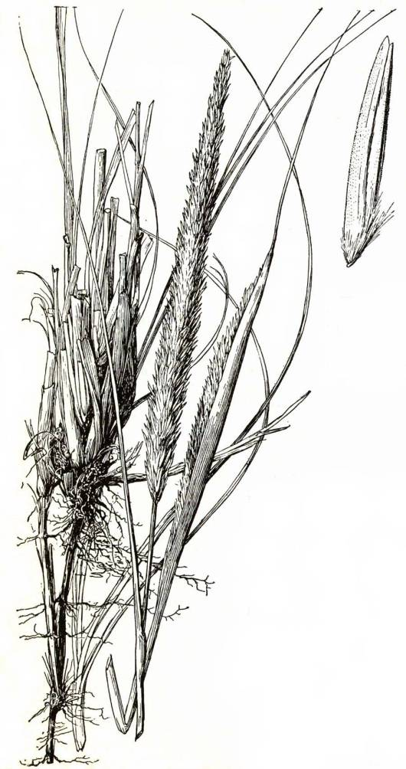

Hitchcock (1951)

One outstanding growth characteristic is the strong underground stems (rhizomes) that spread beneath the sand and give rise to many new plants. Its vigorous growth enables the plant to withstand heavy deposits of sand and grow up through it.

# Distribution

For current distribution, please consult the Plant Profile page for this species on the PLANTS Web site.

# Establishment

*Adaptation*: It is native to the mid‑Atlantic coastal region from Maine to North Carolina, and the Great Lakes region. It will grow on inland sites, high in sand and/or saline content, provided applications of fertilizers containing nitrogen are made. Requires a sunny position in a light, well-drained soil and is very tolerant of severe maritime exposure. The plant has a deep, strong and extensively creeping rhizome, and can become invasive when growing in suitable conditions. This ability to colonize makes this grass very valuable for dune stabilization.

*Planting*: The best time to plant beach grass is from October 1 to March 30 in the Mid-Atlantic region, but may be extended to April 30 in New England in most seasons. If properly planted, good survival can be expected at any time during this period, except when soil is frozen. Summer plantings are not satisfactory.

American beachgrass can be planted either by hand or by mechanical equipment designed for this work. The stems of plants (culms) are used for planting stock. Two to three culms are planted per hole. Space plants 18" by 18" unless wind erosion is severe, then spacing is reduced to 12” by 12”. Stagger the plantings in alternate rows to provide maximum erosion control. On very stable areas where wind is not a factor, a spacing of 24" by 24" is suitable. An 18” by 18" spacing requires 58,500 culms per acre, or 1,350 culms per 1,000 square feet.

Beachgrass culms must be planted at least 8" deep. This prevents plants from drying out, as well as being blown out by the wind. A tiling or ditching spade is an excellent tool for opening the planting hole. The culms and roots must be kept moist before and during planting. Success of planting will increase if the stock is dormant or has made very little growth.

Fertilizer properly applied is the key to good vigorous growth, as coastal sands are rather infertile.Apply fertilizer 30 days after planting, but no earlier than April 1 in the Mid-Atlantic and May 1 in New England. Inorganic, granular fertilizers high in nitrogen are best, if available (N-P-K analysis of 30-10-0, 16-8-8 or 10-10-10). Split the fertilizer applications: One in spring, another early summer, and a third in late summer, only in the establishment year. Apply no more than 1 lb. of N/1000 sq. ft .in a single application.

# Management

Once the stand is well established, the rate of fertilizer applied can be reduced by half, or applied only when the stand appears to be weakening, based on local soil test results. Pedestrian and vehicular traffic that bends or breaks the culms will seriously damage the plants and may kill them if traffic is intensive.

# Cultivars, Improved and Selected Materials

[Vegetative culms] of ‘Cape’ and ‘Hatteras’ are commercially available, though seed is not available.

‘Cape’ is the most recent variety and was developed by the Natural Resources Conservation Service [*in 1970*] at the Cape May Plant Materials Center, Cape May Court House, New Jersey. Material for this release was collected in Barnstable County, Massachusetts. It is very vigorous, a heavy culm producer with leaves exceptionally broad, and spreads rapidly by rhizomes.

‘Hatteras’ was developed by the North Carolina Agricultural Experiment Station and is better adapted to southern climates. Hatteras was developed from a collection of 18 clones screened for vigor and rate of spread. This cultivar is characterized by early vigor.

# References

Alderson, J. & C. Sharp 1994. *Grass varieties in the United States*. Agriculture Handbook No. 170. USDA, Soil Conservation Service, Washington, D.C. 296 pp.

Gleason, H.A. & A. Cronquist 1991. *Manual of vascular plants of northeastern United States and adjacent Canada*. The New York Botanical Garden, Bronx, New York. 910 pp.

Hitchcock, A.S. 1951. *Manual of the grasses of the United States*. Miscellaneous Publication No. 200. USDA, Washington, D.C. 1051 pp.

Radford, A.E., H.E. Ahles, & C.R. Bell 1968. *Manual of the vascular flora of the Carolinas*. The university of North Carolina Press, Chapel Hill, North Carolina. 1183

Selisker, D.M. 1995. *Coastal dune restoration: A strategy for alleviating dieout of Ammophila breviligulata*. Restoration Ecology 3(1):54-60.

Seymour, F.C. 1993. *The flora of New England*. Privately printed. 611 pp.

# Prepared By

## *Chris Miller*

USDA, NRCS, New Jersey State Office

## *J. Scott Peterson*

USDA NRCS National Plant Data Center, Baton Rouge, Louisiana

# Species Coordinator

## *Chris Miller*

USDA, NRCS, New Jersey State Office, Somerset, New Jersey

Edited 05dec00 jsp;07feb03ahv; 30may06jsp

For more information about this and other plants, please contact your local NRCS field office or Conservation District, and visit the PLANTS Web site<<http://plants.usda.gov>> or the Plant Materials Program Web site <<http://Plant-Materials.nrcs.usda.gov>>

*The U.S. Department of Agriculture (USDA) prohibits discrimination in all its programs and activities on the basis of race, color, national origin, sex, religion, age, disability, political beliefs, sexual orientation, and marital or family status. (Not all prohibited bases apply to all programs.) Persons with disabilities who require alternative means for communication of program information (Braille, large print, audiotape, etc.) should contact USDA's* [*TARGET Center*](http://www.usda.gov/oo/target.htm) *at 202-720-2600 (voice and TDD).*

*To file a complaint of discrimination write USDA, Director, Office of Civil Rights, Room 326-W, Whitten Building, 14th and Independence Avenue, SW, Washington, DC 20250-9410 or call 202-720-5964 (voice or TDD). USDA is an equal opportunity provider and employer.*

*Read about* [*Civil Rights at the Natural Resources Convervation Service*](http://www.nrcs.usda.gov/about/civilrights/)*.*