

Plant Guide

|  |
| --- |
| Muhlenberg maidencane |
| Amphicarpum muehlenbergianum  (Schult.) Hitchc. |
| Plant Symbol = AMMU2 |

Contributed by: USDA NRCS Brooksville Plant Materials Center

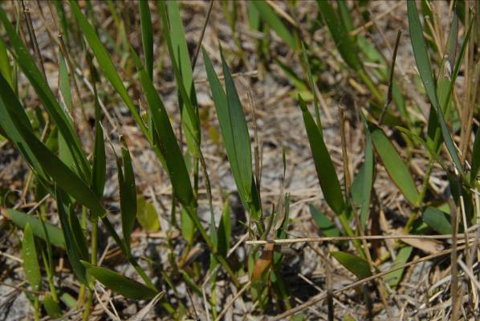

*Figure 1. Plant Materials Center Staff, Brooksville PMC, FL*

**Alternate Names**

blue maidencane*, Amphicarpum muhlenbergianum*, AMFL2 *Amphicarpum floridanum* Chapm., goobergrass

**Uses**

*Forage and Wildlife Use:* Blue maidencane is very palatable forage that produces high yields in pure stands in flatwood and forested areas with up to 50 percent shade. It can be used successfully in silvopasture systems and, in South Florida, provides forage for nine months for cattle and deer. Continuous heavy grazing of this plant will reduce stands and allow the increase of less palatable species (increasers). According to the University of Florida, average annual forage production for blue maidencane is about 4000 lb/ac with most of the growth occurring during the summer months.

*Erosion Control*: Blue maidencane is a facultative wetland species. It most often occurs in wetlands and can be used in freshwater wetland restoration sites and constructed wetlands for wastewater management. Although blue maidencane prefers soils that are wet for part of the year, it will not grow in deep, stagnant water.

Because it spreads rapidly from an extensive network of rhizomes, blue maidencane is an excellent candidate for erosion control and maintenance of water quality. Mechanized harvesting and propagation can be used for plant increase and establishment.

Status

Please consult the PLANTS Web site and your State Department of Natural Resources for this plant’s current status (e.g., threatened or endangered species, state noxious status, and wetland indicator values).

Description

*General*: Blue maidencane is a native, warm season perennial grass with an extensive rhizome system. Hairless blades are flat and firm, narrow, and lance-shaped with no prominent midribs; 3- to 5-inches long; and ¼- to ½-inches wide with rough margins that frequently become white at maturity. Blades are greenish blue in color and are evenly distributed on the culm. Basal leaves are mostly absent. Stems are thin and leafy up to 3-ft tall, but usually decumbent (laying down). Nodes and internodes are glabrous to pubescent. Sheaths are open, with no auricles, and ligules have hairs. Two types of inflorescences are produced, aerial and subterranean, but spikelets on aerial inflorescences are sterile. Subterranean inflorescences are produced in a 1 to 5 spikelet panicle born at the end of the rhizomes. Aerial seed stalks are 1- to 3- feet tall topped with 15 or more spikelets arranged in an open panicle 2- to 4-inches long. Aerial spikelets are usually lacking a first glume, and the second glume and lemma are longer than the floret. Aerial spikelets are lance-shaped, about 7-mm long, while the subterranean spikelets are egg-shaped, white, self-pollinating, and reach to 9-mm long.

*Distribution*: Blue maidencane is common throughout Florida and extreme southern Georgia, but is rare in Alabama, North Carolina, and South Carolina. In Florida, the distribution is centered in south and central Florida and northward through the eastern half of the state. For current distribution, please consult the Plant Profile page for this species on the PLANTS Web site.

*Habitat*: Blue maidencane usually occurs in wetlands (estimated probability 67%-99%) and floodplains of streams and rivers, but it can occasionally found in upland sites. It is well adapted to acid to neutral sandy soils that are wet for part of the year. Associated grass species are creeping bluestem (*Schizachyrium scoparium*) and broomsedge bluestem (*Andropogon virginicus*) in North and South Florida flatwoods, respectively. It is associated with wiregrass (*Aristida stricta*) and switchgrass (*Panicum virgatum*) in intermittently ponded flatwoods and bottlebrush threeawn (*Aristida spiciformis*), wiregrass (*Aristida stricta*), hairy blustem (*Andropogon longiberbis*), and bluejoint panicum (*Panicum tenerum*) in sloughs. It is found in the low pinelands in North and South Carolina and is reported to be tolerant of light shade.

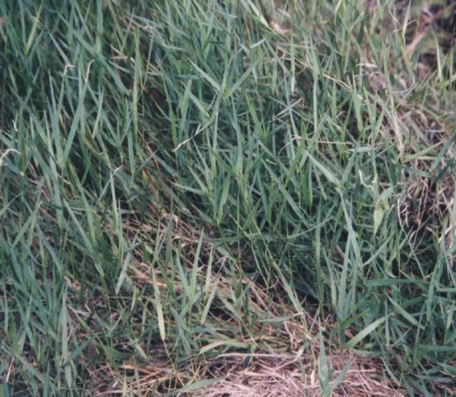

*Figure 2. Plant Materials Center Staff, Brooksville PMC, FL*

**Establishment**

As blue maidencane’s aboveground spikelets are sterile and its underground seeds are very limited and difficult to dig, field plantings are established vegetatively by rhizomes or greenhouse plugs. The recommended planting rate is 20 bu/ac or plugs set on 18 inch centers. A bushel of blue maidencane usually contains about 750, 6- to 8-inch long, 3-mm diameter rhizome pieces. Irrigated upland production fields can produce 2500 bu/acre if hand dug. Yield will be lower if dug mechanically.

Planting sites can be prepared with mechanical cultivation and plants can be established by sprigging or broadcasting rhizomes and disking them roughly 4-inches deep into the site. Appropriate sites would be mesic to wet flatwoods or wet prairies, at landscape positions above (upland) of those that normally support common maidencane (*Panicum hemitomon*). Treating weed populations prior to planting will increase stand establishment success. Non-native or invasive rhizomatous species, such as bermudagrass (*Cynodon dactylon*) or cogongrass *(Imperata cylindrica*) must be eradicated before planting.

Fertilizer applications during the establishment phase are not recommended. Since the establishment area may be wet, runoff rates may be high and additional fertilizer often promotes weed growth. Field trials have shown that nutrients released from vegetation management practices (herbicide and/or cultivation to kill existing vegetation) during site preparation supports excellent establishment of blue maidencane without supplemental fertilizer applications.

Management

Established plants should require no fertilizer or herbicide applications. After the first year of establishment individual plants should spread quickly. On appropriate sites, burning and/or disking in winter or early spring can reduce competition and help thicken stands.

Blue maidencane is very nutritious and will be grazed by cattle most of the year, while deer will graze stands in the winter and spring. To ensure stands will not decrease due to grazing pressure from livestock, they must be rested a minimum of 120 days after grazing to let plants fully recover.

**Pests and Potential Problems**

No serious pests of blue maidencane have been reported.

Environmental Concerns

An environmental assessment has been conducted for this species and no known serious environmental concerns were found. Because the aboveground spikelets are sterile, movement from the planting site is limited to vegetative spread and there is little concern regarding invasiveness. It is moderately competitive for limiting factors (light and nutrients) but can only become established in a narrow range of conditions. It has not been observed to hybridize outside the species. There have been no perceivable negative impacts on ecosystem processes, allelopathic effects on other plants, changes in community composition, or impacts on habitat for wildlife or domestic animals.

**Seeds and Plant Production**

Seed collection from blue maidencane is not suggested because aerial spikelets are sterile and underground fertile spikelets are not abundant.

Individual plants can be propagated in planting trays in a greenhouse in large, cone-like deep plugs that measure 1-inch diameter by 6-inch deep. Two, 4-inch long rhizome pieces that have at least two nodes each should be planted in each cell in a growing medium that allows for ample drainage and is kept moist, but not wet.

Cuttings should be kept in the greenhouse for at least three months to allow for ample root and shoot development. Plants should be fertigated throughout the nursery production period with a 100 ppm of a complete balanced soluble fertilizer such as 15-15-15 or 0.7 lb/100 ft2 14-14-14 slow release granular fertilizer.

**Cultivars, Improved, and Selected Materials (and area of origin)**

Gator Germplasm was collected in Citrus County, Florida not far from its northeastern border with Marion County. The collection site is north of Tsala Apopka Lake in the floodplain of the Withlacoochee River, so it is often seasonally flooded. Soil type at the collection site is Tavares fine sand with 0 to 5 percent slopes. The mean annual precipitation in the area is 53 inches; average maximum temperatures are 83 °F; and average minimum temperatures are 59 °F, with approximately 300 frost-free days per year.

References

Brooksville FL, PMC. 2002. 2001 Activity Report. pp. 9-10. Available from the USDA, NRCS Plant Materials Center, 14119 Broad St., Brooksville, FL 34601.

Clayton, W.D., M.S. Vorontsova, K.T. Harman, and H. Williamson. 2011. GrassBase – the online world grass flora. [Online]. Available at www.kew.org/data/grasses-db/www/imp00402.htm (accessed 29 March 2011).

Leithead, H.L., J.L. Yarlett, and T.N. Shiflet. 1971. 100 native forage grasses in 11 southern states. Agric. Handbook 389, Soil Conservation Service, USDA, Washington, D.C.

Radford, A.E., H.E. Ahles, and C.R. Bell. 1968. Manual of the vascular flora for the Carolinas. Univ. of North Carolina, Press, Chapel Hill.

Mullahey, J.J, G.W. Tanner, and S. Coates. 2009. Range sites of Florida. Publication #CIR951, University of Florida, IFAS Extension, [Online] Available at www.edis.ifas.ufl.edu/uw126 (accessed 29 March 2011).

USDA, NRCS. 2011. The PLANTS Database. [Online] Available at www.plants.usda.gov (accessed 29 March 2011). National Plant Data Center, Baton Rouge, LA 70874-4490 USA.

Hitchcock, A.S. 1971. Manual of the grasses of the United States. 2nd ed. A. Chase (ed.) Dover Publications, New York.

Watson, L., and M.J. Dallwitz 1992. Grass genera of the World: *Amphicarpum* Kunth. [Online]. http://www.biologie.uni-hamburg.de/b-online/delta/grass/www/amphicar.htm. (accessed 29 March 2011).

Williams, M.J., and J. Grabowski. 2006 Brooksville Plant Materials Center: developing sources of native wetland plants for revegetation in Florida. Proceedings of the 33rd Annual Conference on Ecosystems Restoration and Creation, Plant City, FL. [Online]. http://www.plant-materials.nrcs.usda.gov/pubs/flpmssy7475.pdf (accessed 29 March 2011).

Yarlett, L. L. 1996. Common grasses of Florida and the Southeast. The Florida Native Plant Society, Spring Hill, FL.

**Prepared By:** *C.M. Sheahan, J. Grabowski, and M.J. Williams*; USDA-NRCS, Brooksville Plant Materials Center, Brooksville, Florida.

**Citation:** Sheahan, C.M, J. Grabowski, and M.J. Williams. 2011. Plant guide forMuhlenberg maidencane (*Amphicarpum muehlenbergianum*). USDA-NRCS, Brooksville Plant Materials Center. Brooksville, FL.

Edited: 24Jan2011 mjw; 29Jul2011 jmg

For more information about this and other plants, please contact your local NRCS field office or Conservation District at <http://www.nrcs.usda.gov/> and visit the PLANTS Web site at <http://plants.usda.gov/> or the Plant Materials Program Web site <http://plant-materials.nrcs.usda.gov>.

PLANTS is not responsible for the content or availability of other Web sites.

**USDA IS AN EQUAL OPPORTUNITY PROVIDER AND EMPLOYER**